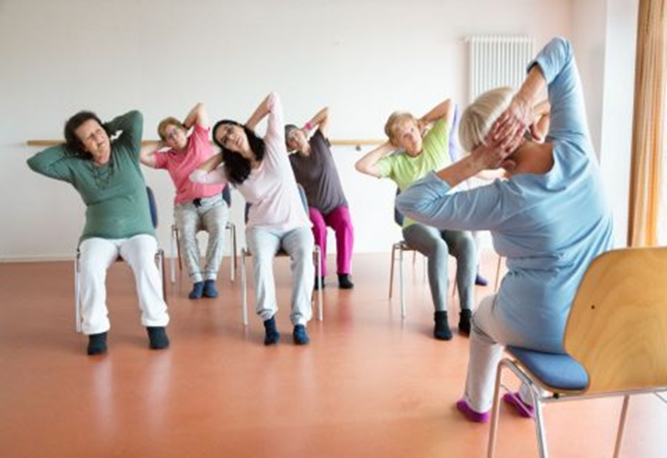
Free Chair Based Exercise Classes
Via Zoom
For residents in Barking and Dagenham
Every Tuesday at 11.30am – 12.30pm
Starting Tuesday 21st July 2021
For more information ring 07341 278919 or email: lorraine.barfoot@ageukrbh.org.uk
Or visit www.ageuk.org.uk/redbridgebarkinghavering/
Barking and Dagenham, Havering and Redbridge CCG

