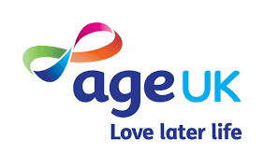

Creative Later Life
Issue 5- February 2021

Welcome to the latest Creative Later Life e-news offering you a flavour of what is free, accessible and available to everyone who wants to get creative this month. Age UK research shows that older people across the UK value the impact that creativity has on their own sense of wellbeing and, as Lockdown 3 continues to impact our lives, it is even more important.

Digital Resources:

- Web of the Week FREE AGE FRIENDLY CREATIVE IDEAS
https://www.weboftheweek.com/
Thank you to Age UK Enfield for highlighting this joyous website. ‘Whatever your background, whatever your age, whatever your level of expertise, Web of the Week is there to help you. It is your trustworthy door to the wonder of the World Wide Web.’ New content is added every week, so check it out.

- A Dose of Music with Covid Vaccinations FREE MUSIC SUPPORT GUIDE AND VIDEO
https://musicfordementia.org.uk/news-and-media/news/a-dose-of-music-with-covid-vaccination/
Vaccinations are on all our minds at the moment, potentially causing a degree of agitation for many. With our new guide, you can find out how music can be used to help alleviate COVID-19 jab anxiety for people living with dementia and others. Developed by industry professionals, get free support today.

- The Reader FREE POST/ PHONE/ ONLINE LITERATURE
https://www.thereader.org.uk/get-involved/the-reader-at-home/
The Reader at Home initiative will bring you wonderful reading materials, Shared Reading online and by phone and more. Our events are for people of all ages and backgrounds. With featured poems every week, and recordings of every Daily Reading, there’s plenty to enjoy.

Non-Digital Resource:

- Great Big Art Exhibition- FREE ART TO DOWNLOAD
https://firstsite.uk/the-great-big-art-exhibition-gallery/
Some of British art’s biggest names, including Antony Gormley, Sonia Boyce and Anish Kapoor, are encouraging Britons to turn their front windows into a gallery as part of a nationwide initiative to create a “magical patchwork of creativity”. Simply draw and create, then display in your windows at home! Go online to get a FREE pack to inspire you or just place a new masterpiece alongside your NHS rainbow.

For more creative opportunities to try visit www.festival.ageofcreativity.co.uk
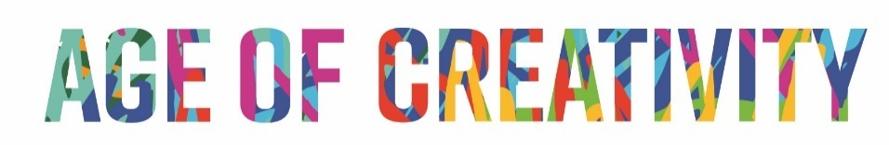

This email was produced by Age UK Oxfordshire, in partnership with Age UK and other local Age UKs across England. Age of Creativity is a project delivered by Age UK Oxfordshire to support more creativity with, for and by older people. Every effort has been made to ensure the content included is suitable, however no liability can be taken for these recommendations.
If you have any feedback about this e-news please contact: farrellrenowden@ageukoxfordshire.org.uk

