Di’s Diamonds
50+ Activities and Events
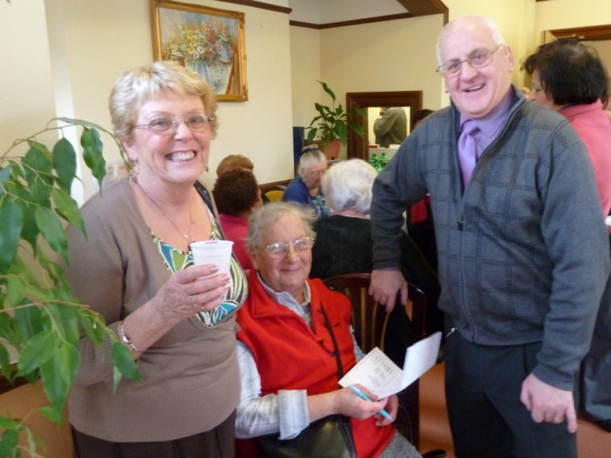
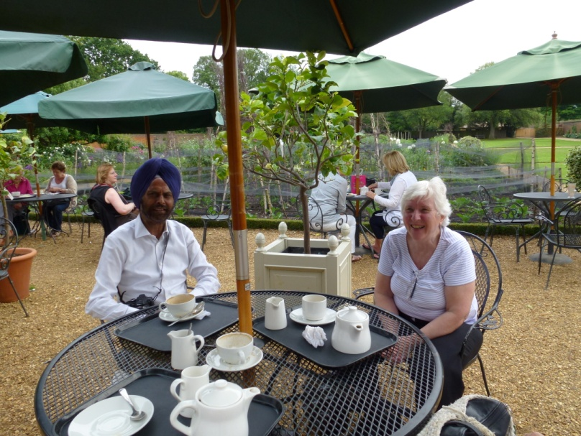
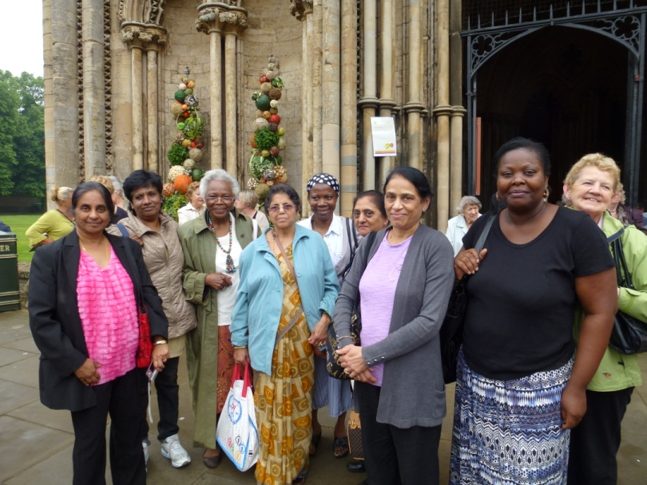
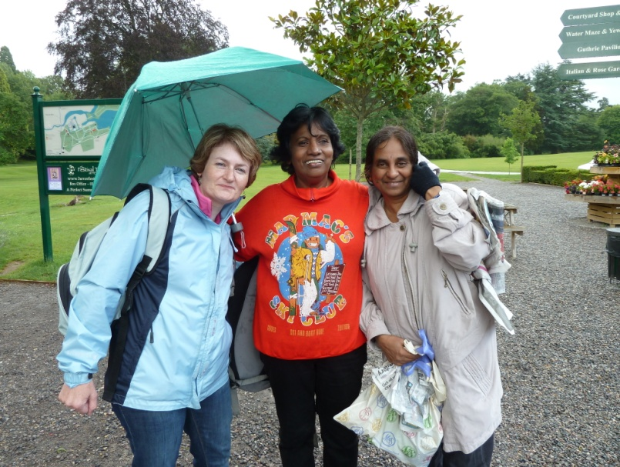
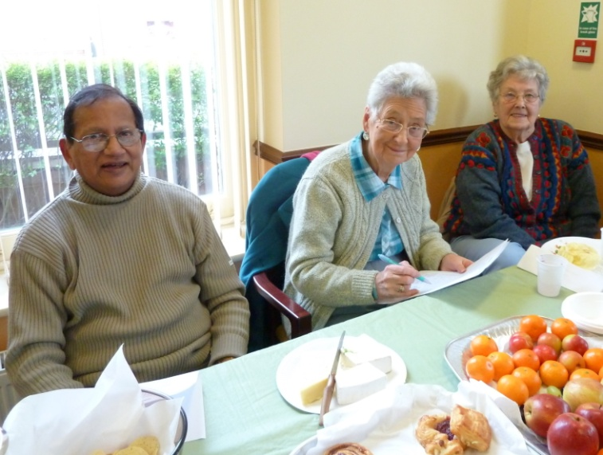
Who are we?
We are a group of men and women living in Havering, Redbridge and Barking & Dagenham, from all walks of life and backgrounds, single or partnered, aged 50+, who want to:
- meet people and make friends
- get out and about
- enjoy activities and events
- discover opportunities and take on new challenges

What do we do?
We organise regular activities and groups and enjoy outings and events, including:
- coffee mornings and meals
- bowling
- tea dances
- cinema and theatre trips
- museum and exhibition outings
- lectures and concerts
- take part in planned coach trips
- and lots more

We also send a monthly calendar of events that you can join.

Age UK Redbridge, Barking and Havering Ltd is a registered charity number 1088435 and company limited by guarantee. Registered in England and Wales number 4246504. Registered office 4th Floor, 103 Cranbrook Road, Ilford, Essex IG1 4PU.
How to join in?
We pride ourselves on welcoming everyone and helping them to make new friends. If you would like to participate contact Kim (details below) and go on our register to receive our monthly programmes. Then come along to a regular activity or pre book for one of our events.

You can also find out about our other services.

Contact us Mon-Fri, 9:00am-3:00pm
Age UK Redbridge, Barking and Havering
4th Floor, 103 Cranbrook Road,
Ilford, Essex, IG1 4PU

e: disdiamonds@ageukrbh.org.uk
m: 07724 508 967
t: 020 8220 6000
www.ageuk.org.uk/
redbridgebarkinghavering

