|  |  |
| --- | --- |
| Redbridge Barking & Dagenham **Di’s Diamonds Events** | 2025 |
|  |  |

|  |  |  |  |  |  |  |
| --- | --- | --- | --- | --- | --- | --- |
| Monday | Tuesday | Wednesday | Thursday | Friday | Sat | Sun |
|  |  |  |  |  |  |  |
| **2**  **11-1 Fairlop waters &** *Walk / coffee Barkingside* | **3**  **1-2.30pm Humphrey’s Café** *Woodford Green* | **4**  **12-2 King George V** lunch *Gants Hill* | **5**  **11-1 Bobby Moore Sports Hub Free Coffee Morning**  *Dagenham* | 6  *XX Amanda off XX* | 7 | 8 |
|  |  |  |  |  |  |  |
| **9**  **12.45-2.45 Bento** *Chinese**lunch**Hornchurch £13.99 2 course £15.99 3 course* | **10** **10.30-12.30 Railway** *Brunch Hornchurch*  **1-3 Greyhound Harvester** *lunch Chadwell Heath* | **11**  **10am Kew Gardens trip** *Romford*  **12-2Old Maypole** *lunch & Quiz**Hainault* | **12**  **12-2 1940’s 1980’s lifestyle project with**  Priority to Barking & Dagenham residents and volunteers  **Crowlands** *Dagenham* | **13**  *XX Amanda off XX*  **10.15 Bowling NAMCO** *Romford* | 14 | 15 |
|  |  |  |  |  |  |  |
| **16**  **11-1 Barking Park** *walk / coffee Barking* | **17**  **1-3 Le Moulin** *Tea & cake Hornchurch* | **18**  **12-2Crowlands** *lunch Dagenham* | **19**  **11-1 Barking FC** *tea / coffee & sandwich lunch Barking* | **20**  *XX Amanda off XX* | 21 | 22 |
|  |  |  |  |  |  |  |
| **23**  **1-3 Fullwell Cross Library** Bring your own Craft  *Barkingside*  3-5 Cocktails Colley Rowe inn | **24**  **10.15 Bowling NAMCO** *Romford* | **25**  **1-3 Kenneth More** BYO lunch tea & music *Ilford* | **26**  **12-2 1940’s 1980’s lifestyle project with**  Priority to Barking & Dagenham residents and volunteers  **Crowlands** *Dagenham* | **27**  *XX Amanda off XX* | 28 | 29 |
|  |  |  |  |  |  |  |
|  |  |  |  |  |  |  |
| **30**  **12-2 Pipe Major** *Lunch & Bingo**Dagenham*  **\*\*subject to reopening date** |  |  |  |  |  |  |

**Monday 02/06/25 11-1pm Walk, Fairlop Waters,** FAIRLOP WATERS COUNTRY PARK, FOREST ROAD, HAINAULT, ILFORD, IG6 3HN <https://my.redbridge.gov.uk/map/parks-and-open-spaces/fairlop-waters> **462 bus from Ilford station to Fairlop Waters tube central line Fairlop, cross the road.** Meet in the café for coffee then walk around the lake, it takes 45 min to an hour (3.2KM) and there are benches on the way but you need to be able to walk that far unassisted. Alternatively, you can stay in the café till we come back and take in the scenery. Suitable footwear required, dress for the weather and bring water / sun hat if hot, we will just have a coffee morning if it’s raining.

email [*disdiamonds@ageukrbh.org.uk*](mailto:disdiamonds@ageukrbh.org.uk) *to book your place so we know who to contact in the event of cancellation / change due to weather*

**Tuesday 03/06/25 1-2,30pm Humphrey’s café,** The Highams Park, Henry’s Ave, Woodford Green IG8 9RB **275** bus from Woodford station, Mill lane stop W then 11 min walk up Chingford lane, L Montalt Rd, into park entrance in Henry’s Ave. On street parking in Tamworth Ave (2 min walk) and Henry’s Ave. email [*disdiamonds@ageukrbh.org.uk*](mailto:disdiamonds@ageukrbh.org.uk) *to book your place so we know who to contact in the event of cancellation / change due to weather*

**Wednesday 04/06/25 12-2pm Lunch, King George V,** 645 CRANBROOK ROAD, ILFORD, ESSEX, IG2 6SX [King George V pub in Ilford | Greene King Pubs (greeneking-pubs.co.uk)](https://www.greeneking-pubs.co.uk/pubs/essex/king-george-v/) 2 course £5.49, 3 courses £6.49. Buses 128, 150 167 from Ilford station, Shere Road stop CQ.

*****email* [*disdiamonds@ageukrbh.org.uk*](mailto:disdiamonds@ageukrbh.org.uk) *to book your place so we know who to contact in the event of cancellation / change*

**Thursday 05/06/25 11-1pm Free coffee morning, Bobby Moore Sports Hub, Parsloes Park, Terrace Walk, Dagenham, RM9 5PU**

**364** bus from Dagenham East station (stop N) then 5 min walk. **No 5** bus from Romford station to Martins corner then **364**

The hub is inside Parsloes Park with lovely views. Unfortunately, Google maps takes you to a house over the road so with the house on your right follow Terrace walk and take a left into the park, up to the car park and football pitches. Go into the hub and we’ll be in the café on the left. Free parking onsite. *email* [*disdiamonds@ageukrbh.org.uk*](mailto:disdiamonds@ageukrbh.org.uk) *to book your place so we know who to contact in the event of cancellation / change*

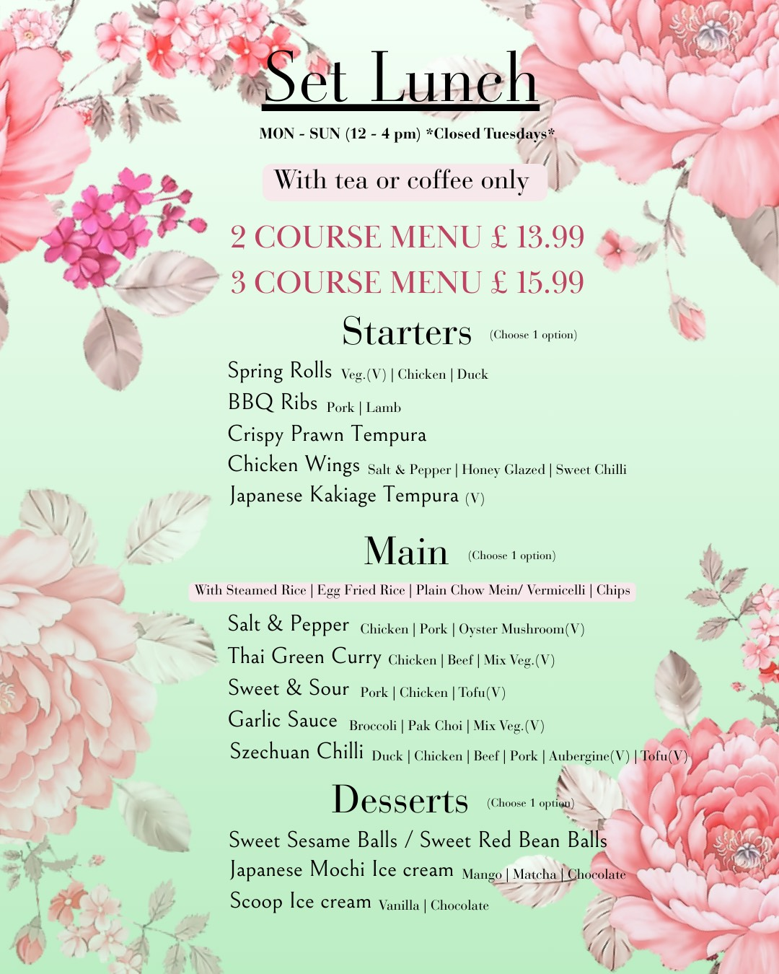**Monday 09/06/25 12.45-2.45 Bento Chinese set lunch, 9 High Street, Hornchurch, RM11 1TP.**

**365 bus from Romford station**

Limited spaces so book early to avoid disappointment.

Parking spaces directly in front of the restaurant are strictly reserved so please park in Lidl, Sainsbury’s or neighbouring car parks / street parking. Please check parking time limits so you don’t receive a fine.

Menu choices to the left please state your lunch choices when booking. Please contact the restaurant directly if you have any special dietary requirements / allergen info. 01708 847046

**Pre booking essential**.

*email* [*disdiamonds@ageukrbh.org.uk*](mailto:disdiamonds@ageukrbh.org.uk) *to book your place and pre order your meal.*

**Tuesday 10/6/25 10:30am** Brunch **Railway Hotel Restaurant,** Station Lane Hornchurch RM12 6SB with Lesley and Maryanne.

*email* [*disdiamonds@ageukrbh.org.uk*](mailto:disdiamonds@ageukrbh.org.uk) *to book your place so we know who to contact in the event of cancellation / change.*

For dietary please contact restaurant directly on 01708 440028

**Tuesday 10/6/25 10:30am** Lunch **Greyhound Harvester**, 900 High Road, Romford RM6 4HU. Free parking onsite, enter registration inside. **86** Bus from Romford / **86 / 364** Dag East. *email* [*disdiamonds@ageukrbh.org.uk*](mailto:disdiamonds@ageukrbh.org.uk) *to book your place so we know who to contact in the event of cancellation / change.*

**Wednesday 11/6/25 Kew Garden–trip via train to Kew Gardens to view the famous gardens.** Small Donation for entrance. Meet hosts Rene & Laurie at Romford Station 10am – arrangements can be made to meet at Kew Gardens. Note this is a walking activity and attendees need to be able to walk unassisted. ***Pre booking essential*** *Email* [*disdiamonds@ageukrbh.org.uk*](mailto:disdiamonds@ageukrbh.org.uk) *to book your place so we know who to contact in the event of cancellation / change.*

**Wednesday 11/6/25 12-2pm Lunch and quiz Old Maypole**, Fencepiece Road, Ilford, Greater London, IG6 2NG. **247 bus** stops outside. Money off voucher and menu https://www.sizzlingpubs.co.uk/findapub/northwest/theoldmaypoleilford/signup

Pay for what you eat and drink, free quiz, win a dessert each for your team. Meet new people. *Email* [*disdiamonds@ageukrbh.org.uk*](mailto:disdiamonds@ageukrbh.org.uk) *to book your place so we know who to contact in the event of cancellation / change*

**Wednesday 12/6/25 12-2 1940’s- 1980’s lifestyle project, Crowlands Golf club**, Wood Lane, Dagenham, Essex, RM8 1JX <https://www.crowlandsheath.co.uk/contact-crowlands-heath/>**.**

Come and join local artists Brennan & Burch. Have lunch and share your memories, photos and stories. We want to see hairstyles, fashion choices, music, food, cars, hobbies. Anything you remember that can be recorded and placed into a final project. Please only commit if you can attend three or more sessions. Priority booking to Barking and Dagenham residents and volunteers as funded by Barking Give it a go fund <https://bdgiving.org.uk/give-it-a-go-fund/> ***Pre booking essential*** *Email* [*disdiamonds@ageukrbh.org.uk*](mailto:disdiamonds@ageukrbh.org.uk) *to book your place so we know who to contact in the event of cancellation / change*

**Monday 16/6/25 11-1 Barking Park Walk** meet in the Big Friendly coffee house then have an optional stroll down past the lake. Please wear appropriate clothing and footwear. Walk slow 20-50 min with rest stops. Please only attend if you are able to walk that far as it’s a fair walk from the bus stop. Bus EL1 from Ilford station, Park Avenue stop then 10 min walk, buses 5. 62, EL2, EL3 from Barking station, Hulse Ave/Barking park stop then 7 min walk.145 bus to Abbey school then enter park via allotments. Free parking next to Abbey School, next left, park

allotments entrance. ***Pre booking essential****. Email* [*disdiamonds@ageukrbh.org.uk*](mailto:disdiamonds@ageukrbh.org.uk) *to book your place so we know who to contact in the event of cancellation / change due to weather*

**Wednesday 17/6/25 1-3 Tea & cake / lunch Le Moulin Patisserie & Boulangerie** 18B Station Ln, Hornchurch RM12 6NJ

Join us for tea and cake in the delightful French patisserie right in the heart of Hornchurch. Treat yourself to brunch / lunch or just cake, the choice is yours. Book early to avoid disappointment as very limited spaces.

*Email* [*disdiamonds@ageukrbh.org.uk*](mailto:disdiamonds@ageukrbh.org.uk) *to book your place so we know who to contact in the event of cancellation / change due to weather*

**Wednesday 18/6/25 12-2 lunch, Crowlands Golf club**, Wood Lane, Dagenham, Essex, RM8 1JX <https://www.crowlandsheath.co.uk/contact-crowlands-heath/>**.** Free tea / coffee, please note soft drinks and alcohol are not included. Buses stop right outside, large car park. This is a popular event so book early to avoid disappointment. ***Pre booking essential****. Email* [*disdiamonds@ageukrbh.org.uk*](mailto:disdiamonds@ageukrbh.org.uk) *to book your place so we know who to contact in the event of cancellation / change*

**Thursday 19/6/25 12-2pm Barking Football Club, Sandwich, Coffee & chat £5.** Mayesbrook Park, Lodge Ave, Barking, Dagenham RM8 2JR

Located in the far right corner of the car park. From Barking station (stop H) 368 bus to Ilchester Road (stop R), from Ilford Elizabeth line Chadwell Heath, 368 bus Ilchester road (stop UN) Bus stops near Barking CC, walk with park on your right for 2 mins and enter car park, far right corner you’ll see the gate. Go into the hut on the left just inside. **Order coffee, tea or something stronger at the hut bar. Lovely local club with really friendly atmosphere. You don’t need to like football to go, just come for a chat. We sit outside if the weather is nice. Free onsite parking, look out for the learner drivers! Limited availability** *email* [*disdiamonds@ageukrbh.org.uk*](mailto:disdiamonds@ageukrbh.org.uk) *to book your place so we know who to contact in the event of cancellation / change*

**Monday 23/6/25 1-3pm Fullwell Cross Library,** 140 High Street, Ilford IG6 2EA, in the big room on the left, access via front doors [Fullwell Cross Library • Vision Redbridge Culture and Leisure (visionrcl.org.uk)](https://visionrcl.org.uk/centre/fullwell-cross-library/) **Cost £3 including tea / coffee. Bring your own art or craft project**, share skills with others, learn a new skill. *email* [*disdiamonds@ageukrbh.org.uk*](mailto:disdiamonds@ageukrbh.org.uk) *to book your place so we know who to contact in the event of cancellation / change*

**Tuesday 24/6/25 Ten Pin** **Bowling** at Romford Namco Meet Ruth 10:15 outside MacDonald’s for 10:30 start for bowling at the Brewery. Bowling and tea/coffee £9.95- email [**disdiamonds@ageukrbh.org.uk**](mailto:disdiamonds@ageukrbh.org.uk). Host Ruth. Please ensure advise Disdiamonds before Friday 20th even those that have been before – so Ruth can draw up the teams.

*email* [*disdiamonds@ageukrbh.org.uk*](mailto:disdiamonds@ageukrbh.org.uk) *to book your place so we know who to contact in the event of cancellation / change*

**Wednesday 25/6/25 1-3pm Kenneth More Theatre. BYO lunch, singing & dancing.** Kenneth More Theatre, Oakfield Road, Ilford, IG1 1BT. ***Pre booking essential with any dietary requirements,*** *£2.50 pay on the day****.***

*Email* [*disdiamonds@ageukrbh.org.uk*](mailto:disdiamonds@ageukrbh.org.uk) *to book your place so we know who to contact in the event of cancellation / change*

**Wednesday 26/6/25 12-2 1940’s- 1980’s lifestyle project, Crowlands Golf club**, Wood Lane, Dagenham, Essex, RM8 1JX <https://www.crowlandsheath.co.uk/contact-crowlands-heath/>**.**

Come and join local artists Brennan & Burch. Have lunch and share your memories, photos and stories. We want to see hairstyles, fashion choices, music, food, cars, hobbies. Anything you remember that can be recorded and placed into a final project. Please only commit if you can attend three or more sessions. Priority booking to Barking and Dagenham residents and volunteers as funded by Barking Give it a go fund <https://bdgiving.org.uk/give-it-a-go-fund/> ***Pre booking essential*** *Email* [*disdiamonds@ageukrbh.org.uk*](mailto:disdiamonds@ageukrbh.org.uk) *to book your place so we know who to contact in the event of cancellation / change*

**Monday 30/06/25 12-2pm** **Lunch followed by free bingo**. **Pipe Major**, 1,Yewtree Avenue, Dagenham, RM10 7FN  
Large car park, Almost opposite Dagenham East station. We have our own area, pay for your own food and drink, bingo is free. Book early to avoid disappointment. *Email* [*disdiamonds@ageukrbh.org.uk*](mailto:disdiamonds@ageukrbh.org.uk) *to book your place so we know who to contact in the event of cancellation / change*