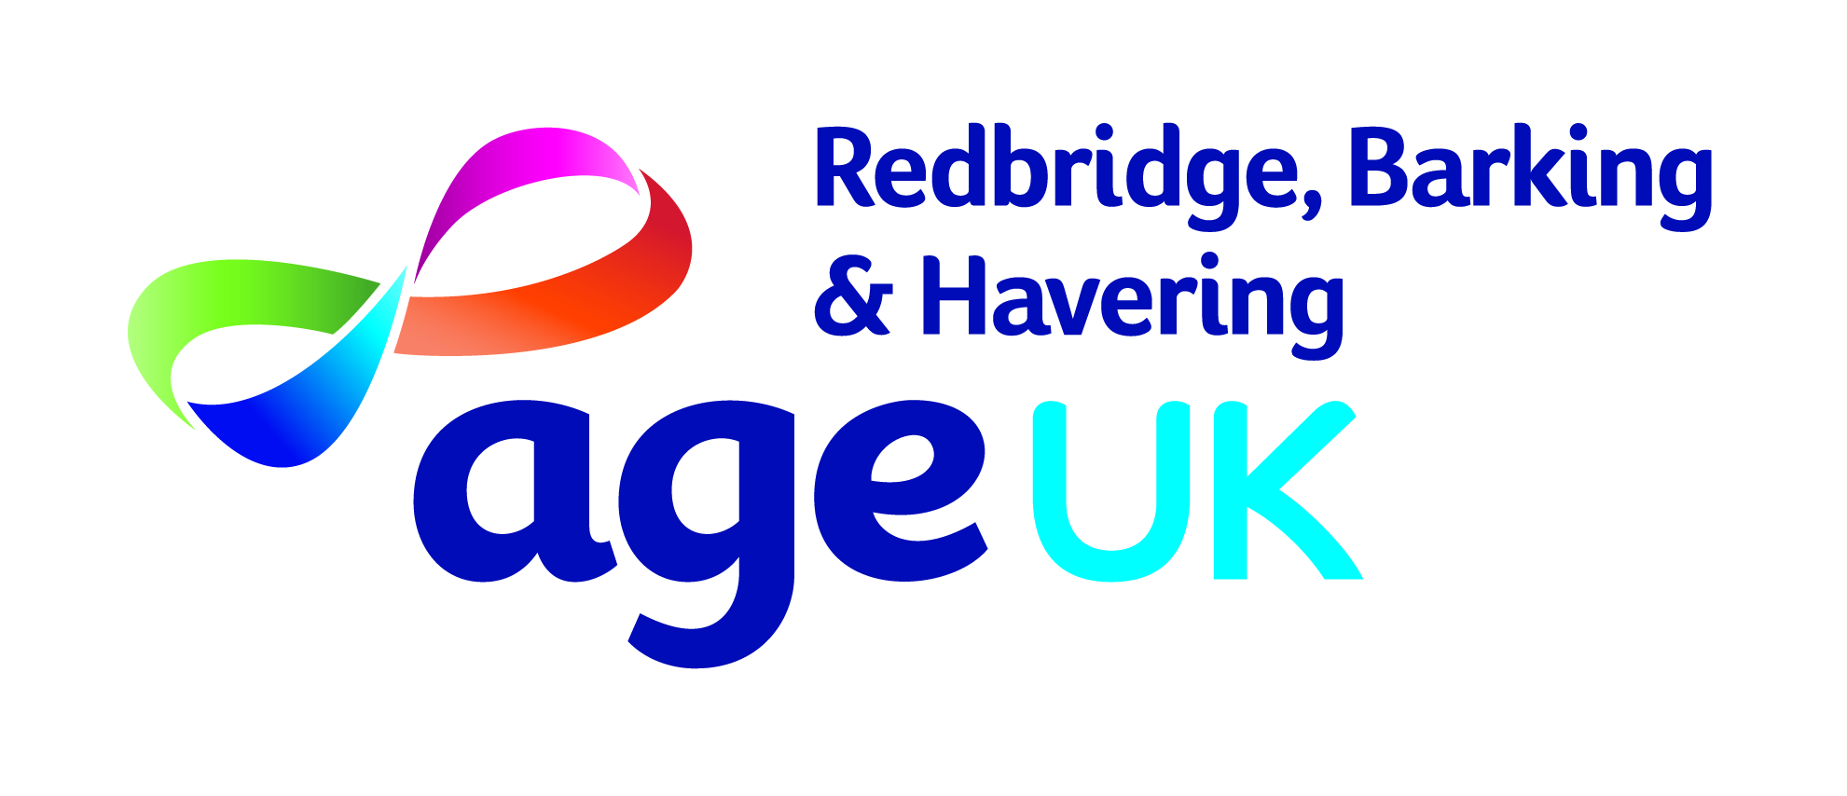
Trustee Role Description
Age UK Redbridge, Barking and Havering

The Board of Trustees are responsible for the overall governance and strategic direction
of the charity, developing the organisations aims, objectives and goals in accordance with
the governing document, legal and regulatory guidelines.
Main Responsibilities

- To ensure that the charity and its representatives function within the legal and
regulatory framework of the sector and in line with the organisations’ governing document, continually striving for best practice in governance.
- To uphold the fiduciary duty invested in the position, undertaking such duties in a
way that demonstrates the organisations commitment to service users, stakeholders and partners.
- Continually striving for best practice in governance. that adds to public confidence
and trust in the charity.
- To determine the overall direction and development of the charity through good
governance and clear strategic planning.

Main Duties
- Ensuring the charity complies with legislative and regulatory requirements, and acts
within the confines of its governing document and in furtherance to organisational activities contained therein.
- Acting in the best interest of the charity, beneficiaries and future beneficiaries at all
times.
- Promoting and developing the charity in order for it to grow and maintain its
relevance to society
- Maintaining sound financial management of the charity’s resources, ensuring
expenditure is in line with the organisations’ objects, and investment activities meet accepted standards and policies.
- Ensuring the effective and efficient administration of the charity and its resources,
- Acting as a counter-signatory on charity cheques and any applications for funds where required
- To maintain absolute confidentiality about all sensitive/confidential information
received in the course of trustee’s responsibilities to the charity.

Accountable to:

As the board are responsible and liable for the governance and functioning of the charity,
they are accountable in varying degrees to a variety of stakeholders, including: service
users, members, funders, the Charity Commission, and Companies House. Close attention
must be given to the governing document to ascertain the type of organisational structure
and the range of interested parties.

Trustee Person Specification
Age UK Redbridge, Barking and Havering

Role Purpose
Trustees provide strategic leadership, governance, and oversight to ensure Age UK Redbridge, Barking & Havering delivers high-quality services that improve the lives of older people across the three boroughs. Trustees act collectively to safeguard the charity’s mission, values, and resources. Our trustees must demonstrate:
Essential Criteria
- Commitment to Older People: Passion for improving the lives of older people and supporting independence, dignity, and wellbeing.
- Governance & Oversight: Understanding of charity governance, financial accountability, and risk management.
- Strategic Thinking: Ability to contribute to long-term planning, policy development, and organisational growth.
- Collaboration: Strong interpersonal skills to work effectively with fellow trustees, the Chair, and the Chief Executive.
- Ambassadorship: Confidence in representing the charity externally to stakeholders, funders, and partners.
- Integrity & Accountability: Commitment to transparency, safeguarding, and ethical practice.
Desirable Criteria
- Professional Expertise: Skills in areas such as finance, law, fundraising, marketing, HR, commissioning, public services, or business development.
- Community Engagement: Experience working with diverse communities and promoting inclusion.
- Leadership Experience: Prior board or senior leadership experience in charities, public sector, or business.
- Local Knowledge: Understanding of the needs and challenges facing older people in Redbridge, Barking, and Havering.
Trustee Responsibilities
- Contribute actively to the Board’s role in setting strategic direction, defining goals, and monitoring performance.
- Ensure the charity complies with its governing document, charity law, and other relevant legislation.
- Safeguard the charity’s assets, property, and finances.
- Support fundraising and advocacy activities.
- Act as an ambassador for Age UK Redbridge, Barking & Havering.
Time Commitment
- Attend regular board meetings and contribute to sub-committees. There are six Board of Trustees Meetings usually on a Friday afternoon and additional training days as require.
- Prepare for meetings by reviewing papers and engaging in discussions.
- Participate in organisational events and fundraising activities.

Eligibility: Some circumstances legally disqualify certain people from acting as trustees. These include;
  - Unspent convictions for an offence involving dishonesty or deception
  - Undischarged bankruptcy.
  - People barred/removed from trusteeship by the Courts or Charity Commission for misconduct or mismanagement.

