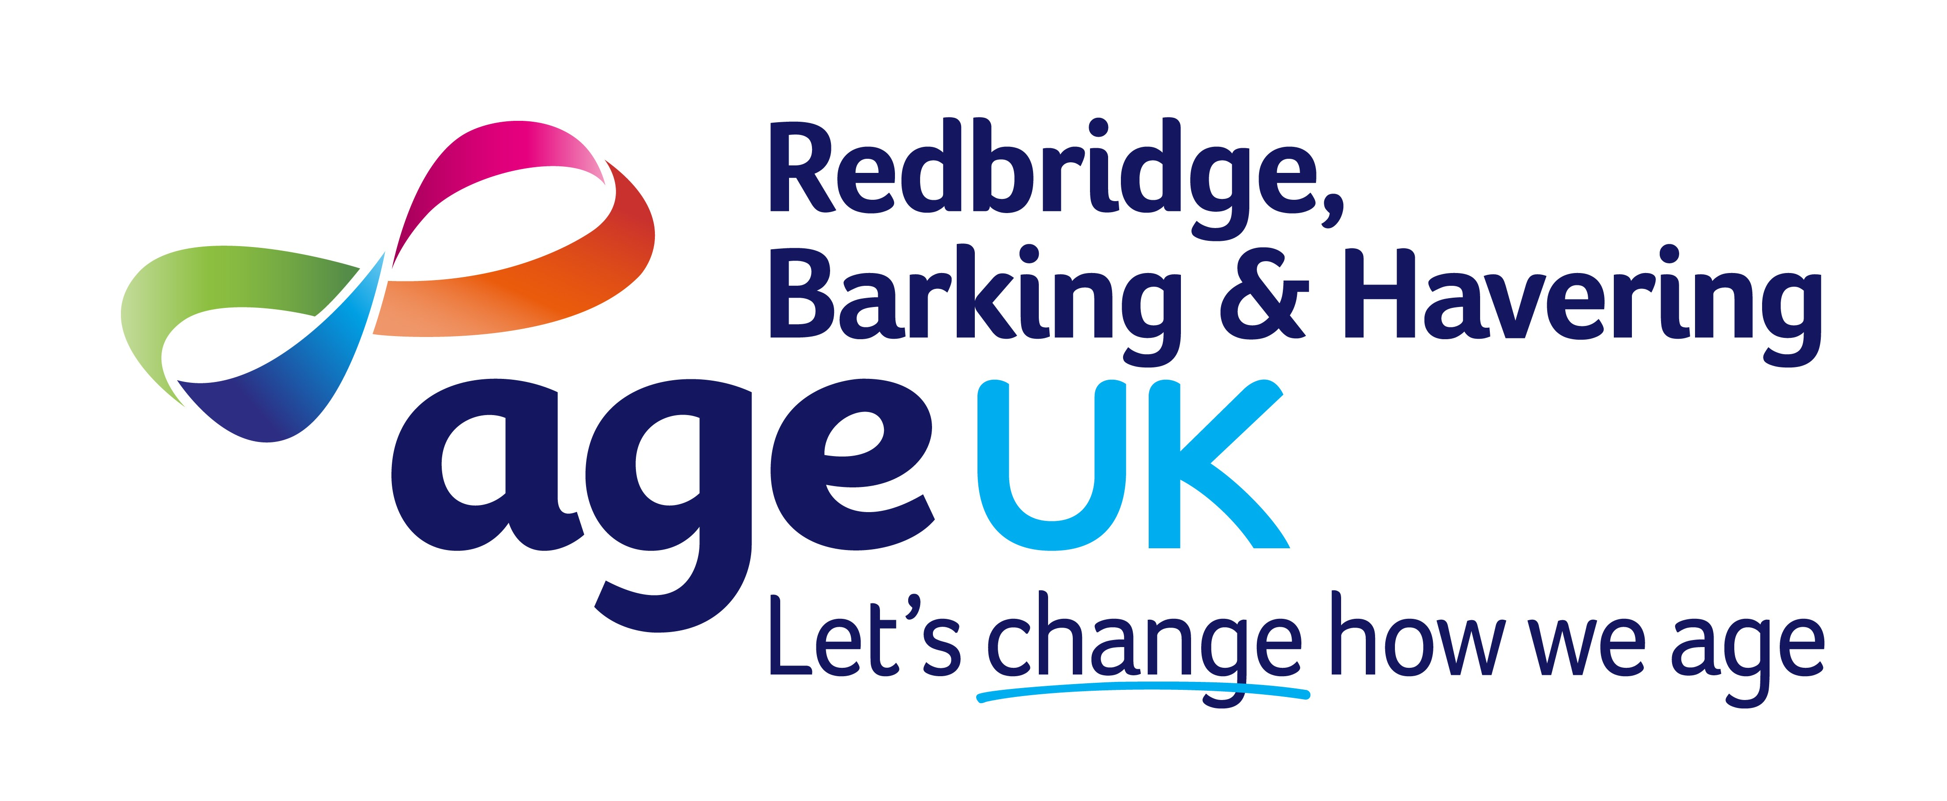
Nail Care Technician Job Description
Age UK Redbridge, Barking and Havering
Job Title: Nail Care Technician (Multiple Sites)
Contract: Zero-hours
Salary: £14.80 per hour
Reports to: Senior Manager – Befriending, Falls and Home Support Services
Annual Leave: 5.6 weeks pro rata (inclusive of bank/public holidays)
Role Purpose
To provide a safe, professional, and high-quality nail care and basic foot care service for older people in community venues. The role supports good foot health by promoting preventative care, maintaining accurate and confidential records, and ensuring clients are referred to appropriate healthcare professionals when needed.
Key Responsibilities
- Service delivery and client care: Provide high-quality nail care and basic foot care in line with organisational policies and recognised best practice.
- Assess clients, monitor treatment outcomes, update care plans where appropriate, and identify when referrals to a senior clinician or healthcare professional is required.
- Promote foot health education and encourage preventative self-care.
- Safety, safeguarding, and infection control: Maintain high standards of infection prevention, cleanliness, and clinical safety before, during, and after each clinic.
- Report incidents, risks, safeguarding concerns, or changes in a client’s health promptly and in line with organisational procedures.
- Records, administration, and payments: Maintain accurate and confidential client records, including updates to medical history, medication, and personal circumstances.
- Manage appointment administration, documentation, and payments in accordance with organisational procedures.
- Communication and service improvement: Communicate effectively with clients, carers, colleagues, and healthcare professionals.
- Deliver excellent customer service, encourage client feedback, and use feedback to support service improvement.
- Teamwork and professional development: Provide flexible cover for colleagues when required and contribute positively to the wider team.
- Attend supervision, training, appraisals, and staff meetings, while complying with all organisational policies.
Person Specification
Knowledge & Experience
- Relevant qualification in foot care or equivalent (desirable).
- Experience providing nail or foot care services (desirable).
Skills & Attributes
- Reliability and organisation: Punctual, dependable, and able to manage appointments efficiently to keep clinics running to schedule.
- Excellent organisational and time-management skills, with the flexibility to adapt to changing clinic needs.
- Teamwork and communication: Able to work independently and collaboratively as part of a wider team.
- Strong observation, record-keeping, and communication skills.
- Systems and record keeping: Confident using databases and electronic records accurately and securely.
- Values and professional standards: Committed to continuous improvement and maintaining high professional standards.
- Understands the needs of older people and is committed to safeguarding, equality, confidentiality, and health and safety.
- Willing to undergo an enhanced DBS check.

