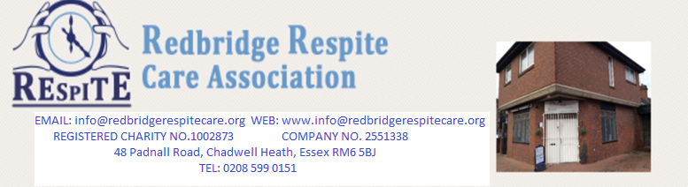
Over 30 years’ experience. We provide person centred support tailored to people’s needs promoting independence and well-being.
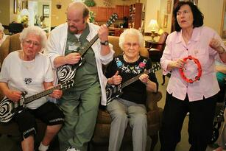
Our charity was set up in 1999 in order to provide support to people with mental health issues and their carers living in the London Borough of Redbridge. We employ fully trained support workers who provide care and information tailored to people’s needs, which includes support at home and a day centre for people living with dementia. Our services are free of charge for Redbridge residents. For people living outside Redbridge we provide services at competitive rates.
This Photo by Unknown Author is licensed under CC BY

Respite at home Day centre
We promote independence, health & well-being Open Mon, Tue, Wed and Friday
Support to Access College courses Opening times are 10am to 3pm
Volunteering opportunities and paid work Easy access to the day centre and disabled access
Information on welfare benefits Delicious two course cooked meal (dietary needs catered) for & refreshments
Encourage hobbies and new interest’s 2:1 staff ratio
Support to attend appointments Encourage Physical activities
Provide emotional & practical support Musical activities
Sitting service Arts & crafts
Help with shopping Cognitive stimulation therapy
Organise household or office items baking & cooking activities
Play music or listen to songs Encourage social bonding and self-expression
Gardening
All Respite at home services is only 2.5 hrs each week
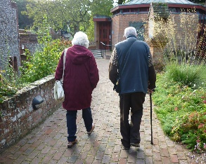
Newsletter
We print a monthly newsletter to inform you of any events we have going on, peer support groups, raffles, celebrations, day trips, day closures and to let you know what your loved ones have been up to at the day centre.
Day Trips
We also have day trips e.g.: trips to Eastbourne, Southend, Brighton, River cruises etc.
We hire a coach for an average of 6 outings per year.

