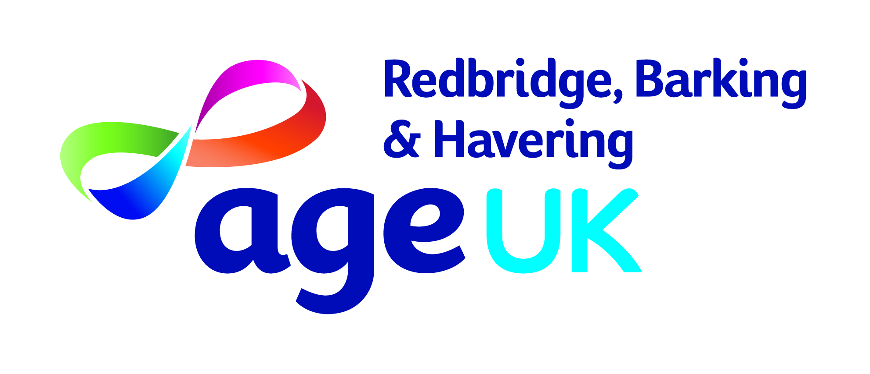

Older People’s Safeguarding Forum

Age UK Redbridge, Barking & Havering is looking to recruit new voluntary members of its Safeguarding Forum, comprised of people aged 60+.


It is the duty of all statutory and voluntary organisations to promote safeguarding of vulnerable people, take steps to reduce risks of abuse of those who might be vulnerable and act when abuse has taken place.

The Older People’s Safeguarding Forum is a consultative forum, meeting 4 times a year for an hour and a half.

We want members of all communities who are concerned about elder abuse and who can take an active interest in promotional work, commenting on local strategies and action plans, to join the Forum.

We especially welcome people who have a care package from an agency or otherwise have experience of local services.

If you would like to find out more, contact
Priti Mistry or Janet West on 020 8220 6000
or by emailing
priti.mistry@ageukrbh.org.uk or janet.west@ageukrbh.org.uk



