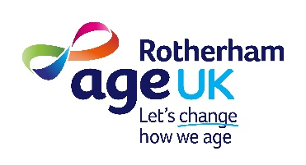 40th Anniversary Gala Ball, 21st March 2026
Raffle Prizes and Auction Lots

Raffle Prizes
- Rotherham United Executive Experience: Enjoy the Barnsley local derby on 11 April, for 2 guests in the platinum hospitality lounge, including a three course meal, match day programme, VIP padded seats, pre/post-match entertainment and parking.
- Overnight Stay for Two at Aston Hall Hotel: Treat yourself and a guest to a relaxing night at the beautiful and historic Aston Hall Hotel.
- Half Hour Flight Simulator Experience for Two: Take to the skies in a realistic flight simulator for a thrilling half-hour session.
- Vulcan Plane Tour: Embark on an exclusive tour of the iconic Vulcan plane.
- Gulliver’s Kingdom Family Voucher: Enjoy a fun-filled day out with the family at Gulliver’s Kingdom with this special voucher.
- Limited Edition Bottle of Champagne: Celebrate in style with a unique bottle of champagne.
- Ordo Sonic Toothbrush: Keep your smile bright with this premium sonic toothbrush.
- Original Limited-Edition Print of Rotherham Minster by Tim Rose: Receive a beautiful print created by local artist Tim Rose

Auction Lots

Lot Number 10: Golf, Golf and…..More Golf
This exceptional lot is perfect for golf enthusiasts, whether aspiring professionals or keen amateurs. It features a four-ball voucher for each of eight local golf clubs, totalling a face value of £1,280. To enhance your experience, the package includes a PING golf bag, accessories, a PING golfing umbrella, hand crafted Sheffield Pewter flask and an Under Armour cap autographed by Matt Fitzpatrick.

Participating clubs offering four-ball vouchers are:
- Rotherham Golf Club
- Rother Valley Golf Club
- Sitwell Park Golf Club
- Styrrup Golf and Country Club
- Bawtry Golf Club
- Far Grange, Skipsea
- Hainsworth Park, Driffield
- Bondhay Golf Club

Lot No. 9: “6am Bluebell Wood” – Paul Freeman Original Painting
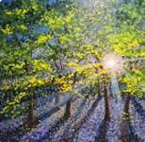
Renowned local artist Paul Freeman, based in Ravenfield, Rotherham, has been painting professionally for a decade following his retirement from hairdressing. He exhibits and sells his work nationally and is a dedicated supporter of local causes, running workshops for school children and fundraising for charities. Paul’s talent lies in capturing the vivid colours and beauty of nature. For this event, he has donated an original acrylic-on-board piece titled “6am Bluebell Wood” to Age UK Rotherham.
Mark Courtney, curator of the Ashbourne Gallery, describes Paul’s work as “A Miracle of Paint and Light”. Paintings of similar size by Paul typically sell for up to £700.

Lot Number 8: Luxurious Countryside Spa Experience for Two

Donated by Broadlands Medical Aesthetics & Spa, this exclusive package offers the ultimate relaxation in the tranquil village of Braithwell. The experience includes a bespoke “Desire & Glow” facial tailored to your skin, a calming Japanese Head Spa, a traditional Moroccan body bath, access to sauna and cold plunge shower, and ample time to unwind in a peaceful countryside setting.
Enjoy bubbly on arrival, healthy snacks, nibbles, and a cheese board. All treatments are performed by qualified medical professionals, ensuring exceptional care. This indulgent package is valued at £500 and is being auctioned in support of a worthy cause.

Lot No. 7: Executive Match Package for 4 at Rotherham United FC
Are you a fan of the Millers? Or maybe a fan a rival team? Similar to our charity RUFC is commemorating a significant anniversary this year – celebrating its centenary (although the club's roots actually go back to 1877, when the club was formed as Thornhill Football Club).
This lot, kindly donated by KCM Waste, offers a hospitality package for 4 people at a Rotherham home match either this season or next. It includes a two-course meal, parking as well as seating for you and your three guests in the stadium’s executive area.
The winning bidder will also receive a signed Rotherham Shirt and a signed Rotherham ball donated by The Mears Group.

Lot Number 6: Dining Out in the Wickersley Area
Wickersley is renowned for its high-end bars and restaurants, making it a prime social venue in the Borough. This lot features a selection of vouchers for diverse dining experiences:
- The Gaslamp (£40): Modern British cuisine in a brasserie and bar setting.
- Bollywood Indian Restaurant (£30): High-quality Indian fare in stylish surroundings.
- The Yellow Broom (£30): A micro bar in Bramley, offering a wide range of drinks and street food.
- The Garrison (£25): 1920s themed restaurant serving local produce and unique drinks.
- Seasons (£20): Fine dining with modern British menu using seasonal produce.
- Ricey Chinese and Asian Fusion Restaurant (£10): Authentic Asian fusion cuisine.

Lot No. 5: Signed Manchester United Shirt
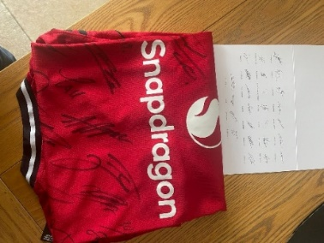
For football fans, a signed Manchester United shirt represents a cherished piece of sporting history. Manchester United is one of the world’s most successful clubs, with a legacy dating back to 1878. Legendary players such as George Best, Eric Cantona, David Beckham, and Cristiano Ronaldo have graced the club over the years. Manchester United has accumulated numerous domestic and international trophies, including 20 league titles, 12 FA Cups, and 3 European Cups. Their memorabilia is highly sought after by collectors worldwide.
This 2025/26 season shirt is authenticated by the club and donated directly from the Manchester United Foundation.

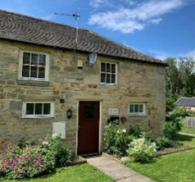
Lot No. 4: A 2-night Stay for up to three people in a beautiful Northumberland Cottage
Kick back and relax in this calm, stylish space. Tucked away down quiet country lanes, surrounded by tranquil woodland, Bluebell cottage is perfect for dog walking and relaxing with family and friends. Carefully equipped with all you need for a home from home escape. With birdsong and wildlife on your doorstep, but close to the many attractions Northumberland has to offer and miles of beaches only 10 minutes away. This comfortable and cosy self-contained retreat is the ideal spot. Value £200 Bluebell Cottage in countryside near coast - Houses for Rent in Acklington, England, United Kingdom - Airbnb

Lot No. 3: The Wentworth Experience – Enjoy a Day in the Village of Wentworth
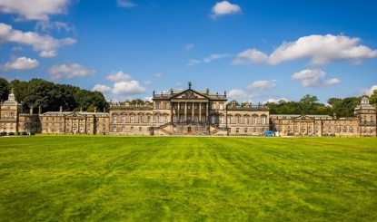
Spend a memorable day in the picturesque village of Wentworth, which is nestled in the Rotherham/Barnsley boundary. Known particularly for its historical estate, Wentworth Woodhouse, the village also offers insights into England’s architectural heritage whilst offering a good number of eateries offering a fantastic range of eating and drinking experiences.
This Lot offers the opportunity to really experience the delights on offer from the village. Start your day with a delicious breakfast at The Bothy restaurant set within the Wentworth Garden centre, using the £25 voucher provided by the Garden Centre. From there meander to the beautiful Wentworth Woodhouse estate taking advantage of the vouchers on offer within the Lot to tour the historic stately house and the magnificent gardens. Stroll around the grounds of the estate marvelling at the natural beauty and wildlife to work up an appetite so you can finish your day at the George and Dragon gastro pub, who have donated a voucher for a complimentary meal for two.

Lot No. 2: Leeds Rhinos Match Tickets for Four Plus Signed Ball
Leeds Rhinos, established in 1870, are among the world’s oldest and most decorated rugby league clubs. They have claimed the League Championship 11 times, the Challenge Cup 14 times, and the World Club Challenge three times. The club enjoys support from notable figures such as Sean Bean, Gabby Logan, the Brownlee brothers, and Boris Becker!
The close friendship between former players Rob Burrow and Kevin Sinfield has inspired national affection and substantial fundraising for NMD. This lot includes a signed Leeds Rhinos ball and four home match tickets for a game of your choice this season.
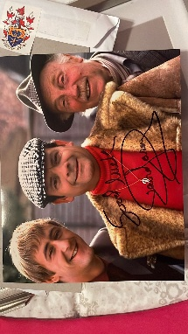

Lot No. 1: Authentic Autographed David Jason ‘Fools and Horses’ Photograph
Many of us will remember Only Fool’s and Horse’s with great affection, reminiscing as Del Boy’s wheeler-dealing schemes unfold, as Rodney’s exasperation reaches new heights, and as Grandad tries to dispense words of wisdom. And who can forget iconic scenes like the chandelier mishap and the wine bar fall!
This David Jason signed Del Boy photo is more than just a picture on the wall. It’s a conversation starter, a reminder of your favourite moments, and a tangible connection to the show you adored in your youth. Kindly provided from David Jason’s office, this item could easily attract £120 on internet memorabilia sites.

All auction prizes must be paid for on the night or payment arranged with Age UK Rotherham.
Charity Number 1039771

