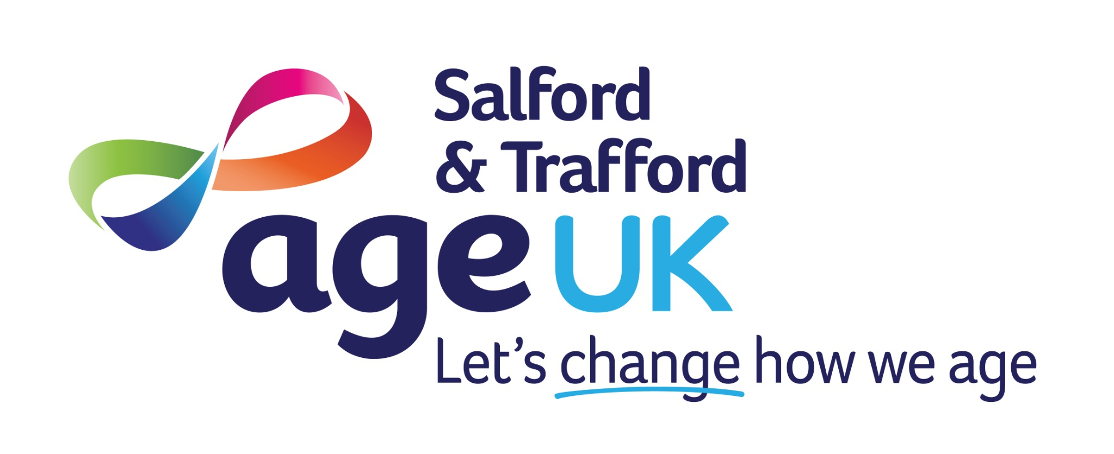
Recruitment Pack
Welcome to Age UK Salford & Trafford
Let’s change how we age


Job Title: Administrator
Responsible to: Line Manager
Location: AUKST Designated site
Hours: We are recruiting for 3 roles: 2 x 35 hours per week and 1 x 21 hours per week
Salary: £24,479 pa FTE, £13.45 per hour pro rate plus pension contributions and cash health plan
Welcome
Thank you for your interest in joining Age UK Salford & Trafford.
We are a local independent charity committed to improving later life for everyone in our communities. Whether through our dementia services, wellbeing activities, practical home support, or community engagement, we aim to empower older people to live full, independent, and dignified lives.
By joining us, you’ll become part of a dedicated team that believes ageing should be celebrated, not feared. Our staff and volunteers are passionate, professional and people-focused — together, we make ageing better for all.

Message from our CEO

I’m proud to lead an organisation rooted in compassion, innovation, and community spirit. This is an exciting time to be part of our journey. Whether you're supporting frontline services, strengthening our infrastructure, shaping new programmes, or helping us build stronger partnerships, your contribution will have real impact. If you're driven by purpose and want to work in a team that values kindness, collaboration and inclusion, we warmly welcome your application.

Our History
Age UK Salford and Age UK Trafford recently joined together to better serve older people across both boroughs. With decades of combined experience, we’re rooted in our local communities and shaped by the voices and needs of those we support.
Our work is driven by a commitment to reduce inequality, improve wellbeing and connect older people to meaningful support. We deliver this through partnerships with health, care, and voluntary organisations across Greater Manchester.
Our Vision & Values
A community where everyone ages well with enjoyment, dignity, purpose, and connection.
We value:
- Compassion
- Respect
- Integrity
- Responsiveness
- Empowerment
Summary of Role – Administrator
We are seeking three Administrators who will be responsible for ensuring the smooth, efficient operation and daily activities across the organisation. They will handle communication, scheduling, documentation, and coordination across teams, acting as the central point of support for staff, clients, volunteers and external partners, supporting service delivery and operational effectiveness. One full-time post will be based at the Humphrey Booth Day Centre site on Eccles Old Road in Salford and one full-time and one 21-hour post based at the Eccles office. Should you have a preference you can express this on the application form.

Principle Duties and Responsibilities:
- Act as a key point of contact for enquiries from clients, carers, staff, and partners
- Provide high-quality administrative support across the organisation and projects.
- Handle incoming calls, emails, and enquiries; draft correspondence; support internal communication.
- Maintain accurate and confidential records and prepare reports using internal CRM systems (e.g. Salesforce)
- Support financial administration, including invoicing, payments, and monitoring payment arrears
- Arrange transport and logistics for clients where required.
- Assist with recruitment, HR and induction processes, training coordination, and employee records
- Assist with quality, compliance and health and safety process
- Provide administrative cover across services and sites as needed

Additional Responsibilities

- To ensure compliance with all relevant service standards, policies and procedures of Age UK Salford and Trafford and all other relevant external compliance standards
- To communicate effectively by maintaining clear, concise and open communication, always ensuring that the Manager is fully informed and updated
- To continuously review own performance and take responsibility for own learning and development by undertaking on-going training as required
- Ensure all tasks are delivered safely and effectively, adhering to the organisation’s Health and Safety policy at all times.

- To undertake any other tasks, duties or projects as required which are relevant to the role as directed by the Manager
Person Specification

Criteria | Essential | Desirable | Assessment
GCSE English and Maths or equivalent | ✓ |  | Application Form
Experience in an administrative role | ✓ |  | Application Form/Interview
Experience using Microsoft Office, databases or Customer Relations Management (CRM) software | ✓ |  | Application Form/Interview
Strong organisational and multitasking skills | ✓ |  | Application Form/Interview
Attention to detail, accurate data entry and careful document handling | ✓ |  | Application Form/Interview
Understanding the importance of handling sensitive information appropriately | ✓ |  | Application Form
Ability to work independently and in a team | ✓ |  | Application Form/Interview
Commitment to person-centred, inclusive, and culturally sensitive practice | ✓ |  | Application Form/Interview
Excellent communication skills, with the ability to keep colleagues and managers fully informed | ✓ |  | Application Form/Interview
Ability to work flexibly and adapt to changing service needs | ✓ |  | Application Form/Interview
High levels of professionalism, reliability, and personal accountability | ✓ |  | Application Form
Capacity to reflect on own practice and engage fully in learning and development | ✓ |  | Application Form/Interview

The successful candidate must be willing to undertake an enhanced DBS check as well as provide references. The cost of the DBS check is covered by the organisation.
Employee Benefits
We offer a supportive and inclusive working environment, including:
• Competitive pay and holiday entitlements
• Contribution to a pension scheme
• Access to a health cash plan
• Ongoing training and development opportunities
• A strong team culture based on respect and inclusion

Our Services
We provide a wide range of services across Salford and Trafford, including:
• Dementia Support and Day Services
• Information, Advice and Signposting
• Community Engagement and Befriending
• Health and Wellbeing Activities and support services
• Support at Home (cleaning, shopping, companionship)
• Falls Prevention and Physical Activity
• Bereavement and Carers Support
We are constantly evolving our services to meet the diverse needs of older people in our communities.
Equality, Diversity and Inclusion statement
At Age UK Salford and Trafford, we are committed to building a diverse and inclusive workforce that reflects the communities we serve. We welcome applications from people of all backgrounds, identities and experiences.
We are proud to be an equal opportunities employer. We value the unique perspectives that each individual brings, and we strive to create a working environment where everyone feels respected, supported and able to thrive.

