Malnutrition Awareness Week 2023; 6th- 12th November
Social Media Pack
The Greater Manchester Nutrition and Hydration team are promoting UK’s Malnutrition Awareness Week 2023 and we need your help! As one of our partners, we are asking you to help us get the messages out about the prevalence, signs, symptoms and consequences of malnutrition in later life. Together we can make a difference!
We have made 5 social media posts which are ready to use, one for each day of the week. Please post on each day with the image, hashtags and tags we have prepared for you.
You can post these on your Twitter, Facebook page or both.
A simple action like this, can really save and improve the lives of many older people living in the UK, by busting myths and spreading the right messages about eating and drinking well in later life.
Thank you,
The Greater Manchester Nutrition and Hydration Team at Age UK Salford

Post 1- to be posted on Monday 6th November 2023

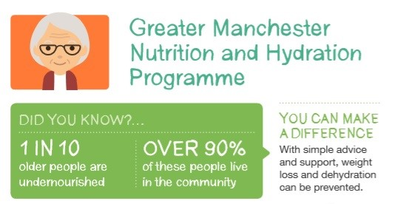

This Malnutrition Awareness Week we are shining a light on the prevalence of #malnutrition in the UK. It is likely that due to #COVID this figure is even higher. Look out for your loved ones #MAW2023 @GMNandH

Post 2 – to be posted on Tuesday 7th November 2023

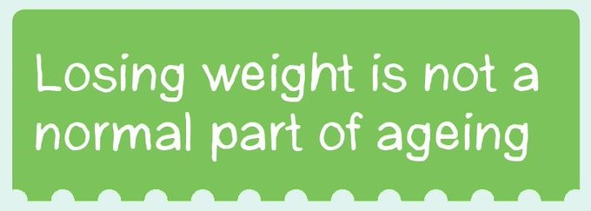

During #MAW2023 we are busting the myth that losing weight is a normal part of ageing. Join us in spreading the right messages #askaboutappetite @GMNandH

Post 3 – to be posted on Wednesday 8th November 2023

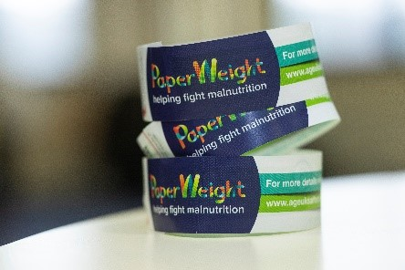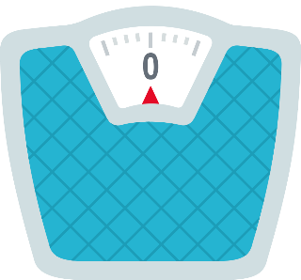
Keeping an eye on you or loved one’s weight as they get older can prevent any unplanned weight loss which can be the first sign of malnutrition. If you don’t have scales, you can use the @PArmband or watch for visual signs such as loose clothing #MAW2023 @GMNandH

Post 4 – to be posted on Thursday 9th November 2023

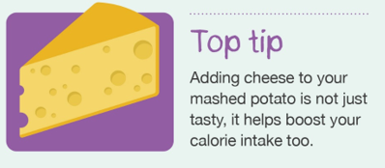
Food fortification is often an effective treatment for malnutrition and unplanned weight loss. The Eat, Drink Live Well booklet has tips for people at risk of malnutrition www.ageuk.org.uk/salford/about-us/improving-nutrition-and-hydration/our-resources/ #MAW2023 @GMNandH

Post 5 – to be posted on Friday 10th November 2023

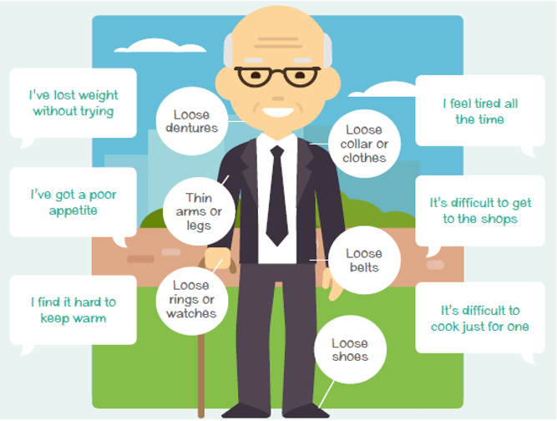

You can look out and listen for signs of malnutrition and encourage others to do the same! By noticing these signs, we can make changes to our diet early to help us stay healthy. If you work in a care setting, check out our free online training: The PaperWeight Armband #MAW2023 @GMNandH

