Did you know - food facts… 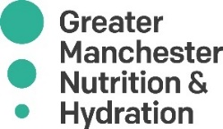
- An avocado has more than twice as much potassium as a banana. 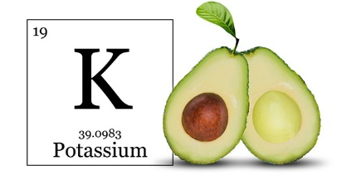 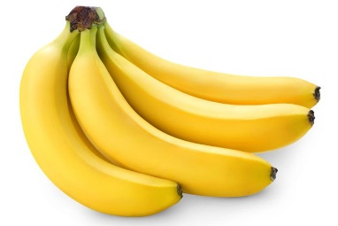 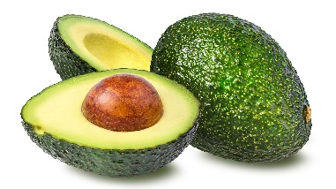
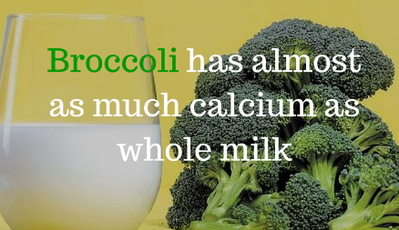
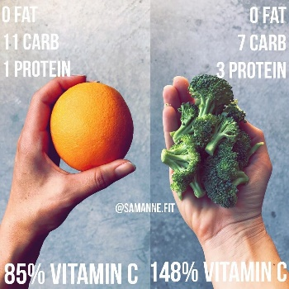
- Broccoli contains twice the vitamin C of an orange and almost as much calcium as whole milk, and the calcium is better absorbed!
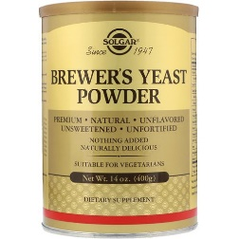
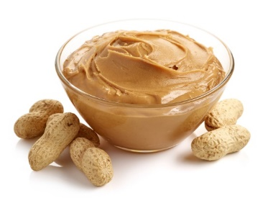
- To increase the protein in peanut butter, Brewer’s yeast can be mixed in - a useful tip for vegetarians.
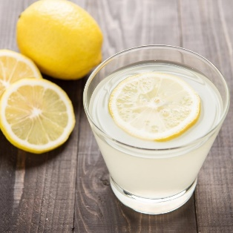
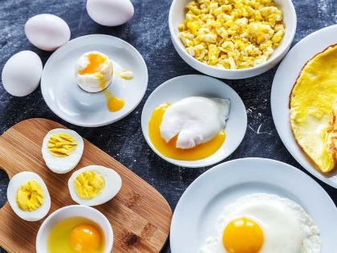
- Lemons are considered one of the world's healthiest foods - one lemon contains your daily dose of vitamin C, it cleanses the liver, boosts your immunity and aids in weight loss. Try adding it to a mug of warm water to kick start your day!

- Eggs contain the highest quality food protein known. All parts of an egg are edible, including the shell which has a high calcium content.

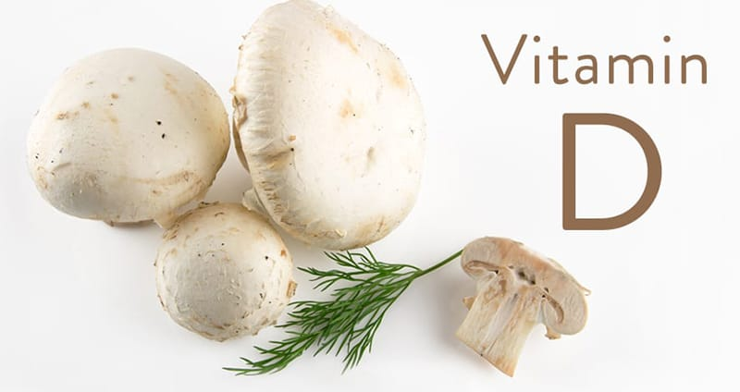
- The mushroom is the only non-animal natural source of vitamin D.

