Slide Notes Brief N&H training

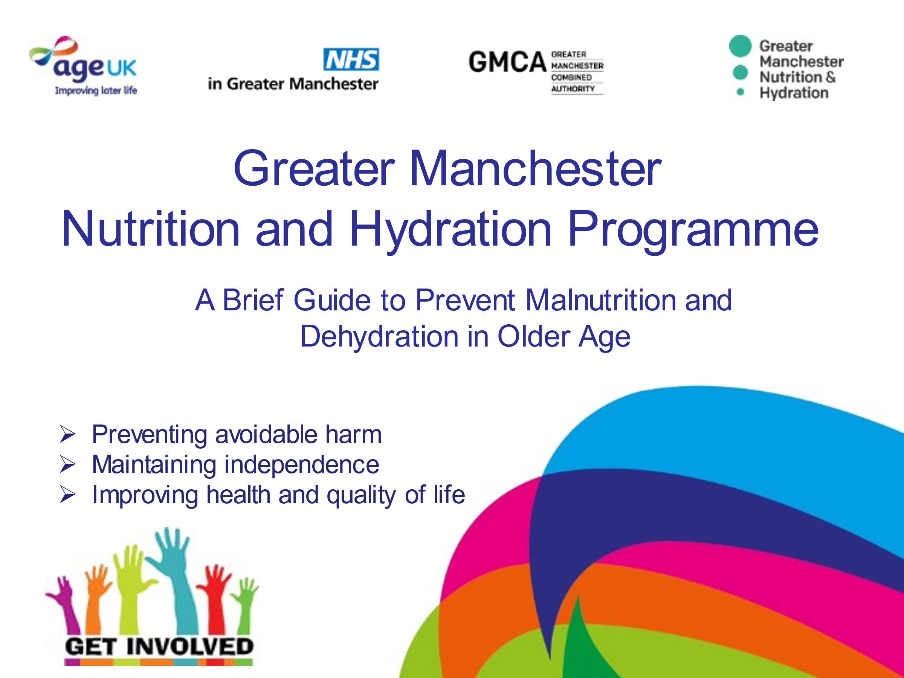
Slide 1 Title Slide
Welcome to the Nutrition and Hydration training. The training is a brief guide to prevent malnutrition and dehydration in older age.
We aim to prevent avoidable harm, help older people maintain independence and improve their health and quality of life.
Our vision is to ensure that the dignity, health and wellbeing of older people are met by understanding and promoting their nutrition and hydration needs.

Slide 2 What is Malnutrition?
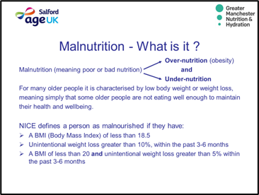
What is malnutrition?
The word malnutrition simply means poor or bad nutrition so it can refer to overnutrition (obesity) and undernutrition.
This training concentrates on UNDERNUTRITION in relation to older people.
READ the NICE guidelines.
That may sound a little complicated. The good news is this programme has simplified this with the PAPERWEIGHT ARMBAND which indicates a BMI of 20 if it fits around the mid-part of the upper non-dominant arm and 18.5 if it is lose / slips up and down this part of the arm.

Slide 3. Signs to look out for.
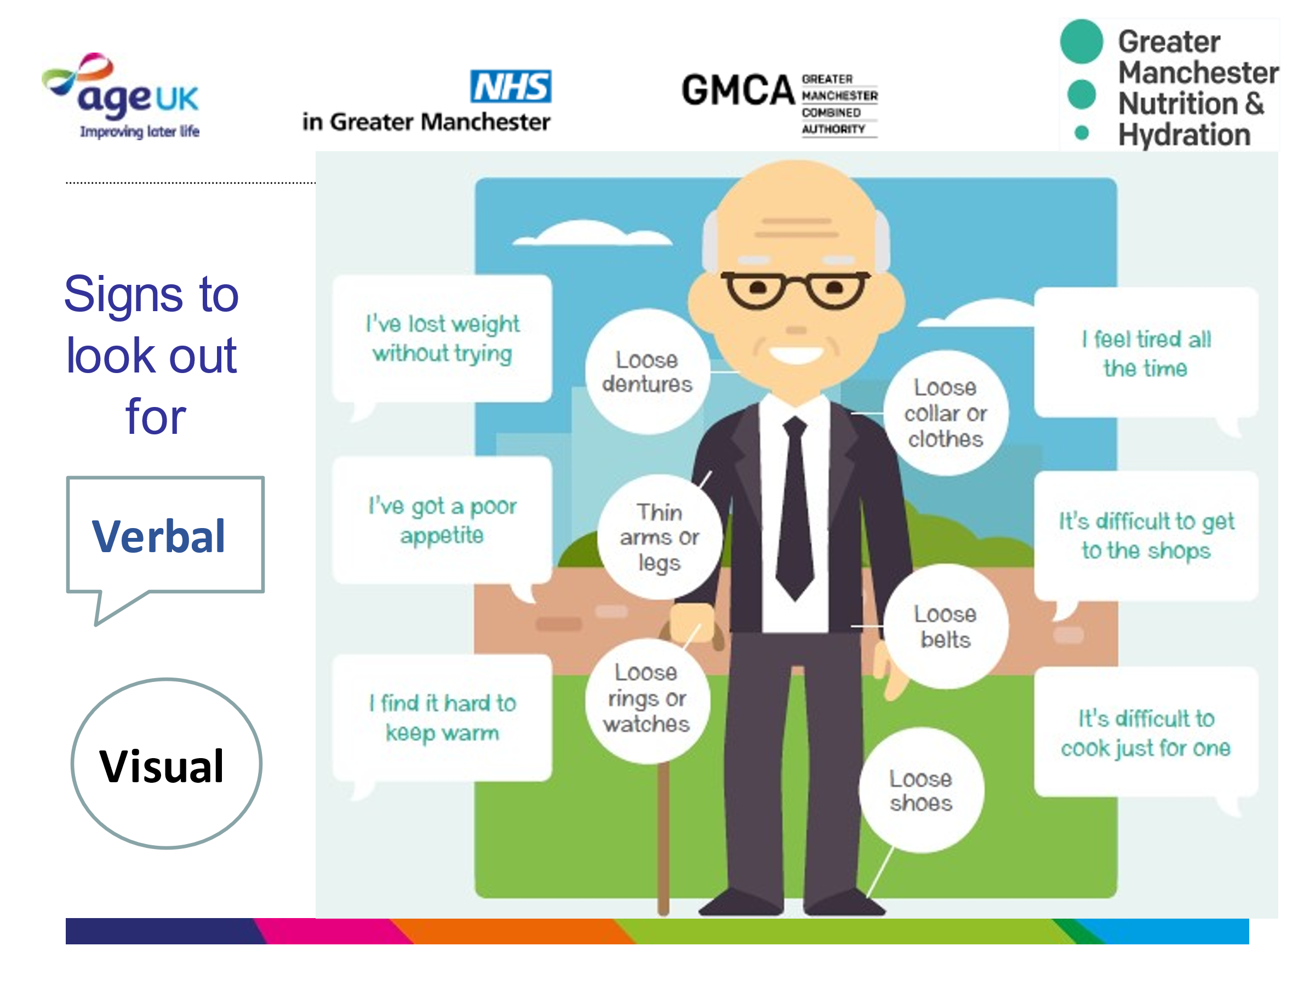
This image paints a really clear picture on what to look out for and what questions to think about when you speak to an older person.
There are some visual and verbal signs that you can look out for in an individual to work out if they are not eating well.
Visual signs include loose clothes, shoes, jewellery and dentures, thin arms and legs. Verbal cues include comments like I feel tired all the time, I have little energy, there is no point cooking just for one person, I don’t have an appetite, I feel as I have lost weight without trying.

Slide 4- Why focus on Malnutrition?
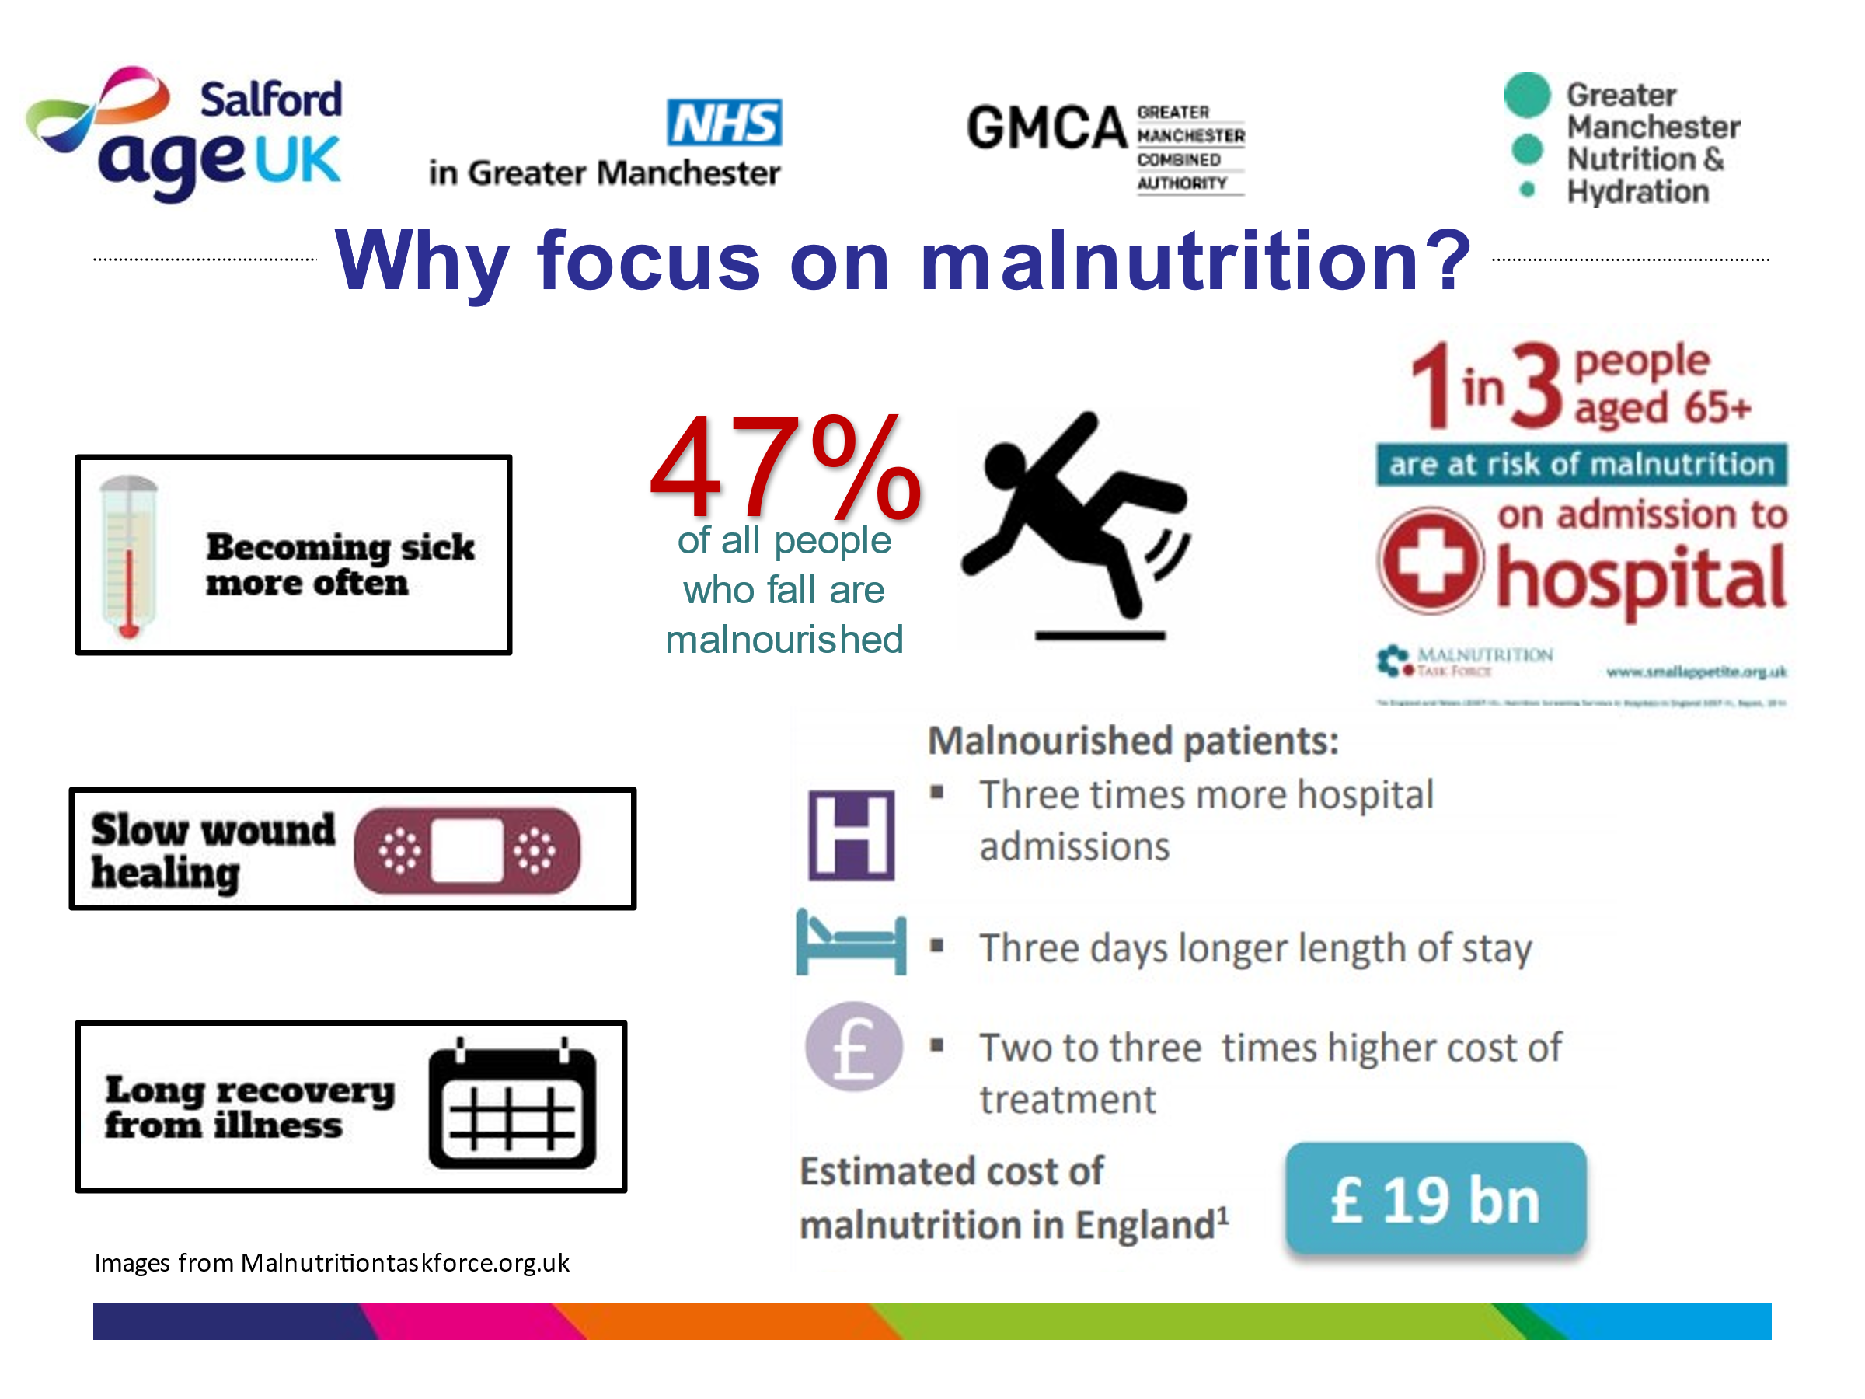
Why focus on Malnutrition? It is estimated that 1 in 10 in the UK is either malnourished or at risk of malnutrition.
We know that almost half of falls in older people can be attributed to malnourishment and we know if a person is malnourished it will take them longer to recover.
It is a common myth that that losing weight is a normal part of aging so it’s a hidden problem.
It usually develops over the medium to long term and often goes unidentified and therefore untreated until it becomes a serious problem and people are admitted to hospital or a care home because their health and independence have deteriorated.
In fact, a third of recent arrivals to hospitals and care homes are already malnourished.
The consequences are huge for the individual and for society. For every 10 days a person over the age of 80 spends in hospital, they lose 10% of muscle mass. This in turn is likely to lead to falls, reliance on health and social care services and lowered overall independence and quality of life.
It’s expensive- malnutrition costs the health and social care system a staggering 20 billion pounds each year.
It affects vulnerable people the most – the older the person, the more likely they are to be at risk.
BUT it’s totally preventable in many cases!

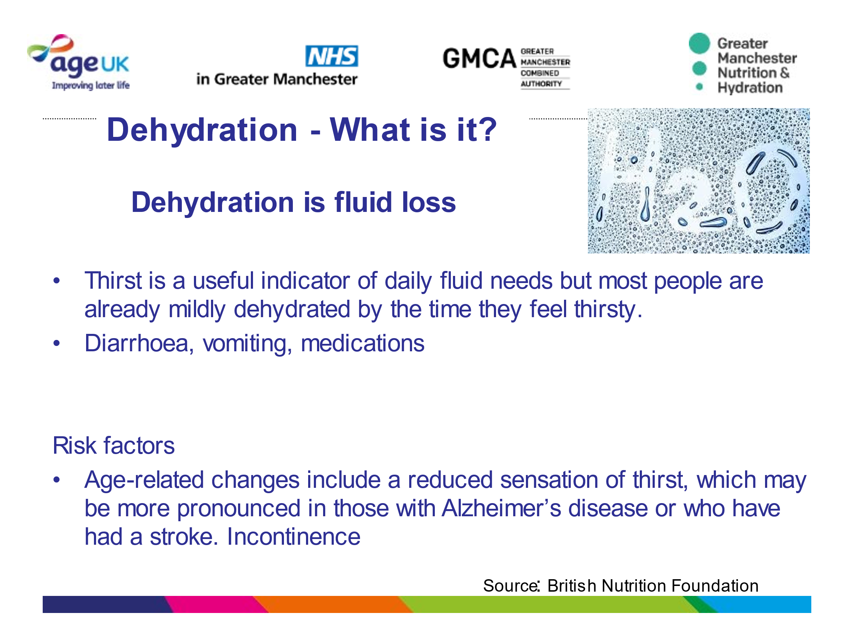
Slide 5. What is Dehydration?
What is dehydration?
Dehydration can be referred to as a loss of fluid from the body – which can be through sweating, vomiting, diarrhoea and some medications can be diuretic so cause excess water loss.
Fluid loss also means simply not drinking enough fluids to hydrate the body.
Did you know that If you are thirsty, you are already mildly dehydrated? So, it is better not to wait until you are thirsty to have a drink. It is a good habit to drink or sip fluids throughout the day because as we age, we lose the sensation that tells us that we are thirsty. This is especially pronounced in people who have had a stroke or suffer from dementia. A reduced sense of thirst due to age or a condition, may mean that prompts to drink are needed.

Slide 6. Dehydration - signs and symptoms
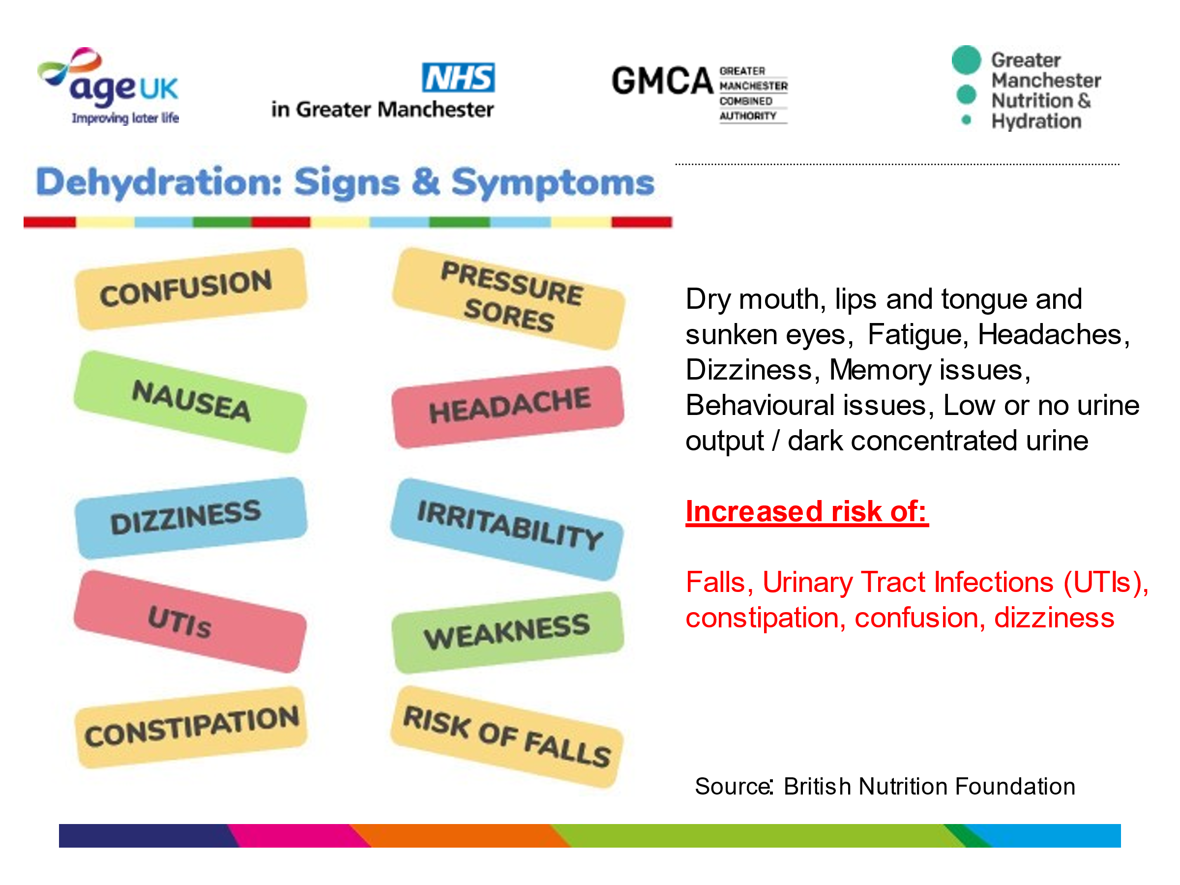
There are some obvious signs and symptoms of dehydration such as dry mouth, lips, tongue and sunken eyes. Others you may notice are fatigue, headaches, dizziness, memory issues and behavioural issues. Others may not be so obvious and possible to overlook such as low or no urine output / dark concentrated urine, urinary tract Infections (UTIs), pressure sores and constipation.

Slide 7 Key Stats on Dehydration.
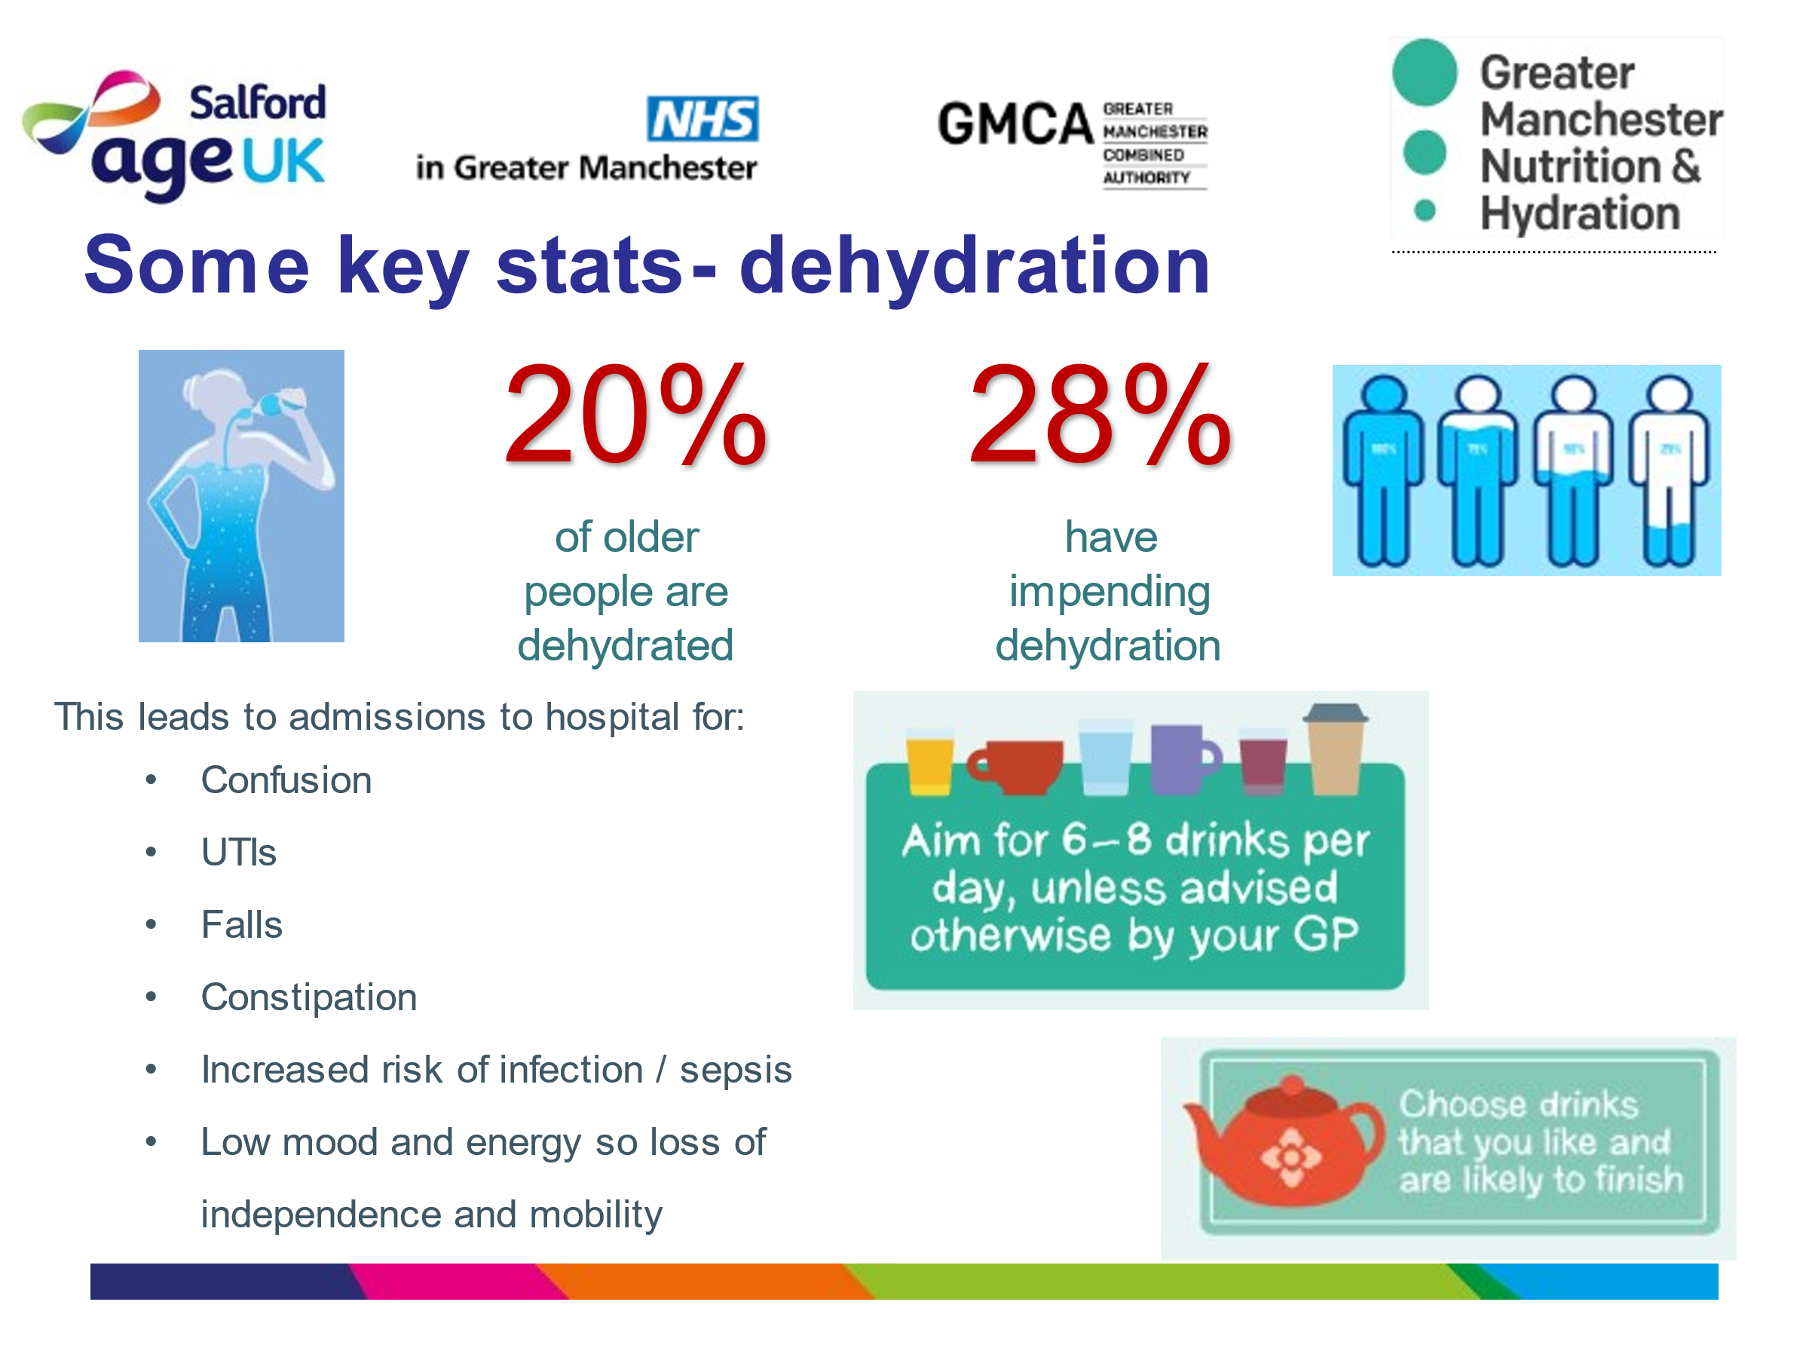
Here’s what we know.
20% of older people are already dehydrated and a further 28% have impending dehydration, meaning that unless they drink more, they are likely to become dehydrated – and we know that could lead to an increased risk of falls, UTIs, constipation, confusion, dizziness – and perhaps hospitalisation.
To stay well hydrated we should aim for 6-8 drinks per day. And this can include all liquids (except alcohol), so encourage people to drink what they enjoy.

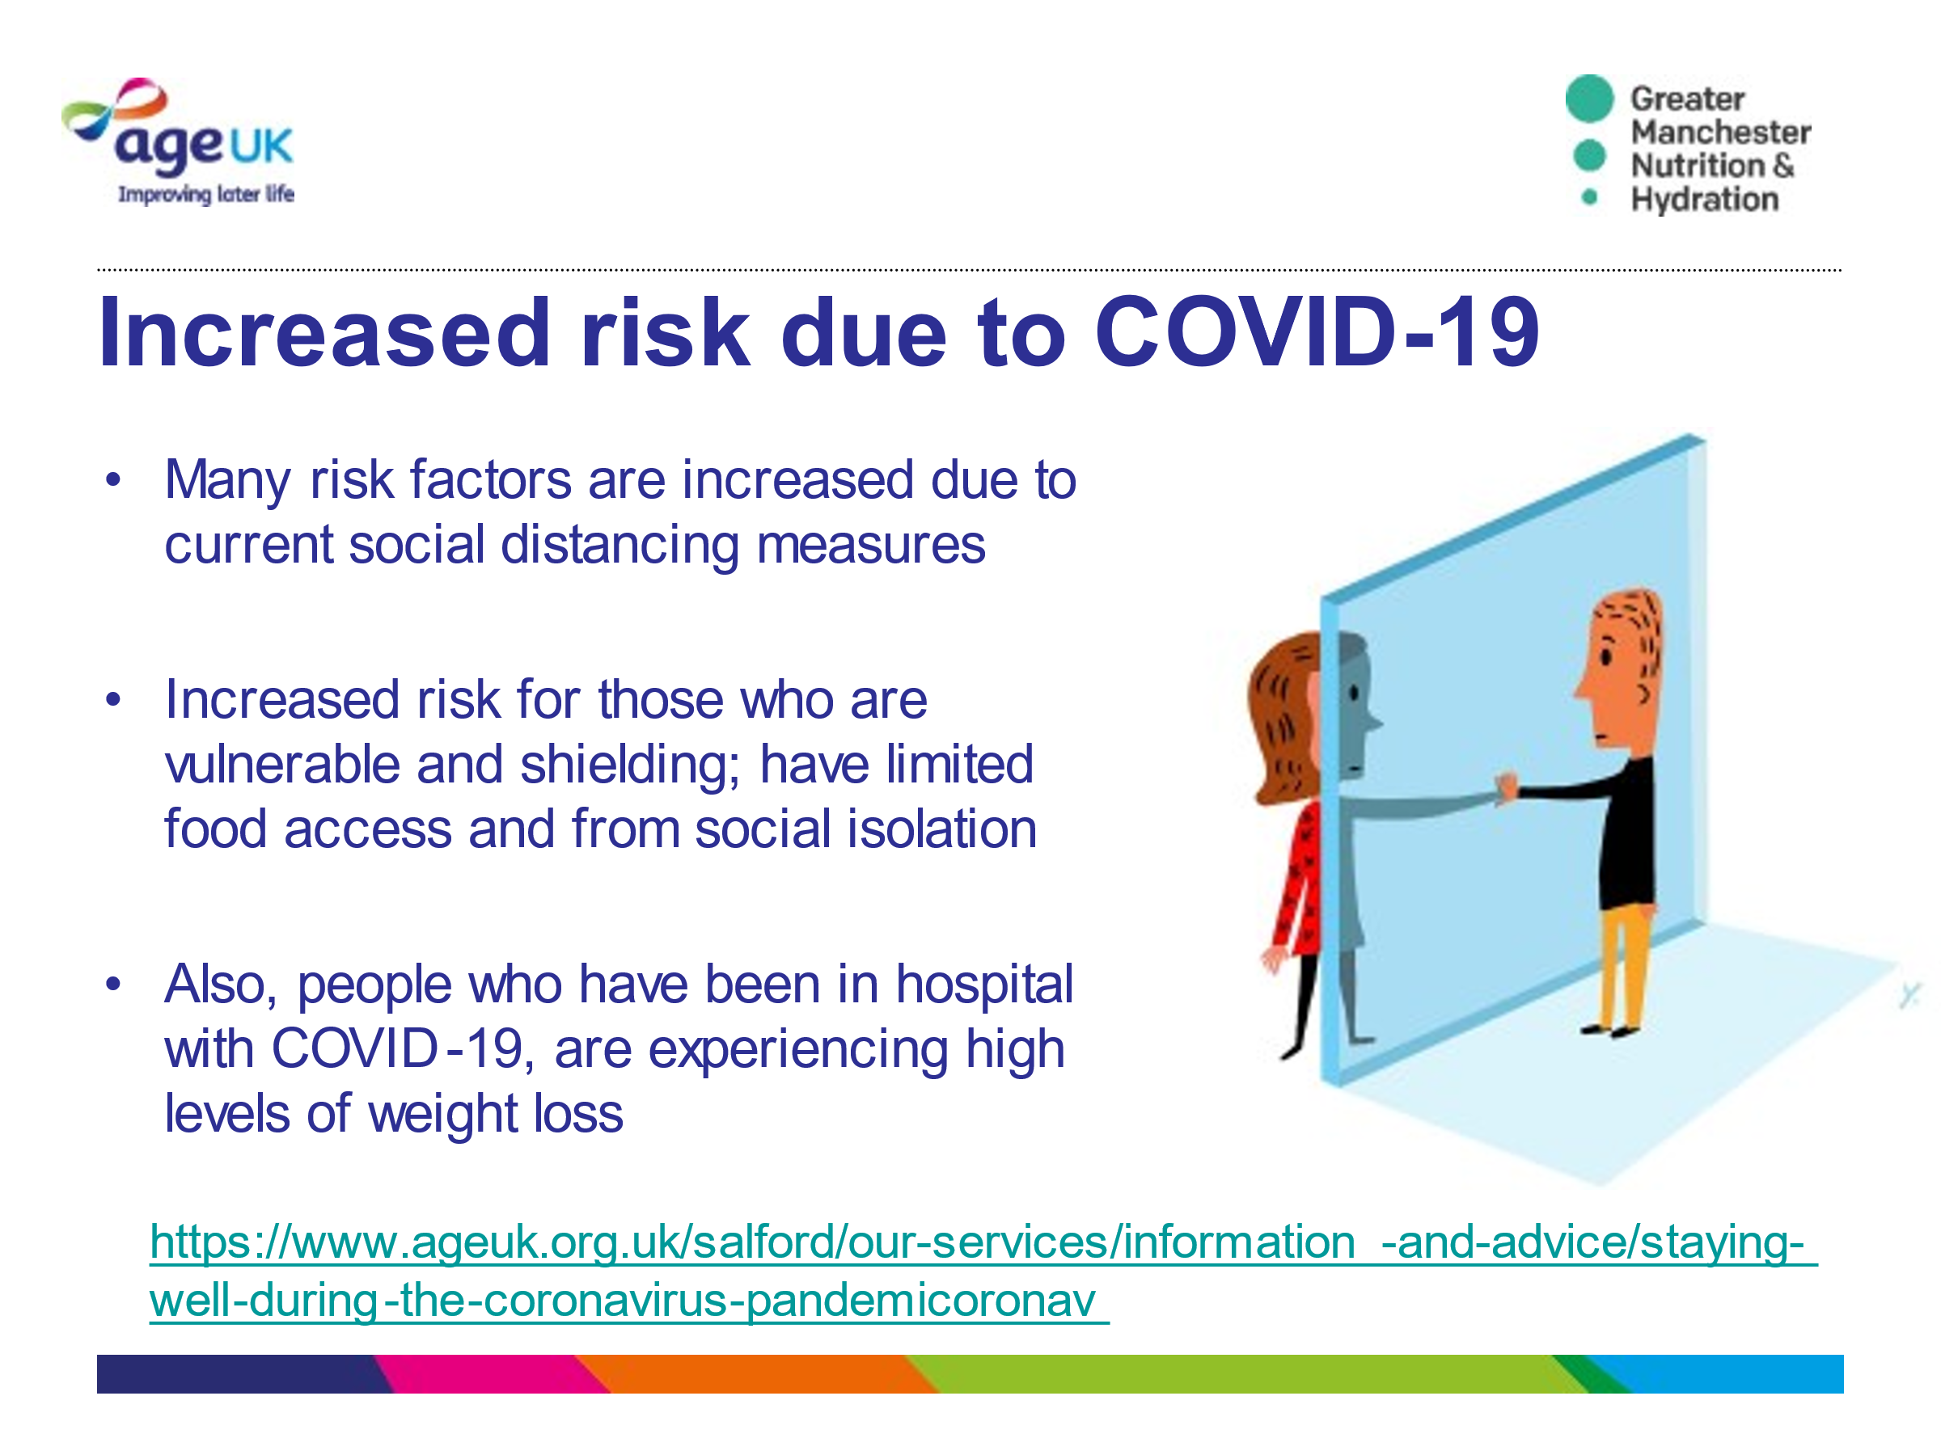
Slide 8- Increased Risk due to Covid-19
We now know that Covid has increased the risk of malnutrition and dehydration.
Malnutrition can increase a person’s risk of infection as well as slow down their recovery.

Weight loss, especially if rapid weight loss usually reflects loss of muscle mass, which may be particularly relevant for people recovering after a period of intensive care.

In turn this slows their recovery and may consequently result in readmission to hospital and further complications

Slide 9 – Long Covid

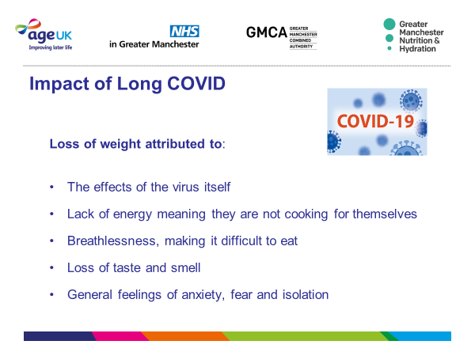
Those that are still suffering from Covid have reported reasons poor appetite and weight loss:
The effects of the virus itself
Lack of energy meaning they are not cooking for themselves
Breathlessness, making it difficult to eat
Loss of taste and smell
General feelings of anxiety, fear and isolation.
This feedback is crucial to understand how Covid and Long Covid are worsening the risk of Malnutrition and Dehydration for older people.

Slide 10. If you notice that someone is not eating and drinking well,
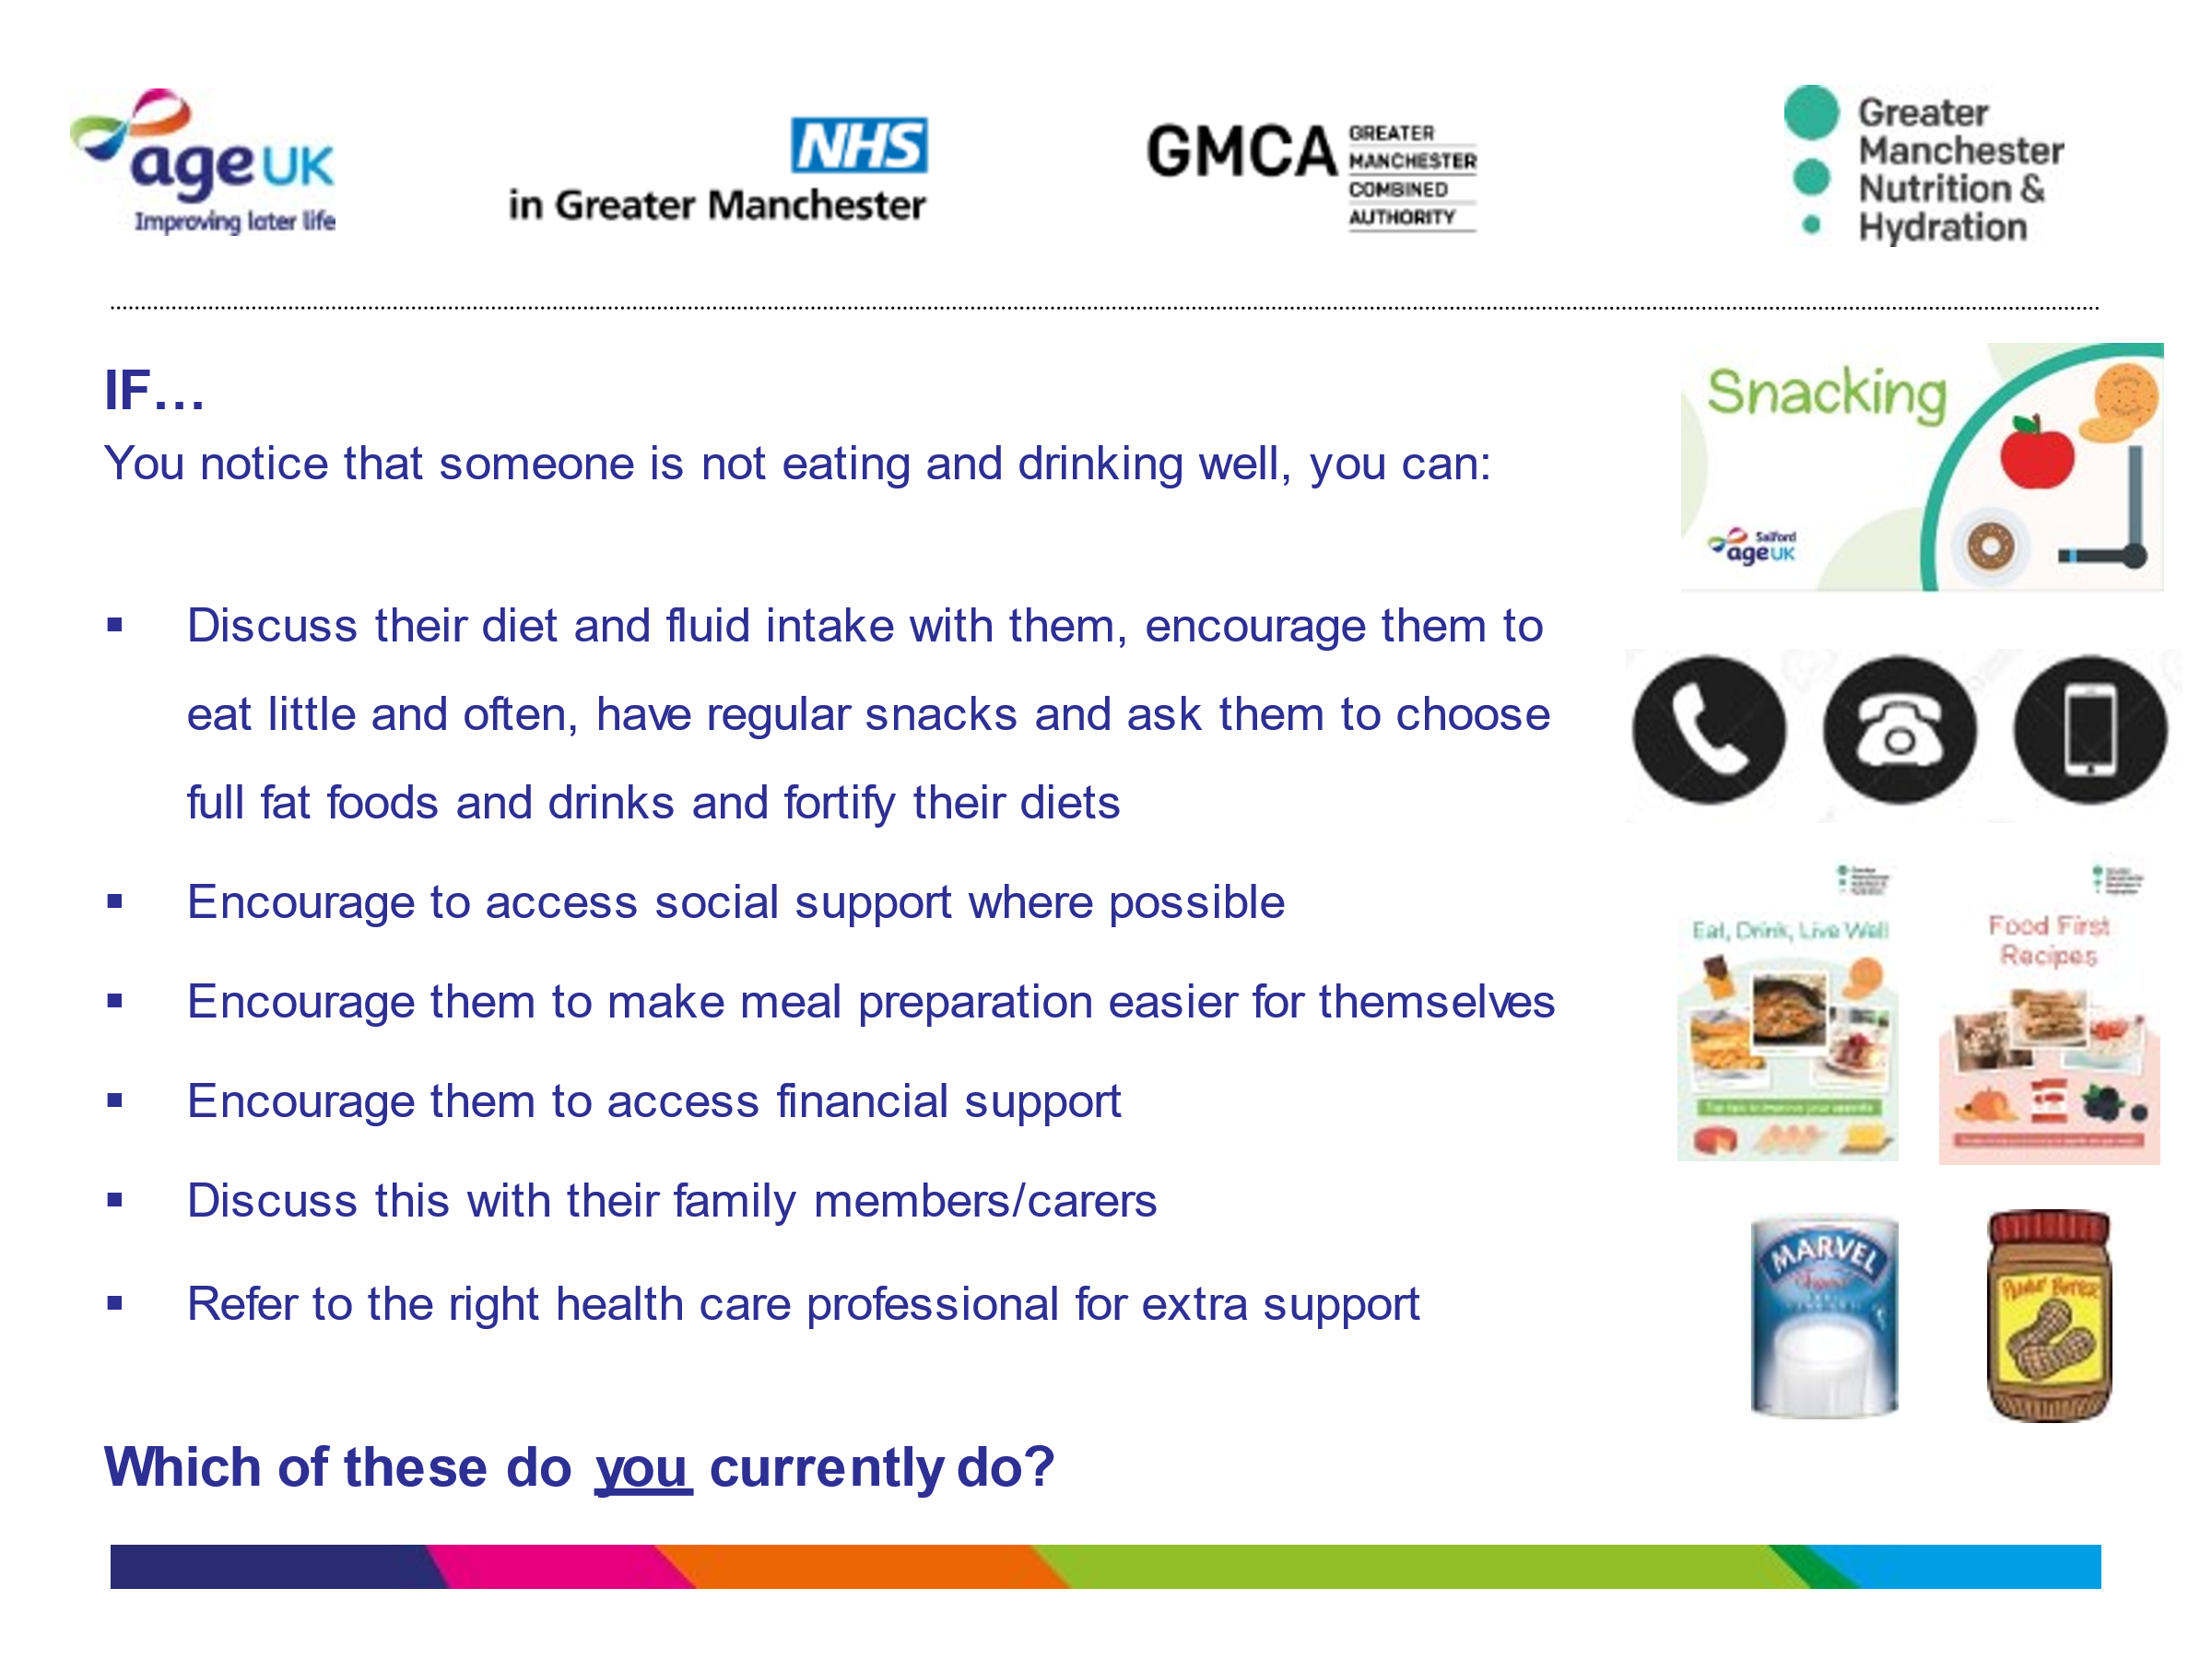
You could:
Discuss their diet and fluid intake with them.
Encourage them to eat little and often
Have regular snacks and ask them to choose full fat foods and drinks and fortify their diets
Encourage them to–
access social support where possible
make meal preparation easier for themselves
access financial support
You could also discuss this with their family members/carers and/or refer to the right health care professional for extra support
Which of these do you currently do?

Slide 11. Raising Awareness
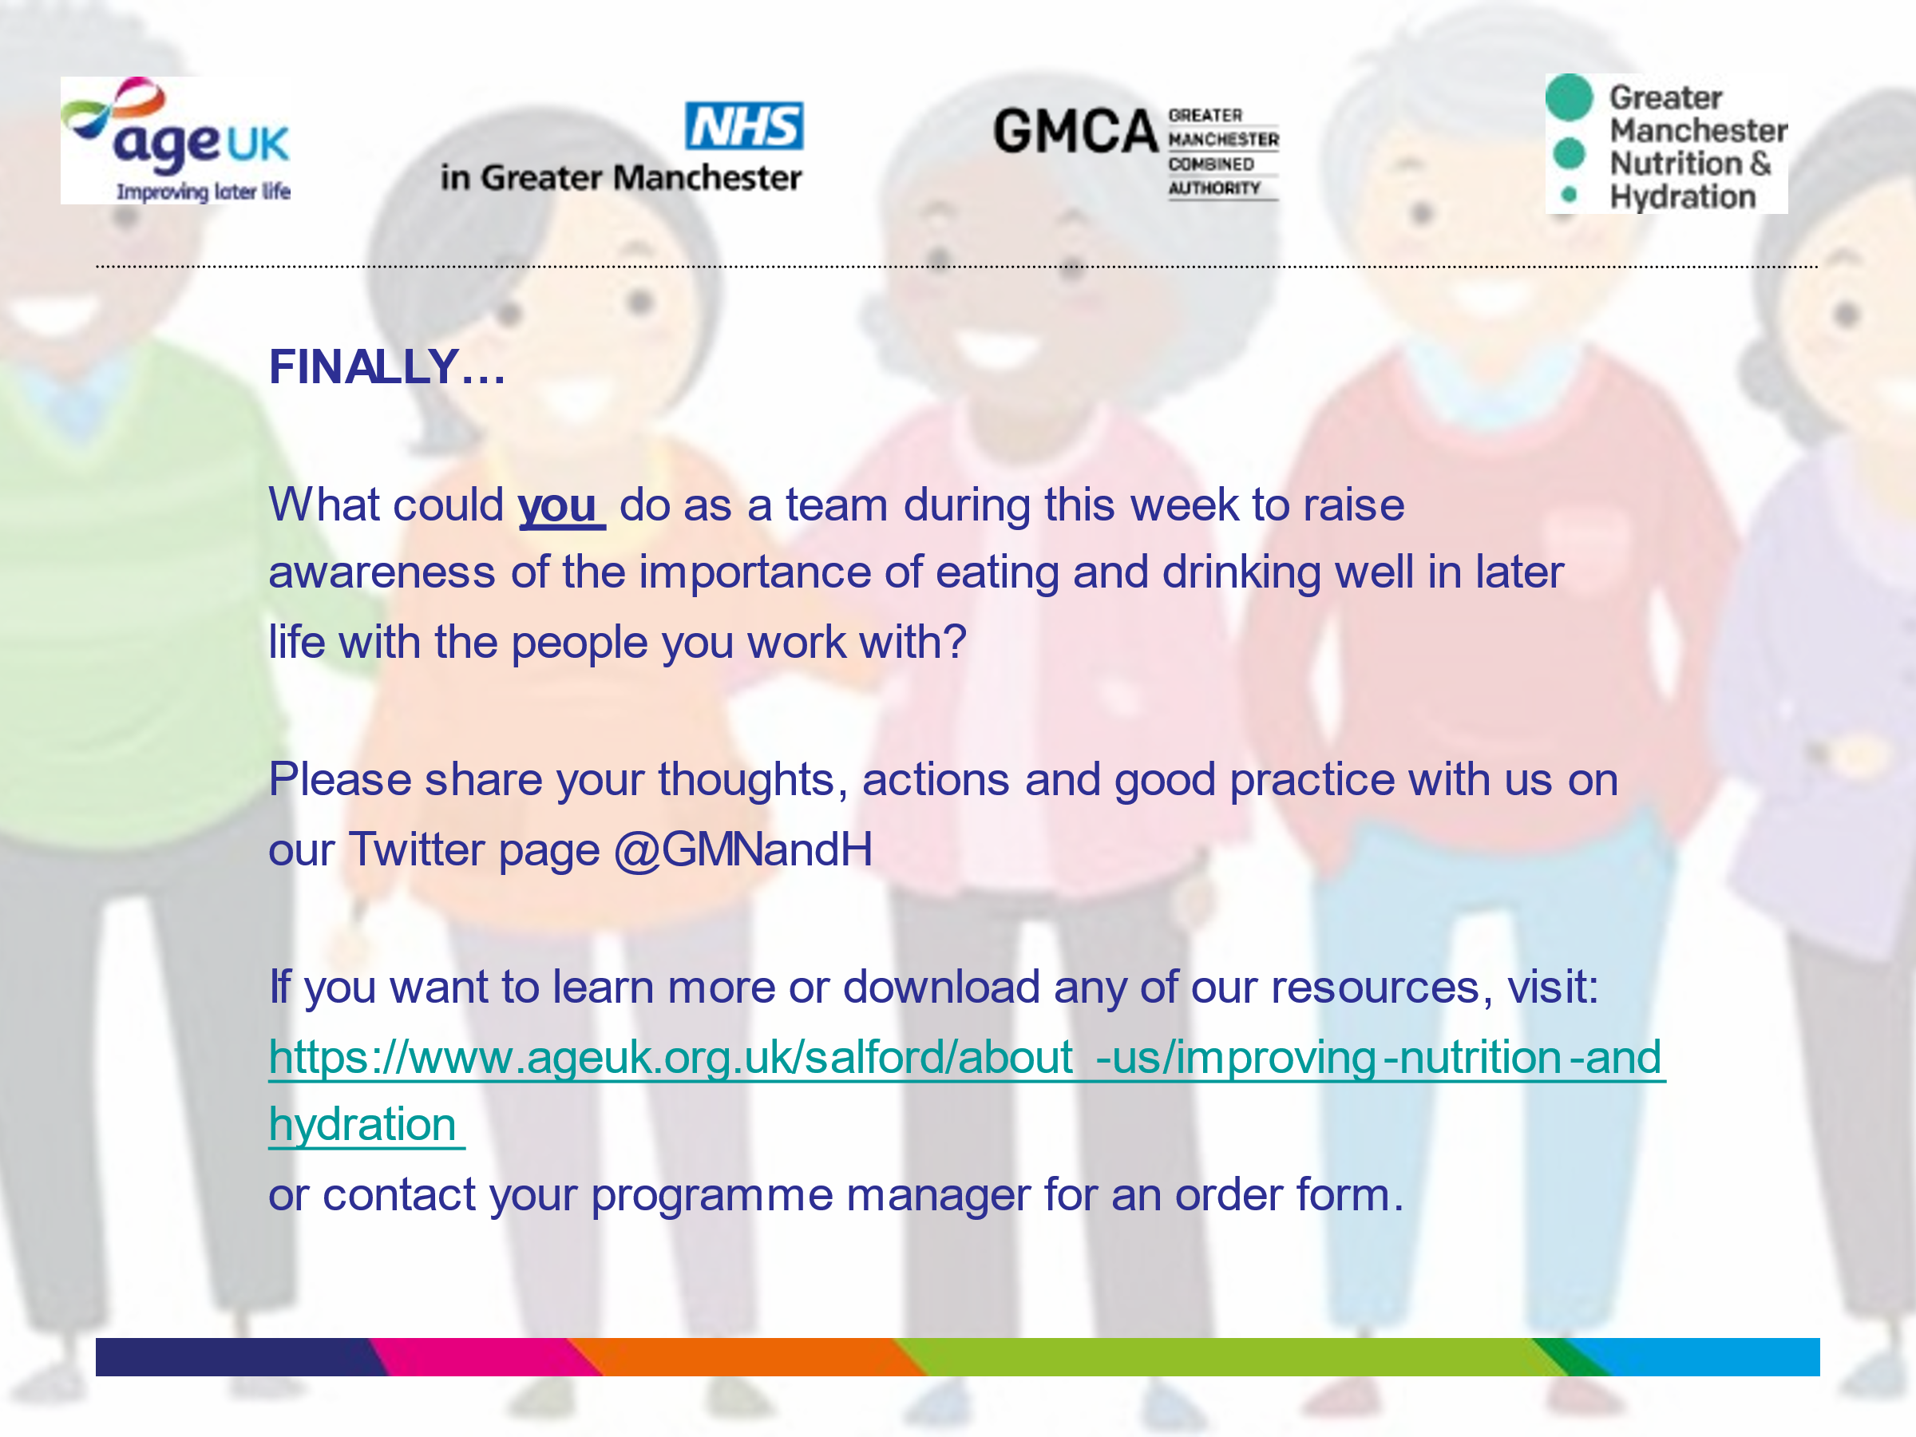
What could you do as a team to raise awareness of the importance of eating and drinking well in later life?
Please share your thoughts, actions and good practice with us on our Twitter page @GMNandH
Learn more by visiting the Age UK webpage

Our resources and further learning details can be found on the next 2 slides.

Slide 12. Available Resources
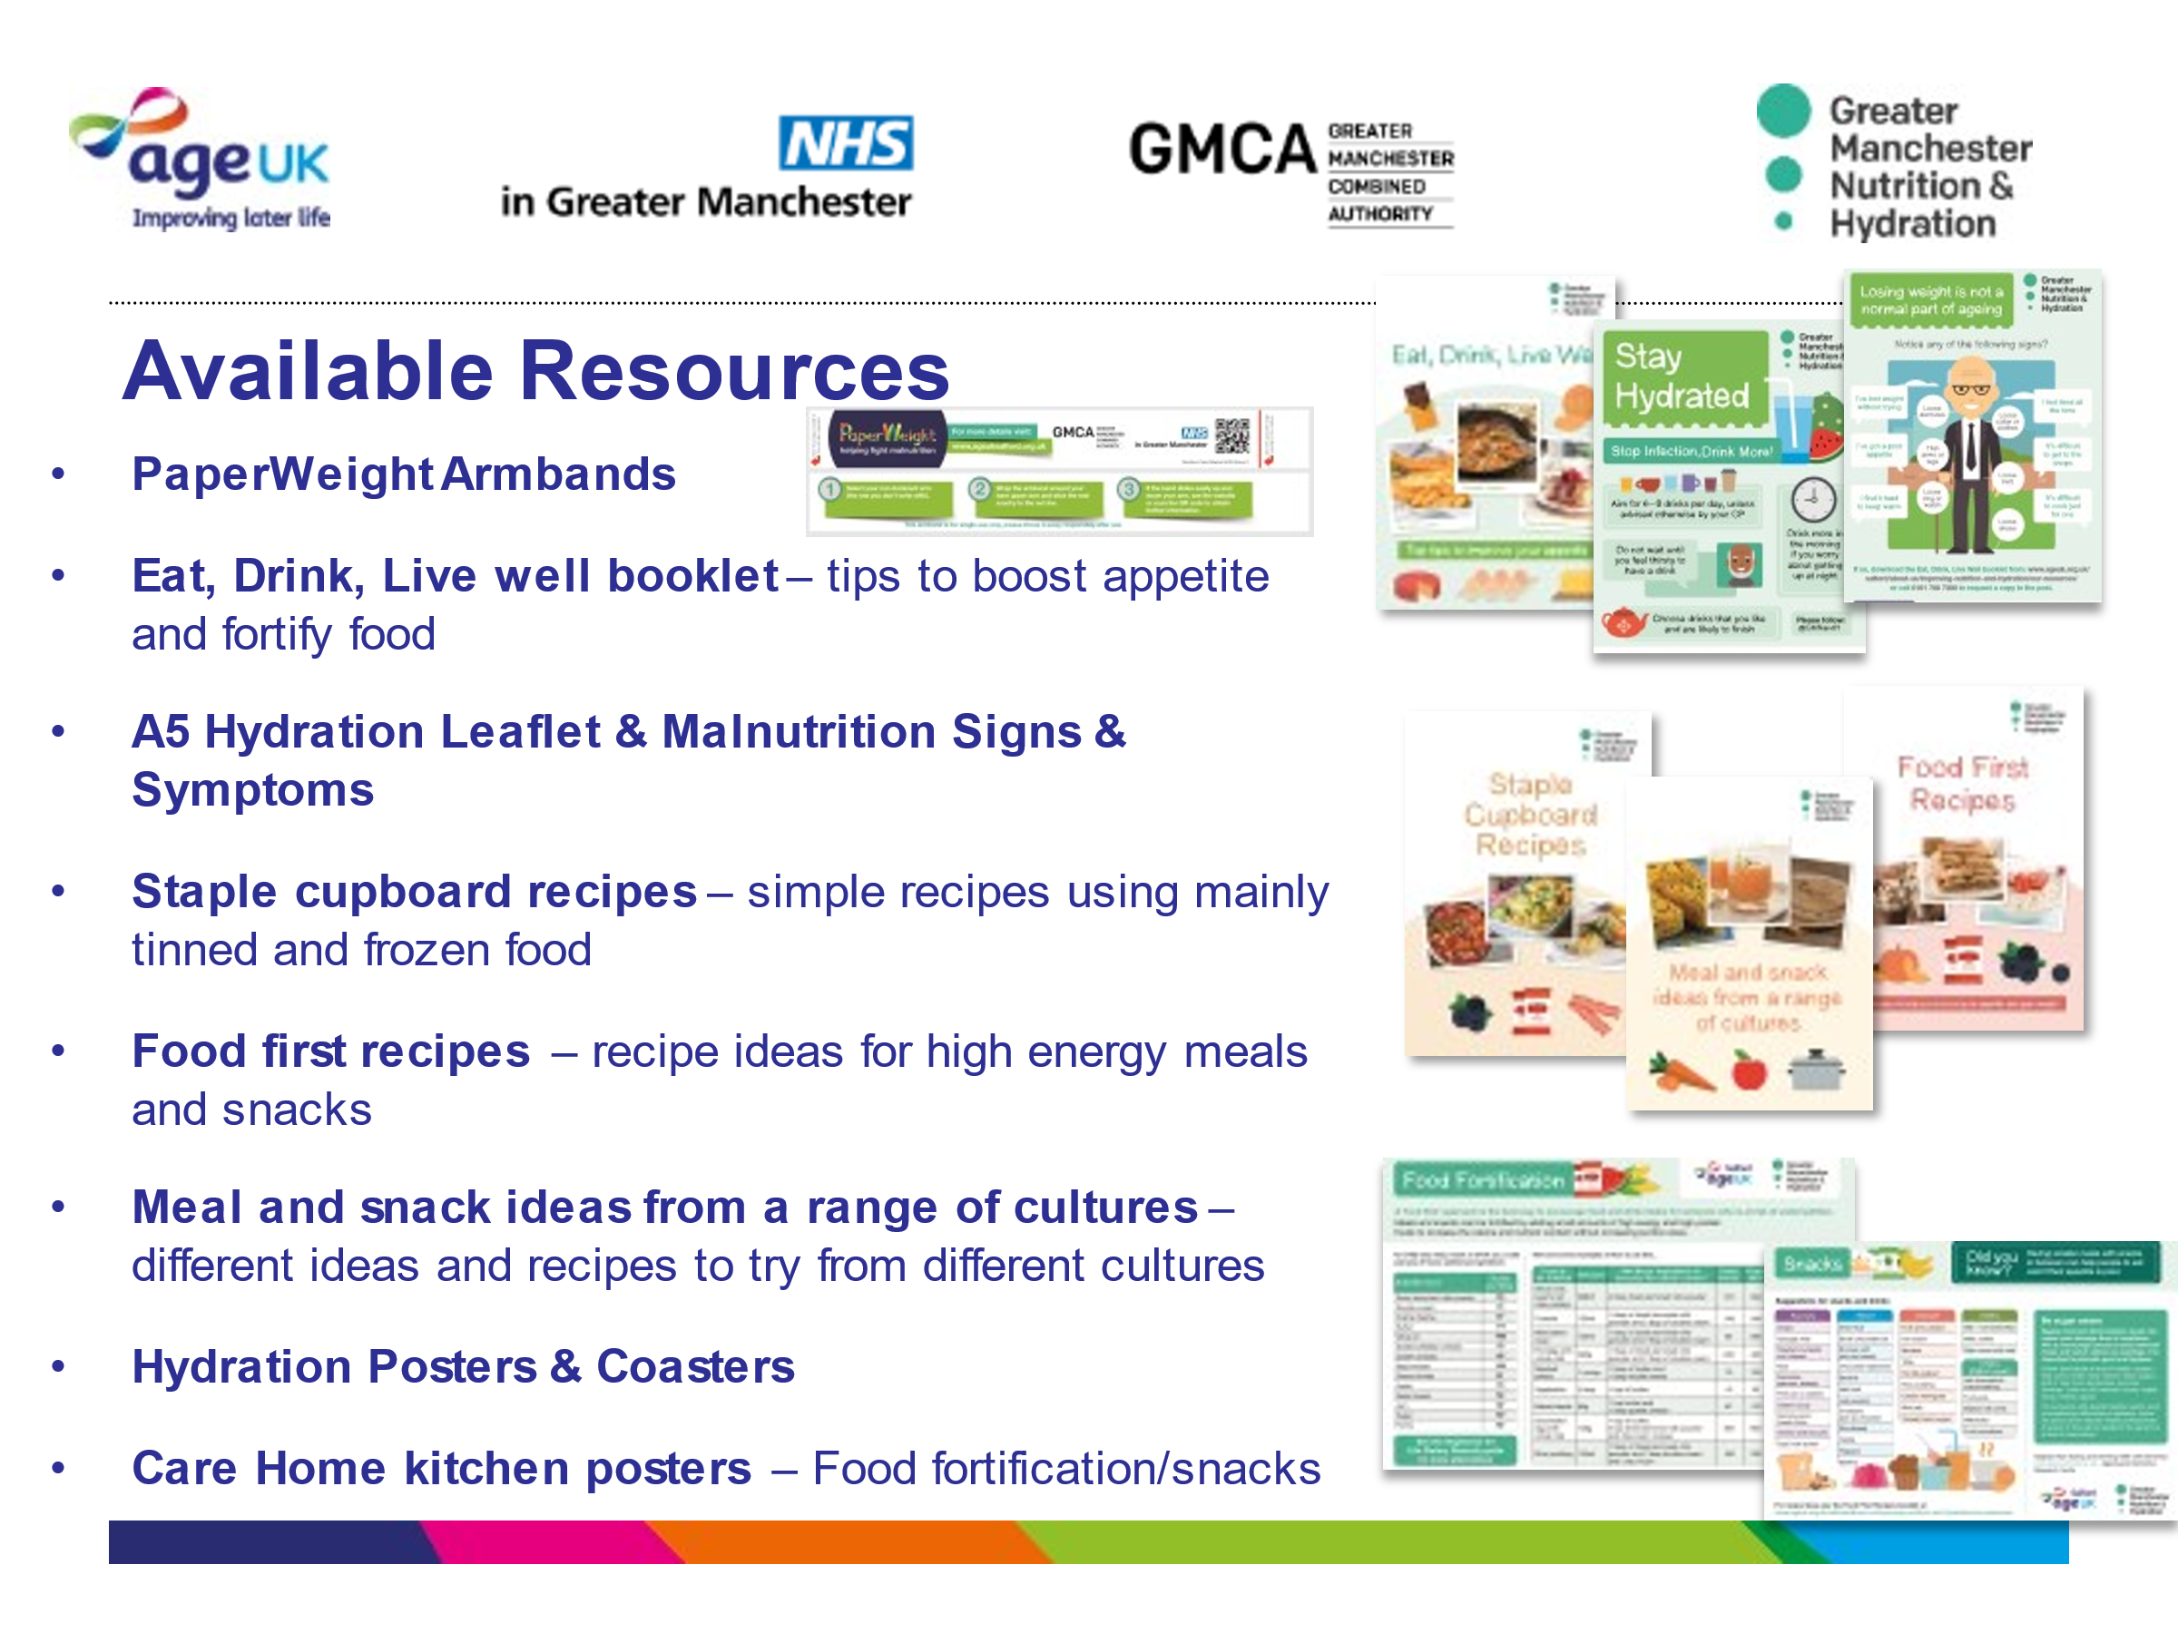
We have materials available for general awareness raising and prevention and materials for people at risk. Contact your programme manager for an order form.

Slide 13 Further Information
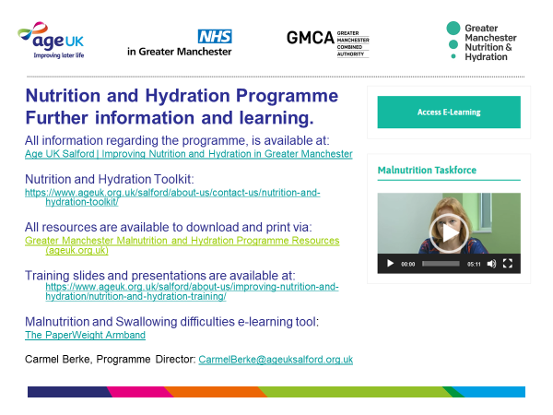
All the details about downloading resources and training can be found on these links.

