Nutrition and Hydration Week 2022
Social Media Pack
The Greater Manchester Nutrition and Hydration team are promoting the UK’s 10th Nutrition and Hydration Week and we need your help! As one of our partners, we are asking you to help us get the messages out about good nutrition and hydration in later life.
We have made 5 social media posts which are ready to use, one for each day of the week. Please post on each day with the image, hashtags and tags we have prepared for you. The images are also attached as JPEG files.
You can post these on your Twitter, Facebook page or both.
A simple action like this can really save and improve the lives of many older people living in the UK by busting myths and spreading the right messages about eating and drinking well in later life.
Thank you,
The Greater Manchester Nutrition and Hydration Team

Post 1- to be posted on Monday 14th March 2022

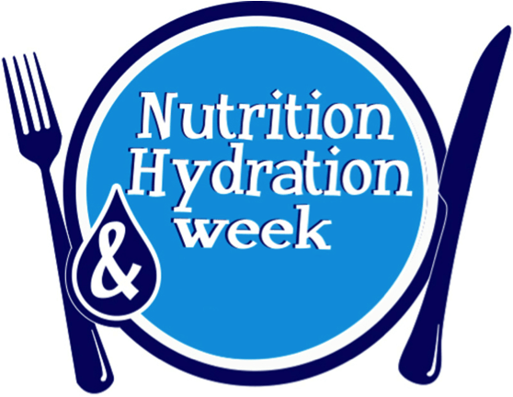

Magnificent Monday- UK’s 10th N&H week is here! Help us celebrate good N&H this week by sharing our messages on the importance of good N&H in older age- it is especially important now due to #covid-19 #NHWeek2022 @NHWeek @GMNandH

Post 2 – to be posted on Tuesday 15th March 2022

Taste Testing Tuesday! Trying new foods is a great way to increase variety in your diet- why not try something from a different culture you have not tried before? You might even find a new favourite! #trysomethingnew #NHWeek2022 @NHWeek @GMNandH

Post 3 – to be posted on Wednesday 16th March 2022

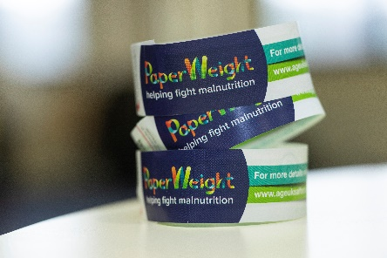
Weigh in Wednesday- Keeping an eye on you or loved ones weight as they get older can prevent any unplanned weight loss which can be the first sign of malnutrition. If you don’t have scales you can use the @PArmband or watch for visual signs such as loose clothing @NHWeek2022 @GMNandH

Post 4 – to be posted on Thursday 17th March 2022
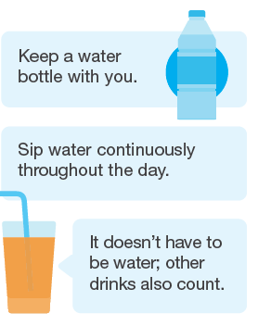
Thirsty Thursday! Did you know that you need 6-8 drinks per day to stay well hydrated? Dehydration can cause infections and falls and sipping fluids throughout the day can help prevent these. #NHWeek2022 #ButFirstaDrink @NHWeek @GMNandH

Post 5 – to be posted on Friday 18th March 2022
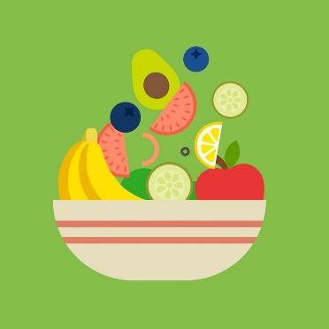
It’s a Fruity Friday! Did you know that fruits are an excellent source of vitamins, minerals, fibre and water? Have an extra piece of fruit today and why not try a new type you have not had before? #trysomethingnew #NHWeek2022 @NHWeek @GMNandH

