Did you know – drink facts… 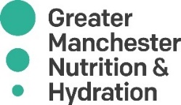
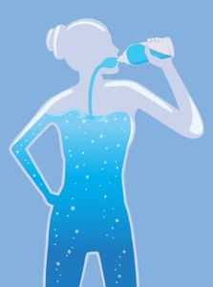
- The UK’s drinking water is considered one of the safest in the world. The 2018 report on public water supply compliance with the EU Drinking Water Directive was 99.95%
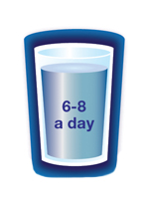
- The average person in the UK uses 141 litres of water per day for daily tasks including drinking, washing and cleaning. Drink 6-8 glasses per day to stay healthy (1.5 – 2 litres).
- Loch Ness in Scotland holds an estimated 263 billion cubic feet of water, which is more than all the water in all the lakes, rivers and reservoirs in the whole of England and Wales combined.
- Water is a natural resource that is required by every person this includes our body composition, mental focus, sleep and recovery.
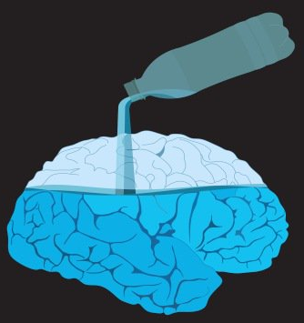
- Water is one of the key elements responsible for human life on earth and is vital for our survival. The human brain is composed of 95% water, lungs are 90%, blood is 83%, muscles are 76%, and bones are 22% water.
- Dehydration can cause a variety of symptoms including headaches, fatigue, lack of focus, dizziness, and in some severe cases, fainting.

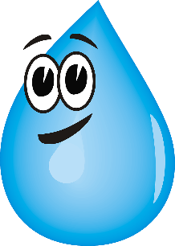
- We can lose around 1 litre of fluids per day through evaporation / sweating.

