Knitting patterns and instructions to knit your favourite treat!
Hot Cross Buns

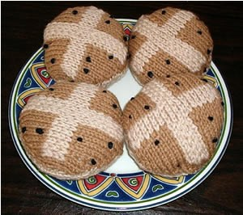

What you need:
3.75mm needles or size 9
8ply wool in Light Brown & Fawn
Black embroidery Thread for Currants
Toy Filling for Stuffing.
How to:
Size: 4 inch each
Tension: Cast on 24st stst 32 rows equals a 4 inch square
Bun Base –
Using Fawn cast on 8st & k 1 row.
Inc 1st at each end of next 4 rows then following 3 alt rows. 22st.
Work 8 rows straight.
Dec 1st at each end of next & following 4 alt rows.
Dec 1 st at each end of next 3 rows. Purl 1 row, Cast off.
Bun Top –
Using L/Brown cast on 8st & k 1 row.
Inc 1 st at each end of next row. 10st.
Using a separate length of yarn for each colour change and twisting yarns together at back of work when changing colour to avoid making a hole, continue as follows:
NEXT ROW:
Using L/Brown inc in 1st stitch, k2, using Fawn k4, using L/Brown k2, inc in last st. 12st.
Keeping the centre 4st in Fawn, inc 1st at each end of next 2 rows then following 3 alt rows. 22st. Work 2 rows straight.
NEXT ROW: P 2 L/Brown, 18 Fawn, 2 L/Brown .
NEXT ROW: Knit 2 L/Brown, 18 Fawn, 2 L/Brown . Rep last 2 rows once more.
NEXT ROW: P 9 L/Brown, 4 Fawn, 9 L/Brown,
NEXT ROW: K 9 L/Brown, 4 Fawn, 9 L/Brown.
Keeping to centre 4st in Fawn dec 1st at each end of next & following 4 alt rows. Dec 1st at each end of next 2 rows.
Using L/Brown only dec 1st at each end of next row. P 1 row. Cast off remaining 8st.
To Finish
Sew 2 circles together leaving an opening for the stuffing. Stuff firmly and sew close the opening.
Embroider black currants using knots on top of the buns.
Jam Swiss Roll

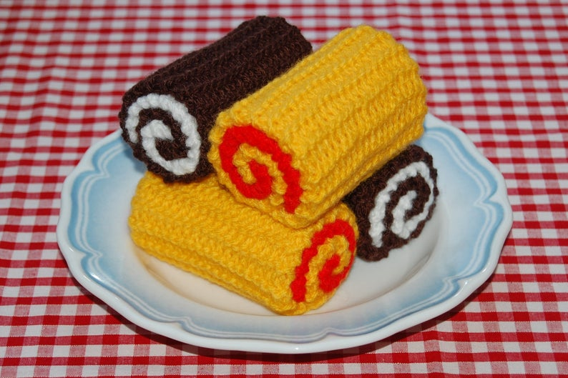

What you need:
4mm needles
Cream or Brown Wool
Red wool for Jam
How to:
Using cream or chocolate colored cast on 26 stitches
Stocking stitch 4 inches and cast off.
Using red cast on 24 stitches and stocking stitch 3 and a half inches
And cast off.
Roll up together with red in the inside and sew into place
Cute Cup cakes

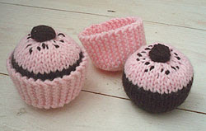
What you need:
4mm needles, aran yarn (I used Patons Toddler Aran)
M1: Pick up loop between stitches and knit into the back of it to make an extra stitch.
How to:
Cake
Start with cake colour (mahogany for choccie cakes)
Cast on 7st
row 1: (K1, M1) 5 times, K1 - 11st
row 2: P
row 3: (K2, M1) 5 times, K1 - 16st
row 4: P
row 5: (K3, M1) 5 times, K1 - 21st
row 6: P
row 7-9: K
row 10: P
row 11: K4, (K1, M1, K6)x 2, K1, M1, K2 - 24st
row 12-14: stst, starting with a P row
row 15: K4 (K1, M1, K6)x 2, K1, M1, K5 - 27st
row 16: P
row 17: (K4, K1, M1) x 5, K2 - 32st
row 18: P
row 19: K6, (K1, M1, K8) x 2, K1, M1, K7 - 35st
row 20: P
Break off yarn and join icing colour
row 21-22: stst 2, starting with K
row 23: (K8, K2tog) x 3, K5 - 32st
row 24: P
row 25: (K4, K2tog) x 5, K2 - 27st
row 26: P
row 27: (K2tog) x 13, K1 - 14st
row 28: (P2tog) to end - 7st
Pass thread through stitches and pull tight. Sew up cake, leaving hole in bottom to stuff. Thread yarn through CO stitches and pull tight.
Chocolate button
CO 6st
Starting with P, stst 8 rows. Thread yarn through stitches and round edges of work. Pull tightly to make ball. Sew onto cake, passing the thread through to bottom of cake to fasten off to give a little 'dip' in the centre of the cake.
Sew straight stitches randomly on top for 'sprinkles'
Case
Using icing colour, Cast on 9st.
garter st 60 rows, Cast off.
Pick up and knit 28 stitches on row ends.
row 1: P
row 2: (K4, K2tog) x 4, K4 - 24st
row 3: P
row 4: (K2 K2tog) to end - 18st
row 5: P
row 6: K2tog to end - 9st
Thread yarn through stitches and pull up tight. Sew sides of case together.

Dounuts

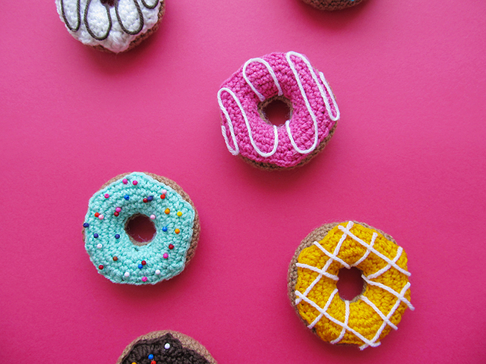
What you Will Need:

100 % acrylic yarn (light brown for the base, any colors for icing)
4mm (G) crochet hook
Toy stuffing
Yarn needle (to sew the parts together)
Beads (for decorating)
Fabric glue (optional, you can also sew your beads on the icing)

Donut Pattern:

Base

With light brown
Ch 18 and sl st in first st to form a ring,
R1: *sc, inc* repeat from * to * around (27)
R2: sc in each st around (27)
R3: *2sc, inc* repeat from * to * around (36)
R4-10: sc in each st around (36)
R11: *2sc, dec* repeat from * to * around (27)
R12: sc in each st around (27)
R13: *1sc, dec* repeat from * to * around (18)
R14: sc in each st around (18)
Fasten off.

Leave a long tail for sewing the donut together. You will pinch the starting chain (18) and ending R14 (18) and sew the donut base closed. You will stuff as you sew.
Icing Pattern:
With color of your choice,
Ch 18 and sl st in first st to form a ring,
R1: *sc, inc* repeat from * to * around (27)
R2: sc in each st around (27)
R3: *2sc, inc* repeat from * to * around (36)
R4: sc in each st around (36)
Now you will start form your icing drops. To form these just work either 2-3 dcs in the same st or work 2-3 trs in the same st. Work the drops randomly around.
R5: sc in each st around (remember to work the drops in some sts)
Fasten off.

