Nutrition and Hydration 14th- 20th of June 2021
14th- 20th June is Nutrition and Hydration Week. There has never been a more important time to raise awareness of the importance of eating and drinking well in later life.

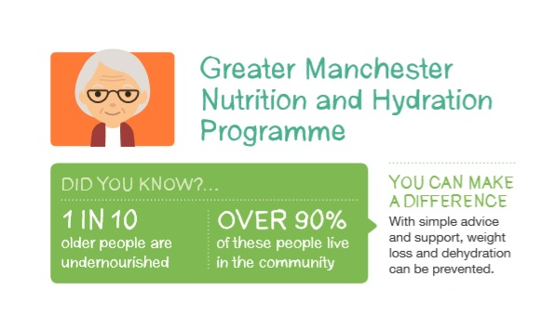

With around 3 million people at risk of malnutrition in the UK we need to engage opportunities to raise the awareness of the risks and promote the good practices that can help prevent malnutrition and dehydration. Preventing malnutrition and dehydration improves health and well-being and helps to reduce the burden on the health and social care services in treating and supporting those suffering from under nutrition and dehydration.
The aim of the global Nutrition and Hydration Week is to reach out to health and social care professionals in clinical, nursing, catering and care situations utilising their expertise to bring you a great campaign you can get on board with in your organisation.
As the public health environment becomes more challenging with even tighter budget constraints coming into place Nutrition and Hydration Week is one of the most cost-effective health interventions possible.

We all have a role to play
We all have a role to play in helping people to notice if they have started to lose weight without meaning to or if they are not drinking enough. It is everyone’s responsibility to encourage good nutrition and hydration intake and to raise awareness of simple tips to better nutrition and hydration intake.

Get involved to raise awareness
If you can see older people face to face, use this week to check for risk of malnutrition using the Paperweight Armband©. You can also give the
armband for family members and carers to try out. Get in touch with us if you would like us to send you armbands. You can find all our materials on Greater Manchester Malnutrition and Hydration Programme Resources (ageuk.org.uk)

Use this week to have conversations about eating and drinking well, memories about favourite childhood foods or play food related games such as food or food for thought with people that you are in contact with. To do this activity, you can get resources from our website.

Feature good Nutrition and Hydration in messages for older adults at the beginning of your team meeting during this week. To do this activity, download our ready prepared short presentation on “a 5 Minute Guide to Prevent Malnutrition and Dehydration in Older Age”. (link)

Get involved on social media (Twitter and Facebook) by posting and sharing our messages. We are on Twitter and Facebook at @GMNandH. To do this activity, we have prepared a ready to post social media pack. We will post this on our website and email it out the week before Nutrition and Hydration Week. Get in touch with us to get the pack directly to your inbox! (link)

If you are hosting a small event, webinar or an activity, promote good nutrition and hydration messages. We can provide resources for this and are happy to discuss ideas you have to do this. You can get in touch with carmelberke@ageuksalford.org.uk if you wish to discuss your ideas or would like support from us.

