Social media posts
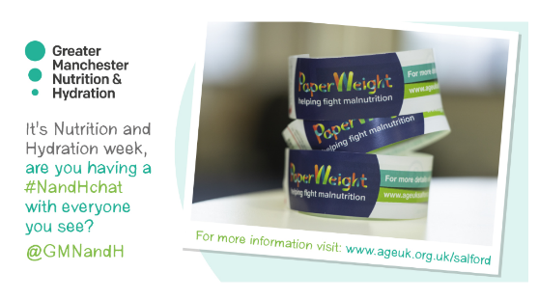
This week we are celebrating food and drink and the important role they play for our health, energy levels and quality of life. You can join us by asking every older person about their appetite and using the @PArmband #NHWeek @GMNandH

Are you joining the #GlobalTeaParty? Get involved by downloading a poster and a Nutrition and Hydration quiz from the @AgeUKSalford website http://tinyurl.com/y4x2548a #NHWeek @GMNandH

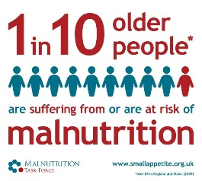
Did you know that around 60,000 older people in Greater Manchester are undernourished? In many cases this can be prevented #NHWeek #NandHChat @GMNandH

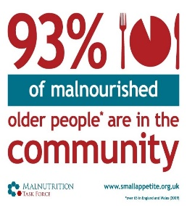
The majority of people who are dangerously underweight are living in the community. Almost 1000 front-line workers in Greater Manchester are now using the @PArmband to open up a conversation about eating and drinking well in later life #pickupapaperweight @GMNandH

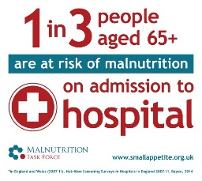
Often malnutrition is not identified until a person becomes seriously ill or loses their independence. We must not dismiss weight loss as a natural part of ageing: in many cases it can be prevented or treated #NHWeek #NandHChat @GMNandH

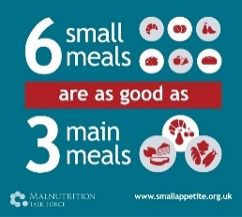
A few simple changes can help older people to maintain a healthy weight, enjoy their food and feel better #NHWeek @GMNandH

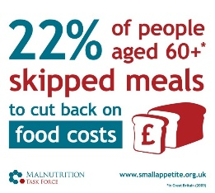
Cost and accessibility of food can be a barrier to eating well #nutritionmatters #NHWeek @GMNandH

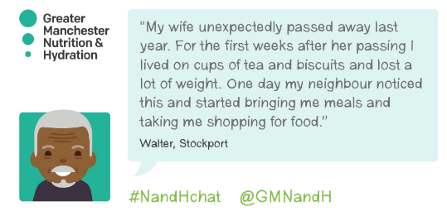
Walter lost weight after his wife passed away. Support from his neighbour helped him to make changes before he became seriously ill #NHWeek #NandHchat @GMNandH

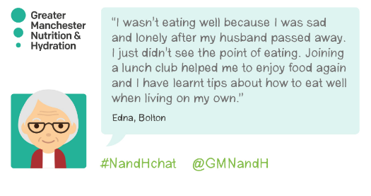
Eating and drinking is more fun when we do it together. Joining a social eating group or attending a social café can make a big difference #NHWeek @GMNandH

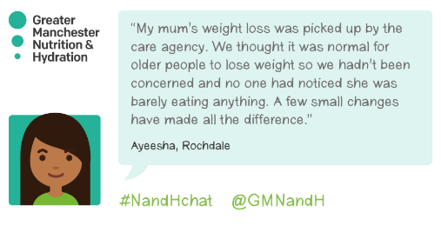
Many people dismiss weight loss as a natural part of ageing. Ayeesha tells us how a few small changes helped her mum to gain weight and feel better #NHWeek #NandHchat @GMNandH
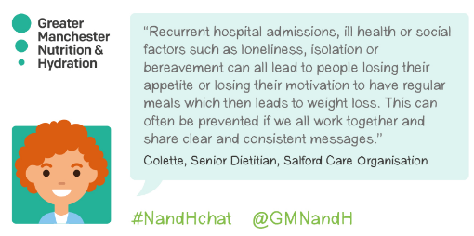
Dietitians are calling for us to share clear and consistent messages to prevent malnutrition #NHWeek #NandHchat @GMNandH

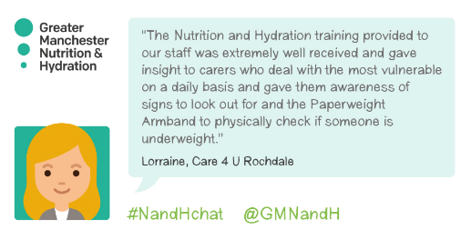
Care4U was one of the first organisations to take advantage of the @PArmband training. Read more about how this has benefitted the people they care for http://tinyurl.com/yytxb4v5 #NHWeek #NandHchat @GMNandH
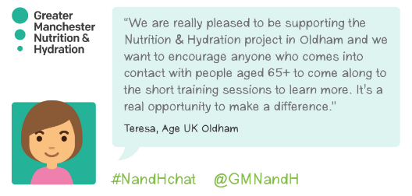
Do you work with older people? Get in touch to arrange training about Nutrition and Hydration and to learn how to use the simple @PArmband #NHWeek #NandHchat @GMNandH

