Using the Paperweight Armband 1:1
Start a discussion about food and drink
- What have you had for breakfast/dinner/tea?
- How is your appetite these days?
- Are you eating and drinking ok?
Ask the key questions
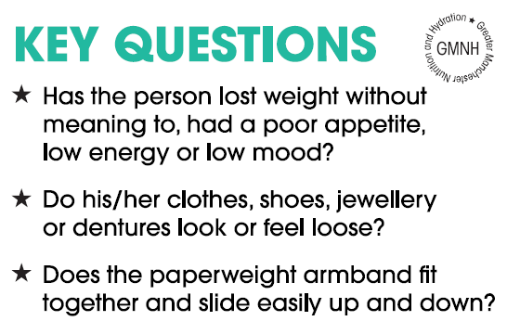
Introducing the Paperweight Armband
“The Paperweight Armband has been developed as a quick test to show if you are underweight. It was developed here in Greater Manchester and is being used by lots of people in the area.
“You wrap the Paperweight Armband around the upper arm of the hand you don’t write with, if this fits to the red line and slides easily up and down it will show that you are likely to be underweight and would benefit from adding more calories to your diet.
“Do you mind if we give this a go?”
At risk?
If the person answers yes to any of the key questions they may be at risk of undernutrition. Give the ‘Are You Eating Enough?’ booklet and discuss ideas to help them to stimulate weight gain, get support for shopping or cooking or get into better habits around eating and drinking, e.g. changing their main meal to lunch time, attending a lunch club.
Highlight some of the key messages about how to stimulate weight gain:
- Eating snacks between meals
- Using full-fat food and drinks, including milk
- Adding high-energy food to your meals and snacks, such as extra butter, cheese, cream, oil or mayonnaise
- Using full-fat ready-meals to make meal preparation easier
Keep a tally of how many people have used it and send this information to your local Programme Manager or econnolly@ageuksalford.org.uk

