Using the Paperweight Armband in a group setting
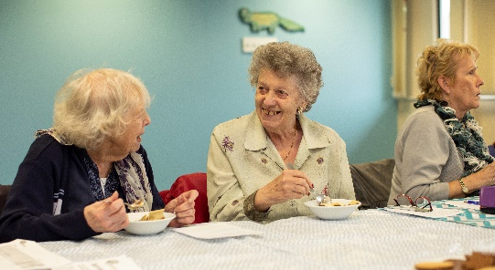
Start a discussion about food and drink
- What is your favourite meal?
- What do you like to drink?
Introduce the topic
- Why do you think it is important to eat and drink well?
- Why do you think some people find it difficult to eat enough when they get older?
- Why do you think some people find it difficult to drink enough when they get older?
- How might you notice if you had lost weight?
- How might you notice if you were dehydrated?
Share some information
- Ways to spot if you have lost weight include – loose clothes, jewellery or dentures, poor appetite
- Ways to spot if you are dehydrated include – looking at the colour of your urine, the pinch test (gently pinch the skin on the back of your hand, if it springs back to normal you are well hydrated), headaches, dizziness, water infections
- We should have 6-8 drinks a day to stay well hydrated (including tea, coffee, water)
Introduce the Paperweight Armband
“The Paperweight Armband has been developed as a quick test to show if you are underweight. It was developed here in Greater Manchester and is being used by lots of people in the area.
You wrap the Paperweight Armband around the upper arm of the hand you don’t write with, if this fits to the red line and slides easily up and down it will show that you are likely to be underweight and would benefit from adding more calories to your diet.”
Hand out Paperweight Armbands and people to try it in pairs.
Look around the group and observe if the Paperweight Armband fits anyone.
If there are people who may be at risk give them an ‘Are you Eating Enough?’ booklet and find an opportunity to discuss other ideas to support them to put on weight.
Some people may wish to take Paperweight Armbands for a friend or family member they are concerned about.
Highlight some of the key messages about how to stimulate weight gain:
- Eating snacks between meals
- Using full-fat food and drinks, including milk
- Adding high-energy food to your meals and snacks, such as extra butter, cheese, cream, oil or mayonnaise
- Using full-fat ready-meals to make meal preparation easier
Keep a tally of how many people have used it and send this information to your local Programme Manager or econnolly@ageuksalford.org.uk

