We are supporting #MAW2019!
- ______ people attended our event
- ______ people used the Paperweight Armband
- ______ people spoke about their hydration, appetite or weight loss
- ______ people needed support or advice to increase food or drink intake
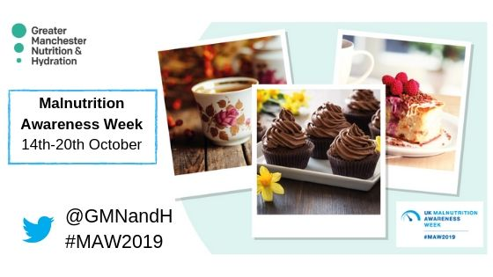

Name of organisation________________________________

Please take a photo with this completed form and share it on twitter with @GMNandH or email it to econnolly@ageuksalford.org.uk

