REQUEST FOR PROPOSAL
COMMUNITY ENGAGEMENT PROJECT:
“OUR HILLSBOROUGH”
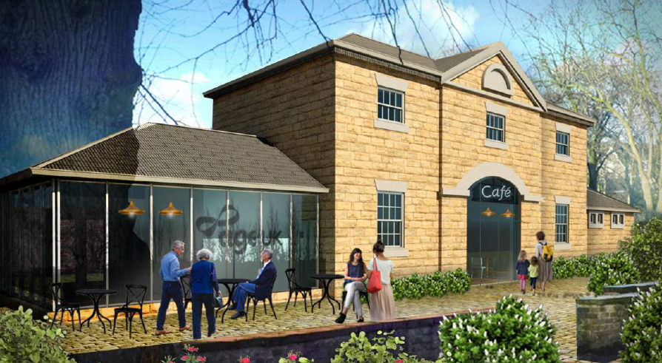
THE OLD COACH HOUSE, HILLSBOROUGH PARK, SHEFFIELD

RfP issued: Friday 5th March 2021
Deadline for seeking clarifications: Thursday 1st April 2021
Deadline for submissions: 9am, Monday 19th April 2021
Selection process: During April
Contract award: By the end of April
Anticipated project start date Tuesday 4th May 2021
Anticipated project completion date By end of October 2021

Clarification requests and submissions should be submitted to steve.chu@ageuksheffield.org.uk by the stated time.
Introduction
Age UK Sheffield has been successful in a bid to the National Lottery Heritage Fund to redevelop a disused Grade II listed building in Hillsborough Park, Sheffield, to become a community café. The ancillary Potting Shed building will become a creative “Makers’ Shed” space and the Hillsborough Park Bowling Pavilion will also be operated by Age UK Sheffield. This campus of facilities will host a programme of activities open to the entire community, with a particular focus on ensuring accessibility for older people, people living with dementia and other long-term health conditions.
Construction work on the new facilities is intended to start in April 2021, with the aim of opening the Coach House café by the end of 2021.
As part of this development, we are now seeking proposals from partners to deliver a range of activity projects to engage people with the heritage of the Old Coach House building, Hillsborough Park, and the wider local community.
About Age UK Sheffield
Age UK Sheffield is a local charity and social enterprise which exists for the benefit of people aged 50 and over in Sheffield. We do that by providing information, advice, representation and services.
We believe our independent living services are unique in Sheffield. We are the only organisation in the city that is totally dedicated to promoting the independence of older people using a holistic, person-centred approach. We believe we have a unique offer to the city in supporting older peoples’ needs, not from the approach of a specific organisation or sector, but as a whole. We seek to understand people's needs and wants to enable them to live fulfilled later lives, and provide the support to maximise their financial, physical and mental wellbeing, and social connectedness.
Project overview
Our Coach House project will:
- Restore the derelict Old Coach House building as a community café;
- Restore the ancillary Potting Shed building as a Makers’ Shed;
- Enable us to take management responsibility for the Hillsborough Park Bowling Pavilion to deliver a programme of enjoyable activities.
We have two main aims for this project:
- To provide us with a beautiful resource in which to deliver dementia-friendly activities and services for older people in Sheffield
- To operate a community cafe as a new income stream which will support the delivery of our charitable work on an ongoing basis.

About the building
Hillsborough House and its outbuildings (including the Old Coach House) were built in 1779 as a dwelling for Thomas Steade (1728-1793) and his wife Meliscent, who had been living 250 yards to the east in Burrowlee House. The Steades were a family of local of landowners whose history went back to at least the 14th century. When built, the house stood in rural countryside well outside the Sheffield boundary. Steade named his new residence in honour of Wills Hill who at the time was known as the Earl of Hillsborough, an eminent politician of the period and a patron of the Steades.
The Coach House was built in a complemenatary Neo-classical style to Hillsborough House with polite architectural details such as the Diocletian window above the main central entrance with simple pedimented gable above the central projecting bay with half round window. Both the House and Coach House were built as a modest country estate for a respected local family in the late 18th Century. In 1993 an extension to the Coach House was built to the north to house a toilet block. These public toilets are no longer in use.
The Old Coach House sits within the Hillsborough Park Conservation Area, which consists of Hillsborough Park itself, sitting within the original boundary of the 18th Century park and garden attached to Hillsborough Hall, as well as a number of buildings which sit outside the park. It benefits from a parkland setting, which features a fishing lake, a bowling green with pavilion, and a playground. The walled memorial garden is immediately adjacent the Old Coach House.
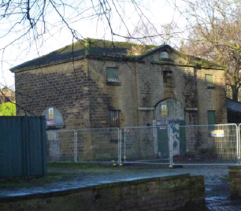

The activity projects
There are six activity projects, which all have some elements of linkage with each other. The six projects are summarised in the table below, with this project highlighted in yellow.
Service Required | Procurement process | Summary
Activity 1: What’s it all about? | Delivered in-house by Age UK Sheffield | A well set-out and managed communications strategy delivered by a PR/Communications specialist that reaches out and engages local people with all aspects of the project from start to finish and records successful interactions in a way that will contribute to the proposed Coach House Timeline Exhibition (Activity 6). This activity is aimed at the general public, park users and special interest groups.  At the end of it, people will have felt informed and engaged with the Restoration Project and many will have learnt about the local heritage associated with the Coach House and have been encouraged to join in with activities that will also encourage skill development.
Activity 2: You can leave your hat on | Delivered by Time Architects | As an integral part of the restoration project our appointed architect will deliver two ‘Hard Hat’ Talks to the general public, one at the start of works and one at an appropriate point near the end of the restoration works. This activity is aimed at the general public, park users and special interest groups.  At the end of it, people will have felt informed and engaged with the Restoration Project and many will have learnt about the local heritage associated with the Coach House and have been encouraged to join in with other activities that will also encourage skill development.
Activity 3: Our Hillsborough | Competitive tender | This is a Community Project to gather key local history stories related to the Old Coach House, the Walled Garden, Hillsborough Hall, Hillsborough Park and the immediate neighbourhood through a Community Project approach. This activity is aimed at local people with an interest in local history.  At the end of it people will have learnt about the local heritage and more importantly they will have developed new skills which could form a foundation for ongoing engagement with the finished exhibition.
Activity 4: Coach House Kids | Competitive tender | An Education/Learning Project that will create a range of renewable learning materials for both formal and informal educational use. The project will deliver a number of renewable learning resources developed from the local history research material designed to engage children from Early Years to KS2 including a Park Kids ‘Treasure Trail’, seasonally-changing café Kids Activity Box material and a National Curriculum KS2 Teachers’ Pack for use in the Park.
Activity 5: Meeting of minds | Competitive tender | A ‘fun/interactive’ project designed to particularly reach out to non-traditional audiences drawn from the local community and the community of park users. Whilst this is delivered as a piece of interactive community theatre the idea is also to capture participation moments by photography, film and in words with a view of allowing parts of this to also form part of the permanent ‘Timeline’ exhibition (Activity 6).  The Project detail is to be developed and managed by an appropriate local Community Theatre Company assisted by the Communication Officer (Activity 1) and any willing local volunteers.
Activity 6: Timeline exhibition | Competitive tender | The design, production and installation of a small, permanent exhibition largely within the Coach House Café that will utilise selected material developed during the activity projects and which helps to bring to life the history of the Coach House in context with the former Hillsborough Hall, the Victorian Park, the fourth-oldest League football club in England and the surrounding Hillsborough neighbourhood as a permanent, fully accessible project legacy.

Consultant Brief: Activity 3: Our Hillsborough
Summary
This is a Community Project to gather key local history stories related to the Old Coach House, the Walled Garden, Hillsborough Hall, Hillsborough Park and the immediate neighbourhood through a Community Project approach. This activity is aimed at local people with an interest in local history. At the end of it people will have learnt about the local heritage and more importantly they will have developed new skills which could form a foundation for ongoing engagement with the finished exhibition.
The Brief
We are seeking a suitably experienced Community History Project Officer to plan and deliver all aspects of this project.
You will be a confident communicator and have skills in organising and delivering community workshops. You will have a strong interest in local history and be familiar with accessing sources of local history material. You will be able to undertake an amount of initial independent research on local stories and the characters that can bring these histories alive to current audiences. You will help participants to learn not only about the local history but to help them to select and interpret material in ways that capture the interests of current audiences.
You will be responsible for organising and delivering four open sessions that will help people learn about heritage and importantly teach them skills in using resource material to select, produce and verify sufficient text and imagery that could be used for a permanent exhibition. Two of these sessions should involve access to archives including the private Sheffield Wednesday archive and Sheffield City Archives.
Your work will make an active contribution to other elements of the activity programme including the ‘Kids Club’ Lesson Plan and Treasure Trail, the Community Theatre event and the Time Line Exhibition. You will provide them with the source material that in turn will help them to develop their projects.
Outputs
- Undertake an initial desk study to locate all easily available source material, to make contact with the Friends of Hillsborough Park and other local heritage groups and to start the process of identifying interesting and engaging stories many of which they will already have collated.
- Organise four workshops which enable FoHP and wider community access to different sources of material and learning experiences around accessing and verifying source material.
- Invite participants to join in on workshops and run each of these.
- Ideally as an integral part working with FoHP, community participants and in conjunction with the exhibition designer, synthesise material into a time line and identify key ‘Character and story line’ development. Note that some initial ‘historical characters’ have already been identified but these may change with and through this project. The aim however is not to provide an exhaustive account of Hillsborough Hall and the Coach House itself to a traditional history audience but to use the material to share a wider story of events using a more inclusive range of ‘voices’ that would have appeal to park users today.
- Map any physical places around the Park, buildings, and Coach House itself which lend themselves to future use in ‘telling the story’ and in setting trail markers.
- Undertake as necessary further checks, permissions, photo rights and verifications on specific material selected for permanent exhibition and associated interpretive material use.
- Support the Communications Officer in collating information and feedback from participants.
- Pass on all material to Interpretive designer, Education Officer and character scripts to Community Theatre Director

Indicative Budget
Up to £3,750 is available to deliver this project for an estimated 15 days of delivery over a 5-6 month period. A further £250 has been set aside for refreshments, participant travel and consumables.
Promotion, communication and recording of events will be undertaken by Age UK Sheffield’s Communications/PR Officer
Reporting To:
Steve Chu, Chief Executive, Age UK Sheffield

Instructions to bidders

Please complete all the blank boxes in pages 8-12. Do not leave any boxes blank. If a section is not applicable or relevant to you, write “N/A” in the box.
This tender will be scored 70% on quality and 30% on price.
How we will score the pricing element
The lowest bid will score 100% of the price marks (30% of the total marks). Other bidders will score price marks compared to the lowest bid. For example:
If the lowest bid is £3,000, that bid will score 100% on price (30% in total).
If another bid is £3,300, that is 10% higher than the lowest bid. That bid would score 90% on price (100% minus 10%) which is equivalent to 27% of the total marks.
Any bid we deem has been priced “abnormally low” will be excluded.
Company information
Question | Your response
Name of the company or sole trader submitting this information
The company’s registered address, or personal address
The company’s website address (if applicable)
Trading status (select one):
- Pa) Public limited company
- Lb) Limited company
- Lc) Limited liability partnership
- Od) Other partnership
- Se) Sole trader
- Tf) Third sector
- gg) Other (please specify your trading status)
Company registration number (if applicable)
Date of registration in country of origin (if applicable)
Charity registration number (if applicable)
Registered VAT number (if applicable)

Relevant experience
Please provide details of between one and three similar projects you have delivered in the past five years.

 | Project 1 | Project 2 | Project 3
Name of project
One-sentence summary
Which organisation did you deliver this project for?
Please provide the name and e-mail address of a contact at that organisation who could give us feedback about your delivery of the project
Approximately, what was the budget for this project?

Self-certification
Please self-certify whether you have, or can commit to, ensuring the following prior to the opening of the café. Evidence may be sought at a later date.
If Not Applicable, please state why this is not required for this project.
Item | Your response (Yes/No/NA)
Employer’s liability insurance (£5 million)
Public liability insurance (£5 million)

How you would deliver this project

In no more than 1,000 words, please describe how you would deliver this project, including:
- Your overall vision for the project;
- How you will approach the research element of the project;
- How you will design and deliver the workshops;
- How you will work with local groups, ourselves, and people delivering our other activity projects;
- The experience which you believe makes you the right person/company to deliver this project for us.
If you would like, you may include a small number of illustrative documents (eg. photos, videos or website pages) with your submission, in addition to the 1,000 words.

Price
Please state your quote for this project by completing the blank box below. There is an additional £250 available to support participant travel and refreshment expenses – please disregard this for the purposes of this tender, and do not include that sum in your quote.
The maximum budget available is £3,750 for an estimated 15 days of delivery over a 5-6 month period. Please ensure you include all your costs within the stated price.
Price | £

Contact details and declaration
I declare that to the best of my knowledge the answers submitted and information contained in this document are correct and accurate.
I declare that, upon request and without delay, I will provide any certificates or documentary evidence required to support claims made in this document.
I understand that the information will be used in the selection process to assess my organisation’s suitability to be invited to participate further in this procurement.
I understand this submission may be rejected in its entirety if there is a failure to answer all the relevant questions fully, or if false/misleading information or content is provided in any section.
I am aware of the consequences of serious misrepresentation.
Contact name
Name of company
Role in company
Phone number
E-mail address
Postal address
Signature (electronic is acceptable)
Date

Please submit your proposal to steve.chu@ageuksheffield.org.uk by 9am on Monday 19th April 2021.

