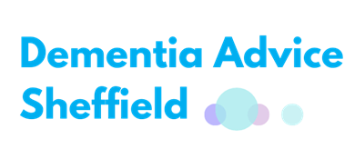
Dementia Friendly New Years
Resolution
The start of a new year is a chance to have a fresh view, clean slate, and opportunity to try new things. Here at Dementia Advice Sheffield, we want to set a new year’s challenge for all
our colleagues and individuals currently working with people living with dementia.
Language Matters
People living with dementia undoubtedly face a disproportionate amount of discrimination and stigma in everyday life, be that through access to work, transport, benefits, social opportunities or social care. We are all familiar with the ‘big topics’ affecting those with dementia, but (ironically) little is spoken about regarding the way our language and choice of words can add to stigma and negative stereotyping.
As Trish O’Hara (2014) demonstrates in her infographic below, the way people living with dementia, their feelings or their needs are commonly described can impact directly on the way society treats individuals living with the condition.
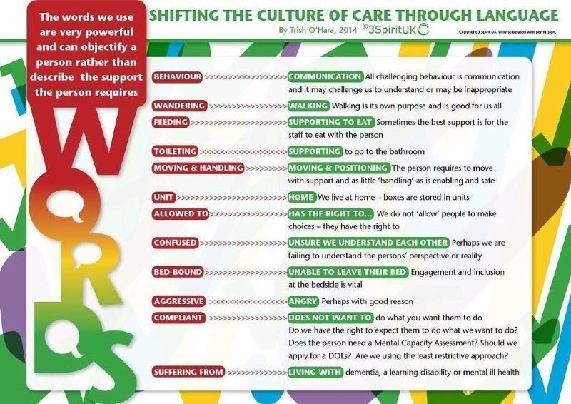
One of the most common examples of careless language choices with regards to dementia is labelling people who are expressing their feelings as being ‘aggressive’. When we start to understand that people’s actions and words are simply an expression of their emotions, we can start to understand why somebody may appear withdrawn, frustrated or irritated.
For example, Mr Smith might want to walk around a hospital ward because he is bored or in an unfamiliar environment or to merely stretch his legs. Staff may deem that as being disruptive or unsafe because he may no longer be in an area he can easily be seen by staff. Rather than enabling Mr Smith to walk safely, staff may insist he sits down, or put restrictions in place to make him do so. Naturally this would infuriate anyone, as it removes freedom, autonomy and choice. When Mr Smith expresses these frustrations in ways he still can, he may get labelled as having ‘challenging behaviour’ or being ‘disruptive’ and ‘aggressive’.
In similar situations, someone who had broken their arm may be encouraged and enabled to remain mobile, independent and in control of their daily choices. Any bad feelings towards their situation would likely be regarded as a natural expression of frustration, pain or boredom, otherwise known as normal human responses.
This is just one of the many examples we could all share to demonstrate ways in which our choice of words can impact so prominently on people’s experiences of services. Ian Donaghy illustrates this concept beautifully in his book, ‘Dear Dementia’
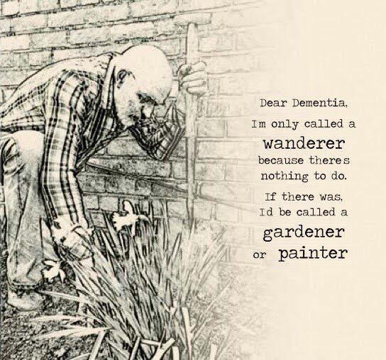
Changing Language Today
It is striking how much influence words have on the way we view & treat people, which in turn can be hugely influential on the way somebody views themselves and their own self-worth. Life with dementia can undoubtedly be difficult and uncertain, but it can also be filled with joy, laughter, purpose, significance and joie de vivre!
When the way people living with dementia express themselves is described negatively, the onus is on us to improve our compassion, understanding and communication. That is why Dementia Advice Sheffield is setting the #languagematterschallenge for 2020.
Send us ways you and your organisation have worked to positively change language around dementia and you could feature as our dementia friendly star of the month! You can enter your #languagematterschallenge nominations via any of the contact details below.
#LanguageMattersChallenge

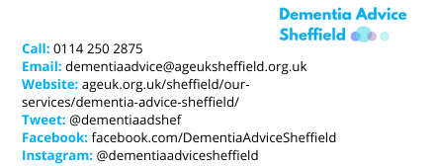

A Final ‘Word’
Language around dementia has the potential to be inspirational, encouraging, positive and compassionate. Let’s use the New Year and the whole of 2020 to positively transform the way dementia is spoken and written about. Kindness, dignity, caution & respect cost nothing but time and consideration.

Some really helpful resources and further reading on this topic
Language Around Dementia Guide:
A guide from the Alzheimer’s society
https://www.alzheimers.org.uk/sites/default/files/2018-09/Positive%20language%20guide_0.pdf
Language you should and shouldn’t use:
A guide from DEEP, which is an involvement and empowerment group made up of people living with dementia about what language you should and should not use when talking to or about somebody living with dementia
http://dementiavoices.org.uk/wp-content/uploads/2015/03/DEEP-Guide-Language.pdf
Impacts of negative language research:
A research article in The Lancet journal about how negative language can disable people living with dementia more than the disease itself
https://www.thelancet.com/action/showPdf?pii=S0140-6736%2810%2961286-X
101 Reasons:
Reasons which might help to explain the way people with dementia express their needs, commonly mislabelled as ‘challenging behaviour’
http://myalzheimersstory.com/2017/11/25/101-potential-causes-of-behaviours-by-people-living-with-dementia-that-institutional-care-staff-may-find-challenging/
Personal Insight and experience of the stigmatising impact of words:
Kate Swaffer lives with early onset dementia and blogs about her experiences. Here she talks about how our language can stigmatise and marginalise people living with dementia
https://kateswaffer.com/2018/09/03/rethinking-dementia-normal-human-responses-2/
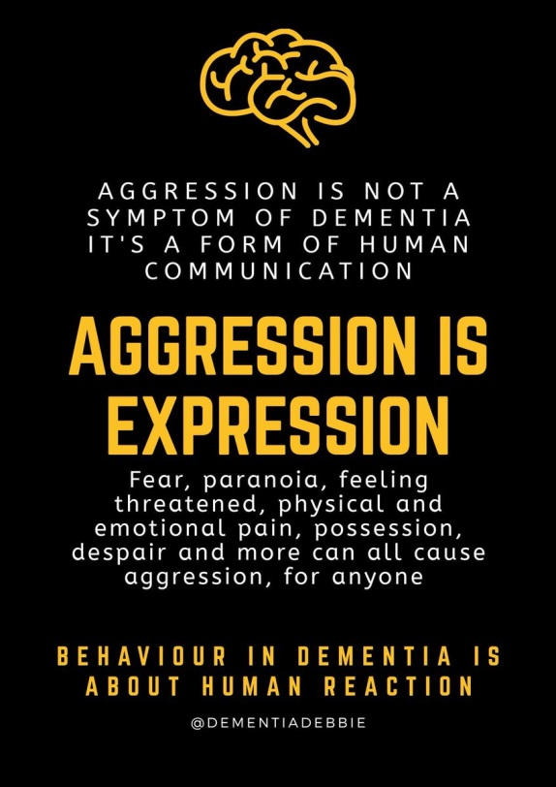
For specific advice & information contact Sheffield’s Dementia Advice Service:
0114 250 2875
dementiaadvice@ageuksheffield.org.uk

