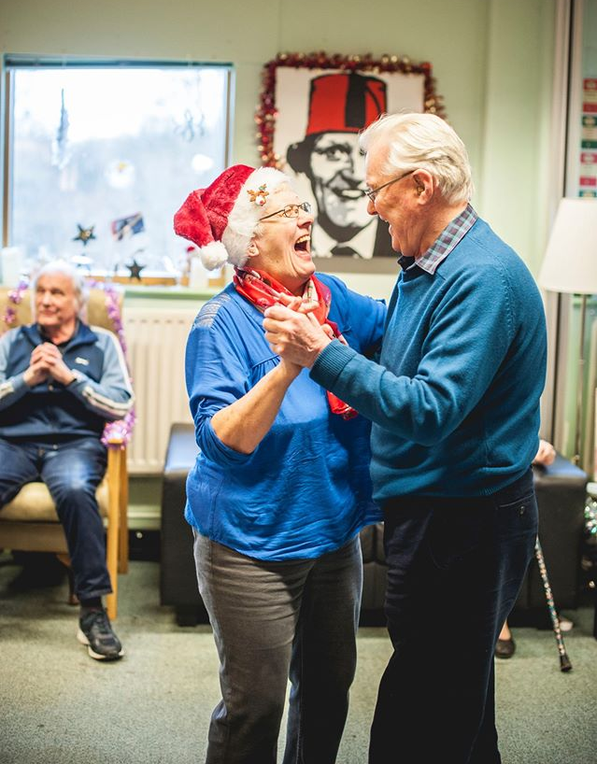
Having a Dementia Friendly approach
this Christmas Time
Christmas is a fantastic time of year to bring people
together, celebrate and start to unwind a little. Whilst
this is the case for many people, some people living with
dementia in their lives can find the festive season difficult
for a number of reasons.
For people living with dementia
Christmas can be a sensory overload which makes it difficult
to process information, follow conversations and feel relaxed
in what can often be noisy and bright environments. This in
turn can cause a person living with dementia to become
withdrawn, anxious, worried and overwhelmed.
Christmas is typically a time when the hustle and bustle of daily life ceases, and we start to do things at different times and in different locations. This loss of routine can be confusing and disorientating for people living with dementia. Predictability helps people with dementia navigate their lives more independently, and so disruptions to this can be worrying. In addition, quick and significant changes can be difficult for a person with dementia to make sense of or process, for example decorating a house for Christmas may make it difficult for somebody to recognise it as their own.
With Winter only just arriving, darker evenings and lack of sunlight can sometimes make people living with dementia feel disorientated. For example, a person may muddle daytime and night time routines, making them more tired and confused during the day. Darker evenings may also cause a person with dementia to have a very urgent sense that they need to be somewhere else, like work or to pick children up from school. This is often referred to as sundowning, but describes a set of feelings being experienced by someone with dementia.
A person with dementia may have always been the lynchpin of a family Christmas. Sometimes, through no fault of their own, a person’s family and friends may take away old responsibilities or roles over the festive season, to try and help the person relax or prevent harm. For example, somebody’s family may take over cooking on Christmas Day when their loved one may be used to doing this for many years. Whilst this comes from a place of care and love, it may cause a person with dementia to feel a sense of loss of their identity and purpose. For some, this can have implications on self-worth, confidence and mental wellbeing.
For carers, family or friends of people living with dementia
Christmas can mean juggling lots of responsibilities at once, from buying gifts, writing cards, food shopping, visiting family and friends, attending children’s nativity’s, decorating the house to name but a few. Add caring for a person with dementia on top of all that and it becomes easier to understand why the festive season may be a particularly unenjoyable one with high levels of stress, pressure and worry.
Stigma around dementia and a lack of understanding can cause carers to feel anxious about how friends and family might react to a person’s changing personality, expressions or abilities.
Christmas is a typically a reflective time filled with nostalgia. Whilst it can be mutually beneficially to reminisce, it can also stir up feelings and emotions of grief, thinking about times when a loved one didn’t have dementia.
Typically, support services close for at least a week over the festive period, meaning that family carers may lose out on respite, support and routine.

How you and your organisation can help
one.

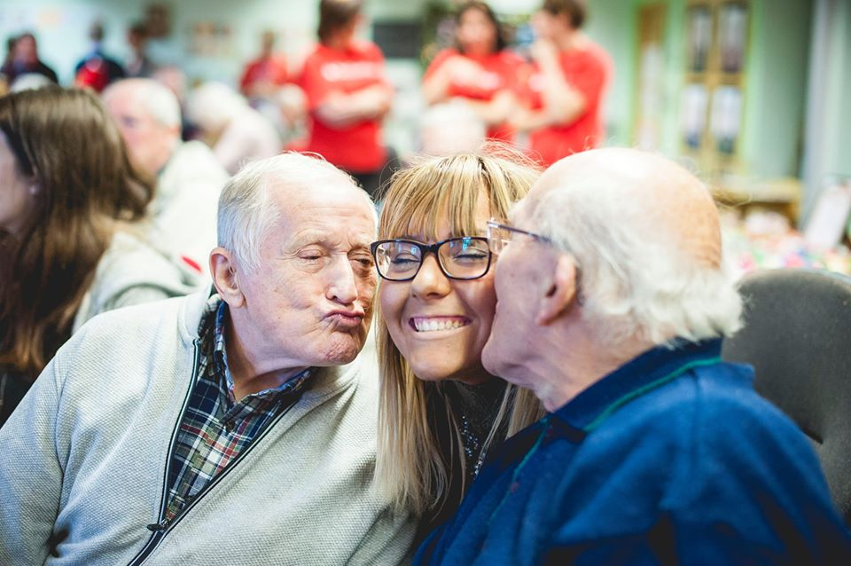
How you or your organisation can help
Create opportunities for people to get together and enjoy themselves. That could involve music, baking, decorating a community Christmas tree, watching a local schools nativity play, painting baubles or simply just getting together for a chat. Ensure the emphasis is on togetherness, enjoyment or empowerment.
You could share ways a person with dementia can still be involved with previous traditions. For example, even if it is no longer appropriate for someone to cook, they could still be involved with setting the table, reading a recipe, stirring a mixture… Get creative in your suggestions!
Put on activities and events earlier in the day when it is still light and provide quiet spaces away from the main event for people who may need some time out.
Offer a supportive, listening ear free of judgement. Sometimes that’s all a person needs.

Further reading and resources
https://www.dementiauk.org/tips-for-dementia-care-at-christmas/
https://www.dementiauk.org/helping-a-relative-with-dementia-have-a-peaceful-christmas/
https://www.alzheimers.org.uk/blog/how-support-somebody-dementia-christmas
For specific advice & information contact Sheffield’s Dementia Advice Service:
0114 250 2875
dementiaadvice@ageuksheffield.org.uk

