Activity Pack

We know these are difficult times so we thought we would create something to keep you occupied. We hope it helps.

Page 2 Quiz
Page 3 Jokes
Page 4 Word search
Page 5 They said poetry
Page 6 Drawing challenge and hand jive
Page 7 Read: Jabberwocky by Lewis Carroll
Page 8 Star Gazing
Page 9 Who stole the jam tarts?
Page 10 Maths quiz and maze
Page 11 Colour
Page 12 Create a picture
Page 13 Quiz Answers
Page 14 Maths quiz answers and maze solution

Quiz
Finish the saying

As steady as _______________

As straight as ______________

As sour as _______________

As sober as _______________

Questions

‘On the street where you live’, ‘A hymn to him’ and ‘Get me to the church on time’ feature in which musical?

What is the capital of Australia?

What is the only vowel not on the top line of a QWERTY keyboard?

How often are the commonwealth games held?

In what year did the battle of Hastings take place?

How many can you get?

Name all the characters who try to see the Wizard in the Wizard of Oz.

Name all the countries beginning with the letter A.

Name the British football players who have won the Ballon D’or

Jokes

Why did the student eat his homework?

Because the teacher said it would be a piece of cake!

How do you stop an astronaut’s baby crying?

You rocket!

Why are ghosts bad liars?

Because you can see right through them!

What did the paper say to the pencil?
Write on!

Word search

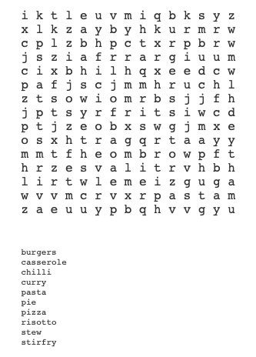

They said Poetry
They said.......

So I listened.....

They did not......

So I waited....

They......

So I watched.....

Then I finally.....

Drawing Challenge

Draw something:
- Orange
- You need
- Brand new

It’s up to you what you draw with these challenges, it can mean something different for you than it might be for someone else.

Use different forms if you have them paint, pencils, felt tips, chalk, crayons. These can be helpful to layer up and bring texture if they suit your drawing.

Hand Jive

Why not put on some music and hand jive?

- Pat your thighs twice
- Clap twice
- Crisscross your hands twice
- Tap your fists together twice
- Using a thumbs up sign, move your hand up towards one shoulder and then the other
- Repeat

Read: Jabberwocky by Lewis Carroll

’Twas brillig, and the slithy toves
Did gyre and gimble in the wabe:
All mimsy were the borogoves,
And the mome raths outgrabe.

“Beware the Jabberwock, my son!
The jaws that bite, the claws that catch!
Beware the Jubjub bird, and shun
The frumious Bandersnatch!”

He took his vorpal sword in hand;
Long time the manxome foe he sought—
So rested he by the Tumtum tree
And stood awhile in thought.

And, as in uffish thought he stood,
The Jabberwock, with eyes of flame,
Came whiffling through the tulgey wood,
And burbled as it came!

One, two! One, two! And through and through
The vorpal blade went snicker-snack!
He left it dead, and with its head
He went galumphing back.

“And hast thou slain the Jabberwock?
Come to my arms, my beamish boy!
O frabjous day! Callooh! Callay!”
He chortled in his joy.

’Twas brillig, and the slithy toves
Did gyre and gimble in the wabe:
All mimsy were the borogoves,
And the mome raths outgrabe.

Star gazing

Find a comfortable spot to look out of your window or to sit in your garden. Turn the lights off and stare up into the night sky.

Look out for:

Ursa Major

Orion’s belt

Orion’s Bow

Who stole the jam tarts?

Earlier today someone ate the jam tarts I left on the side. They left only crumbs and a splodge of jam where the jam tarts were.

Can you work out who stole them?

Name

___________ __________ _________ _________ ___________

The one in the middle is called Christa.

The tallest is called Chris.

To the right of Chris is Christie.

Chrissy is the smallest.

Christine is at the other end to Chris.

The one at the other end to Chris was feeling sick.

The one to the right of Chris was sick of his indigestion.

The smallest said she was already eating a hamburger.

Peter was reading.

The middle one said it couldn’t be her as she had already eaten some crisps.

Use the first letter of the excuses and rearrange to work out who stole the Jam Tarts and circle them above.

Maths quiz

If a melon costs £1.55 but it has a 20% off sticker on it how much does the melon cost now?

If Aldi sells 375,877 bags of chocolate buttons, Tesco sells 355,678 and Lidl sells 365,800 who sells the least?

What is 8765 + 987 =

What is next in the sequence 8, 15, 29, 57,

Maze

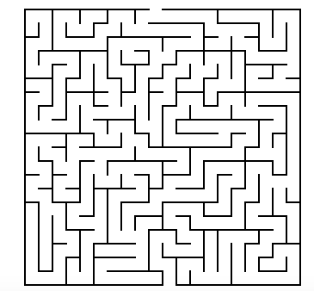

Colour

Create a picture

Quiz Answers
Finish the saying

As steady as __a rock_____________

As straight as ___an arrow___________

As sour as ____vinegar___________

As sober as __as a judge_____________

Questions

‘On the street where you live’, ‘A hymn to him’ and ‘Get me to the church on time’ feature in which musical? My fair lady.

What is the capital of Australia? Canberra

What is the only vowel not on the top line of a QWERTY keyboard? A

How often are the commonwealth games held? Every 4 years.

In what year did the battle of Hastings take place? 1066

How many can you get?

Name all the characters who try to see the Wizard in the Wizard of Oz.

Lion, Tinman, Dorothy and the Scarecrow.

Name all the countries beginning with the letter A.

Afghanistan, Albania, Algeria, Andorra, Angola, Antigua and Barbuda, Argentina, Armenia, Australia, Austria, Azerbaijan

Name the British football players who have won the Ballon D’or

Sir Stanley Mathews, Denis Law, Bobby Charlton, George Best, Kevin Keegan, Michael Owen.

Maths quiz answers

If a melon costs £1.55 but it has a 20% off sticker on it how much does the melon cost now? £1.24

If Aldi sells 375,877 bags of chocolate buttons, Tesco sells 355,678 and Lidl sells 365,800 who sells the least? Aldi

What is 8765 + 987 = 9752

What is next in the sequence 8, 15, 29, 57, 113, 225.

Who stole the Jam tarts solution

Chris

Maze solution

