

Apply for a 2027 Double TCS London Marathon Charity Place in aid of Age UK Solihull

Please complete this form for your chance to secure one of our limited places for the 2027 Double TCS London Marathon on Saturday 24 April 2027.
We ask that you raise a minimum sponsorship of £2,250
We will be on hand every step of the way to help you with that target.

About you
Name:
Date of birth:
Address:
Email address:
Phone number:

About your fundraising
Why would you like to run for Age UK Solihull?
Please provide as much detail as possible here. Tell us about any personal connection you have to our charity or to the challenges faced by older people.
The minimum sponsorship commitment is £2,250 but of course we’d love you to raise as much as you can. How will you raise the money? Please tell us about your fundraising plans and how you will promote them, including as much detail as possible.

Have you completed a marathon before?
What other experience of running do you have?
Did you enter the London Marathon 2027 ballot?
Have you supported Age UK Solihull before?

About your employer
What is your job?
What is the name of your employer?
Does your employer have a matched giving scheme?

Please let us know how you heard about Age UK Solihull’s places in the 2027 Double TCS London Marathon and what prompted you to apply to us.

Terms & Conditions
- I agree to Age UK Solihull using my information to enable my participation in this Event. I consent to the Charity contacting me about fundraising, this challenge and future events.
- I acknowledge the registration fee is non-refundable and not part of the minimum fundraising commitment. I acknowledge this is a fundraising event and I commit to raise at least the minimum amount, excluding Gift Aid.
- I acknowledge I am physically capable of undertaking the challenge and if I have a medical condition will seek advice prior to participating. I participate at my own risk, and Age UK Solihull will not be liable for any injury, loss or damage as a result of my participation.
- I will follow and adhere to all instructions given by the event organisers.
- I consent to photographs or footage taken at the event being used for Age UK Solihull promotional/marketing purposes, in print or social media.
If at any time I would like to change or withdraw these consents I will notify the Charity in writing.
Signed:
Print Name:
Date:
We know that your personal information needs to be kept safe and we never give or sell any personal data to other charities or organisations. Please see our Privacy Policy for more information at ageuk.org.uk/Solihull/privacy-policy

And Finally…

Thank you for your interest in running for Age UK Solihull!
We will let you know whether your application has been successful.

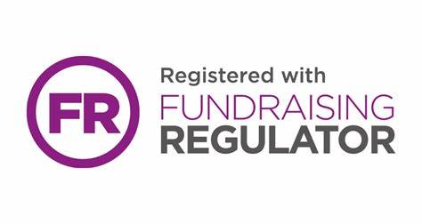
Charity Registration Number: 1055887
Registered Office: The Core, Homer Road, Solihull, West Midlands B91 3RG
Tel: 0121 704 7842
Website: www.ageuksolihull.org.uk
E-mail: fundraising@ageuksolihull.org.uk

