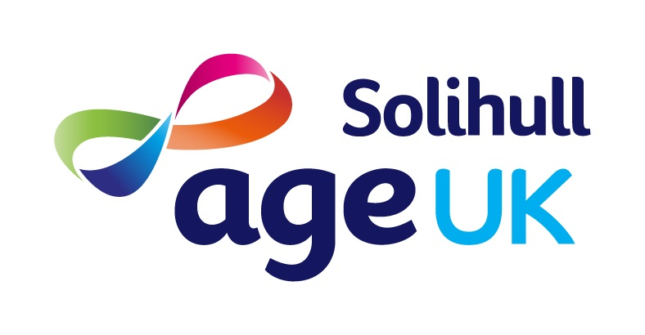

Age UK Solihull Client Information Leaflet

Data Protection and Privacy Notice
It is important to let you know how we use information and how we ensure that it cannot be misused in any way. Age UK Solihull is compliant with the General Data Protection Regulation (GDPR) 2018.
Age UK Solihull is an independent Charity, we provide a range of services to residents of Solihull and carers of residents of Solihull. Most of our services are focussed on the needs of older people, however we do provide some services for all age groups, including the Community Advice Hubs and the Direct Payments Information and Advice Service. Age UK Solihull receives funding from Solihull Council, Birmingham and Solihull CCG, other external agencies, grant-making trusts and, we fundraise locally.
In the course of providing services to you, Age UK Solihull will collect, record and store your personal information. We require your explicit consent to do this. We will only ask you for personal information that is relevant to the service(s) we are providing you with. The type of personal information we require will depend upon the service(s) you are using. The basic data we record includes:
- Name, address, telephone number and an email address if available
- Gender, age and ethnicity

Some services will require more personal information, which may include:

- Marital Status
- GP Practice
- Next of Kin
- Household tenure
- Disability, medical and health information

Information we take from you will be held securely on Age UK Solihull’s database, Charitylog which can only be accessed by relevant Age UK Solihull employees and volunteers. The Home Support Service also records and stores personal information onto a Scheduling Roster called StaffPlan. This is only accessible to Home Support Service employees.
In order to fully meet your individual needs we may need to work with other organisations to ensure you receive all the services you require. With your consent we may share relevant information about you with organisations who you agree should be involved in your support, this would usually be another voluntary service or an organisation such as Adult Social Care.
We will not use your data in a way you would not wish. We may give some statistical data to our funders, however this will always be anonymous and not contain any information that could identify you.
Age UK Solihull will only disclose your personal information without your consent when we are required to by law. We may also provide relevant information to medical personnel or other professionals in case of an emergency when you are under our care or we believe you are at immediate risk. We will always work in your best interests.

Your personal details will remain on our database only for as long as it is relevant to store them (this may depend on the issue(s) we have supported you with or who we are funded by). You have the right to expect your personal information to be accurate. You have the right to ask for certain personal data to be erased. You have the right to withdraw your consent at any time. You have the right to request access to any personal information Age UK Solihull holds about you. This is known as a Subject Access Request. You can find out more about this on our website at www.ageuksolihull.org.uk or by telephoning 0121 704 7840.
If you have any specific questions about how we use your information or look after it, please contact the Age UK Solihull Head of Services on 0121 704 7840. If you think your data rights have been breached, you are able to raise a complaint with the Information Commissioner (ICO). You can contact the ICO at Information Commissioner's Office, Wycliffe House, Water Lane, Wilmslow, Cheshire SK9 5AF or by telephone on 0303 123 1113 (local rate) or 01625 545 745.

A full Privacy Notice can be found on our website www.ageuksolihull.org.uk or please ask for a copy.

Safeguarding
Age UK Solihull will not tolerate any form of abuse and believes that all people have the right to live in an environment free from abuse.

Equality and Diversity
We operate under an Equalities and Diversity Policy that is available upon request.
Accessible Information
You can request information relating to this service in formats to suit your communication and/or information needs if you have a disability, impairment or sensory loss.
Complaints
A full copy of our Complaints Policy is available upon request.
Age UK Solihull believes that those using its services should find it easy to make a complaint and/or register a concern. It is our policy to welcome complaints and look upon them as an opportunity to learn, adapt, improve and provide better services. All complaints or comments by service users and their relatives and carers are taken seriously.

Monitoring Our Service
Age UK Solihull aims to provide the highest standard of services possible. We may ask you for your opinion on the service you have received from us, whether you were satisfied and whether you would recommend the service to others. Unless you tell us otherwise, this information will only be used anonymously.

Physical or Verbal abuse
Under no circumstances will any type of abuse towards employees or others in this organisation be tolerated. We will cease to help anyone who shows any type of abuse to people within this organisation.

Age UK Solihull is an independent Charity – Number 1055887 and a company limited by guarantee – Number 3180062.
Registered Office : The Core, Homer Road, Solihull B91 3RG
Telephone Number : 0121 704 7840 Website : www.ageuksolihull.org.uk

