

SAFEGUARDING ADULTS

POLICY AND PROCEDURES

This Policy refers to Age UK Solihull’s commitment to minimising the risk of abuse to individuals who receive
Age UK services and to supporting people who disclose that they are being abused by someone else. ‘Safeguarding is everybody’s business’.

Adopted by the Directors of Age UK Solihull at the Board of Trustees Meeting on .....................................................

Signed on behalf of the Directors

..........................................................

Chairman

All Age UK Solihull Policies are subject to an annual desktop review and will be presented to the Board of Trustees for adoption in light of any changes made.

Initial Date: May 2005
Reviewed Date: August 2017

Details of Review Dates

Initial Date: May 2005

August 2017

Age UK Safeguarding Adults Policy and Procedures

Content | Page
Introduction | 4
Safeguarding and The Care Act 2014 | 5
Mental Capacity | 9
Deprivation of Liberty | 10
Domestic Abuse | 11
Hate Crime | 12
Forced Marriage | 12
Whistleblowing | 13
Safe Recruitment | 13
Training | 14
Procedures for Reporting and Recording Adult Safeguarding | 14
Managing Allegations Against Employees and Volunteers | 17
West Midlands Multi-agency Policy and Procedures | 20
Monitoring of the Policy | 20
Appendix 1 – Solihull SAB MCA and DoLs Guidelines 21

- Introduction

- Age UK Solihull is a member of Solihull’s Multi-agency Safeguarding Adults Board which meets quarterly.

- Age UK Solihull adheres to the West Midlands Multi-agency Policy and Procedures for the protection of adults with care and support needs.

- This Policy replaces all previous Policy documents and reflects the new legal requirements of the Care Act 2014, together with its associated guidance. The Care Act 2014 replaces the ‘No Secrets’ Guidance.

- Age UK Solihull will work with and provide information to the Solihull Safeguarding Adults Board as requested.

- Safeguarding means protecting an adult’s right to live in safety, free from abuse and neglect. It is about people and organisations working together to prevent and stop both the risks and experience of abuse or neglect, while at the same time making sure that the adult’s wellbeing is promoted including, where appropriate, having regard to their views, wishes, feelings and beliefs in deciding on any action. This stance recognises that adults sometimes have complex interpersonal relationships and may be ambivalent, unclear or unrealistic about their personal circumstances.

- The safeguarding duties apply to an adult who:

- has needs for care and support (whether or not the local authority is meeting any of those needs),and;
- is experiencing, or is at risk of, abuse or neglect, and;
- as a result of those care and support needs is unable to protect themselves from either the risk of, or the experience of abuse or neglect.

- Age UK Solihull employees and volunteers will be vigilant about adult safeguarding and recognise we are often well placed to notice changes in people and their behaviour that may indicate they are being abused or neglected.

- Types and patterns of abuse - this is not intended to be an exhaustive list, but an illustrative guide as to the sort of behaviour which could give rise to a safeguarding concern. What constitutes abuse or neglect can take many forms and the circumstances of the individual case will always be considered.

- Types of abuse include:

- Physical Abuse
- Domestic abuse
- Sexual Abuse
- Psychological Abuse
- Verbal Abuse
- Financial or Material Abuse
- Modern Slavery
- Discriminatory Abuse
- Organisational Abuse
- Neglect and Acts of Omission
- Self-neglect

- Age UK Solihull is committed to supporting the right of adults at risk to be safeguarded from abuse and ensuring that all employees and volunteers work together in accordance with this Policy and act promptly in investigating allegations or suspicions of abuse. It is recognised that adults at risk from specific key groups may experience discrimination and less favourable treatment on the grounds of their age; disability; race; colour; ethnic or national origin; financial or economic status; gender or marital status; HIV status; homelessness or lack of a fixed address; political view or trade union activity; religion or belief; sexuality; or unrelated criminal convictions. We will take positive steps to stop any unfair/unlawful discrimination, and carry out positive action where lawful.

- Safeguarding and The Care Act 2014

Safeguarding means protecting an adult’s right to live in safety, free from abuse and neglect. It is about people and organisations working together to prevent and stop both the risks and experience of abuse or neglect, while at the same time making sure that the adult’s wellbeing is promoted including, where appropriate, having regard to their views, wishes, feelings and beliefs in deciding on any action. This must recognise that adults sometimes have complex interpersonal relationships and may be ambivalent, unclear or unrealistic about their personal circumstances. Organisations should always promote the adult’s wellbeing in their safeguarding arrangements. People have complex lives and being safe is only one of the things they want for themselves. Professionals should work with the adult to establish what being safe means to them and how that can be best achieved. Professionals and other employees should not be advocating “safety” measures that do not take account of individual wellbeing.

‘Wellbeing’ is defined in Section 1 of the Care Act (2014) as follows: Wellbeing, in relation to an individual, means that individual’s well-being so far as relating to any of the following:
(a) personal dignity (including treatment of the individual with respect);
(b) physical and mental health and emotional well-being;
(c) protection from abuse and neglect;
(d) control by the individual over day-to-day life (including over care and support, or support, provided to the individual and the way in which it is provided);
(e) participation in work, education, training or recreation;
(f) social and economic well-being;
(g) domestic, family and personal relationships;
(h) suitability of living accommodation;
(i) the individual’s contribution to society.

The following six key principles must underpin all adult safeguarding work:

Empowerment – People being supported and encouraged to make their own decisions and informed consent. “I am asked what I want as the outcomes from the safeguarding process and these directly inform what happens.”

Prevention – It is better to take action before harm occurs. “I receive clear and simple information about what abuse is, how to recognise the signs and what I can do to seek help.”

Proportionality – The least intrusive response appropriate to the risk presented. “I am sure that the professionals will work in my interest, as I see them and they will only get involved as much as needed.”

Protection – Support and representation for those in greatest need. “I get help and support to report abuse and neglect. I get help so that I am able to take part in the safeguarding process to the extent to which I want.”

Partnership – Local solutions through services working with their communities. Communities have a part to play in preventing, detecting and reporting neglect and abuse. “I know that staff employees treat any personal and sensitive information in confidence, only sharing what is helpful and necessary. I am confident that professionals will work together and with me to get the best result for me.”

Accountability – Accountability and transparency in delivering safeguarding. “I understand the role of everyone involved in my life and so do they.”

In addition to these principles, it is also important that all safeguarding partners take a broad community approach to establishing safeguarding arrangements. It is vital that all organisations recognise that adult safeguarding arrangements are there to protect individuals. We all have different preferences, histories, circumstances and life-styles, so it is unhelpful to prescribe a process that must be followed whenever a concern is raised.

The response to safeguarding concerns must be personal to the individual.

Making Safeguarding Personal means it should be person-led and outcome-focused. It engages the person in a conversation about how best to respond to their safeguarding situation in a way that enhances involvement, choice and control as well as improving quality of life, wellbeing and safety.

  - Aims
The aims of adult safeguarding are to:

- stop abuse or neglect wherever possible;
- prevent harm and reduce the risk of abuse or neglect to adults with care and support needs;
- safeguard adults in a way that supports them in making choices and having control about how they want to live;
- promote an approach that concentrates on improving life for the adults concerned;
- raise public awareness so that communities as a whole, alongside professionals, play their part in preventing, identifying and responding to abuse and neglect;
- provide information and support in accessible ways to help people understand the different types of abuse, how to stay safe and what to do to raise a concern about the safety or well-being of an adult, and;
- address what has caused the abuse or neglect.

2.2 Who do we safeguard?
The safeguarding duties apply to an adult who:

- has needs for care and support (whether or not the local authority is meeting any of those needs), and;
- is experiencing, or is at risk of, abuse or neglect, and;
- as a result of those care and support needs is unable to protect themselves from either the risk of, or the experience of abuse or neglect.

Workers need to be vigilant about adult safeguarding in all walks of life including health and social care, welfare, policing, banking, fire and rescue services, trading standards, leisure services, faith groups and housing. GPs, in particular, are often well placed to notice changes in and adult that may indicate they are being abused or neglected.

2.3 Types of abuse
This is not intended to be an exhaustive list, but an illustrative guide as to the sort of behaviour which could give rise to a safeguarding concern. What constitutes abuse or neglect can take many forms and the circumstances of the individual case should always be considered.

Types of abuse include:

Physical abuse – including assault, hitting, slapping, pushing, misuse of medication, restraint or inappropriate physical sanctions.

Domestic abuse – including psychological, physical, sexual, financial, emotional abuse; so called ‘honour’ based violence.

Sexual abuse – including rape, indecent exposure, sexual harassment, inappropriate looking or touching, sexual teasing or innuendo, sexual photography, subjection to pornography or witnessing sexual acts, indecent exposure and sexual assault or sexual acts to which the adult has not consented or was pressured into consenting.

Psychological abuse – including emotional abuse, threats of harm or abandonment, deprivation of contact, humiliation, blaming, controlling, intimidation, coercion, harassment

Verbal abuse, cyber bullying, isolation or unreasonable and unjustified withdrawal of services or supportive networks.

Financial or material abuse – including theft, fraud, internet scamming, coercion in relation to an adult’s financial affairs or arrangements, including in connection with wills, property, inheritance or financial transactions, or the misuse or misappropriation of property, possessions or benefits.

Modern slavery – encompasses slavery, human trafficking, forced labour and domestic servitude. Traffickers and slave masters use whatever means they have at their disposal to coerce, deceive and force individuals into a life of abuse, servitude and inhumane treatment.

Discriminatory abuse – including forms of harassment, slurs or similar treatment; because of race, gender and gender identity, age, disability, sexual orientation or religion.

Organisational abuse – including neglect and poor care practice within an institution or specific care setting such as a hospital or care home, for example, or in relation to care provided in one’s own home. This may range from one off incidents to on-going ill-treatment. It can be through neglect or poor professional practice as a result of the structure, policies, processes and practices within an organisation.

Neglect and acts of omission – including ignoring medical, emotional or physical care needs, failure to provide access to appropriate health, care and support or educational services, the withholding of the necessities of life, such as medication, adequate nutrition and heating.

Self-neglect – This covers a wide range of behaviour neglecting to care for one’s personal hygiene, health or surroundings and includes behaviour such as hoarding.

2.4 Patterns of Abuse Incidents
Patterns of abuse may be one-off or multiple, and affect one person or more. Professionals and others should look beyond single incidents or individuals to identify patterns of harm. Repeated instances of poor care may be an indication of more serious problems and of what we now describe as organisational abuse. In order to see these patterns it is important that information is recorded and appropriately shared.

2.5 Who abuses and neglects adults?
Anyone can carry out abuse or neglect, including:

- spouses/partners
- other family members
- neighbours
- friends
- local residents
- acquaintances
- people who deliberately exploit adults they perceive as vulnerable to abuse
- paid employees or professionals
- volunteers and strangers.

Abuse can happen anywhere, for example, in someone’s own home, in a public place, in hospital, in a care home or in college. It can take place when an adult lives alone or with others. Neglect can be intentional or unintentional and it is important to understand that being unintentional does not mean it is not abusive.

2.6 Independent Advocacy and the Duty to Involve
Local Authorities have a duty to involve the adult in a Safeguarding Enquiry. Involvement requires supporting the adult to understand how they can be involved, how they can contribute and take part, and lead or direct the process.

The Care Act requires that each local authority must arrange for an independent advocate to represent and support an adult who is the subject of a Safeguarding Enquiry or Safeguarding Adult Review where the adult has ‘substantial difficulty’ in being involved in the process and where there is no other suitable person to represent and support them.

Where an independent advocate has already been arranged under section 67 of the Care Act or under MCA 2005 then, unless inappropriate, the same advocate should be used. Advocacy should be seamless for people who qualify, so that they can benefit from the support of one advocate for their whole experience of care or safeguarding work. People who have ‘substantial difficulty’ in engaging should not be expected to have to tell their story repeatedly to different advocates.

If a safeguarding enquiry needs to start urgently then it can begin before an advocate is appointed, but one must be appointed as soon as possible.

- Mental Capacity

People must be assumed to have capacity to make their own decisions and be given all practicable help before anyone treats them as not being able to make their own decisions.

Where an adult is found to lack capacity to make a decision then any action taken, or any decision made for, or on their behalf, must be made in their best interests. All professionals and other employees are required to work in accordance with the Mental Capacity Act 2005 (‘MCA’) and have regard to the relevant Code of Practice. The provisions of the Act are binding upon anyone seeking to make decisions for a person who may lack capacity. When safeguarding concerns arise the mental capacity of the individuals involved – victims as well as those alleged to be responsible - is central to the assessment and decision-making processes. It is essential that in any level of safeguarding enquiry the mental capacity of those involved is clarified at the outset. However it is important to ensure that safeguarding decision-making and mental capacity best interests decision-making do not become confused. In essence this is because safeguarding procedures do not convey any authority to act on behalf of a person who may lack mental capacity. Any protective measures thought to be necessary for a person who lacks mental capacity to consent to them must be subjected to a robust consideration and follow the MCA principles of acting in the person’s best interests and using the principle of ‘least restriction’.

Where there are disputes about a person’s mental capacity or the best interests of an adult deemed to be at risk and these cannot be resolved locally, legal advice should be sought about whether an application to the Court of Protection is required. The MCA created the criminal offences of ill-treatment and wilful neglect in respect of people who lack the ability to make decisions. The offences can be committed by anyone responsible for that adult’s care and support e.g. paid employees; family carers, people who have the legal authority to act on that adult’s behalf i.e. persons with power of attorney or Court-appointed deputies. If there are concerns about abuse by an attorney or deputy then the Office of Public Guardian should be contacted.

- Deprivation of Liberty

The state has a duty under the Human Rights Act 1998 to ensure citizens are protected from unlawful deprivation of liberty. The Deprivation of Liberty Safeguards (‘DoLs’) were introduced in 2009 and apply if a person may be deprived of their liberty as a consequence of their accommodation and care arrangements, and lacks capacity to give their consent.

In March 2014 the Supreme Court (P v Cheshire West and Chester Council, March 2014) clarified that a deprivation of liberty occurs whenever a person is under the continuous supervision and control of others and is not free to leave. This definition applies equally in all settings and to all people regardless of their disability or other impairment. If the person who may be being deprived of their liberty is in a registered care home or a hospital it is the responsibility of the manager of the care home or hospital to make the relevant application to the relevant local authority following the local DoLs process. The relevant local authority is the local authority funding the person who may be being deprived of their liberty, regardless of where the person is living; If a Clinical Commissioning Group (‘CCG’) are funding the person who may be being deprived of their liberty e.g. Continuing Healthcare, then the application must be made to the local authority in which the funding CCG is based, regardless of where the person is living; or if the person who may be being deprived of their liberty is funding their own care, the application must be made to the local authority of the area in which the person is living.

At present although a deprivation of liberty can occur in other community settings such as supported living, it cannot be assessed under the usual DoLs procedures. In these cases the manager of the service should seek advice from the local authority which covers the service in which the person is living.

See Appendix 1 for the Solihull Safeguarding Adults Guidelines

- Domestic Abuse

In 2013 the Home office defined domestic abuse as: ‘Any incident or pattern of incidents of controlling, coercive or threatening behaviour, violence or abuse between those aged 16 or over, who are or have been intimate partners or family members regardless of gender or sexuality. This can encompass, but is not limited to, the following types of abuse: psychological; physical; sexual; financial; emotional. Family members are defined as: mother, father, son, daughter, brother, sister and grandparents, whether directly related, in-laws or step-family.’

Effective safeguarding is achieved when agencies share information to obtain an accurate picture of the risk and then work together to ensure that the safety of the adult at risk is prioritised. In high-risk situations it may be relevant to use the Multi-Agency Risk Assessment Conference (MARAC) process. A MARAC is a meeting where information is shared on the highest risk domestic abuse cases between representatives of the local police, probation, health, children and Adults Safeguarding bodies, housing practitioners, substance misuse services, Independent Domestic Violence Advisers (IDVAs) and other specialists from the statutory and voluntary sectors.

A MARAC is a meeting where information is shared on the highest risk domestic abuse cases between representatives of the local police, probation, health, children and Adults Safeguarding bodies, housing practitioners, substance misuse services, Independent Domestic Violence Advisers (IDVAs) and other specialists from the statutory and voluntary sectors. The four aims of a MARAC are as follows:

- to safeguard adult victims who are at high risk of future domestic abuse
- to make links with other public protection arrangements in relation to children, people causing harm and vulnerable adults
- to safeguard agency employees, and
- to work towards addressing and managing the behaviour of the person causing harm.

If the adult meets the criteria to be an adult at risk and the concern is in relation to domestic abuse a safeguarding response may be considered appropriate.

A Domestic Homicide Review (DHR) would be required when the definition in section 9 of the Domestic Violence, Crime and Victims Act (DVCVA) 2004 is met in that:

The death of a person aged 16 or over, has or appears to have resulted from violence, abuse or neglect by:

- a person to whom he was related or with whom he was or had been in an intimate personal relationship, or
- a member of the same household as himself.

- Hate Crime

A hate crime is any criminal offence that is motivated by hostility or prejudice based upon the victim's:
- disability
- race
- religion or belief
- sexual orientation
- transgender identity

Hate crime can take many forms including:
- physical attacks such as physical assault,
- damage to property, offensive graffiti and arson
- threat of attack including offensive letters, e-mails, abusive or obscene telephone calls, groups hanging around to intimidate and unfounded, malicious complaints
- verbal abuse, insults or harassment, taunting, offensive leaflets and posters, abusive gestures, dumping of rubbish outside homes or through letterboxes, and bullying at school or in the workplace
- The use of electronic media to abuse, insult, taunt or harass.

If the adult meets the criteria to be an adult at risk then any safeguarding concern that is also a hate crime should also be reported to the local Police.

The Community Advice Hubs, managed by Age UK Solihull, are a Hate Crime Reporting Centre. The person with Lead Responsibility is Amie Westwood.

- Forced marriage

Forced marriage is a term used to describe a marriage in which one or both of the parties is married without their consent or against their will. A forced marriage differs from an arranged marriage, in which both parties consent to the assistance of their parents or a third party in identifying a spouse.

In a situation where there is concern that an adult at risk is being forced into a marriage they do not or cannot consent to, there will be an overlap between action taken under the forced marriage provisions and the Safeguarding Adults process. In this case action will be co-ordinated with the police and other relevant organisations. The police must always be contacted in such cases as urgent action may need to be taken.

- Whistleblowing

Age UK Solihull aims to ensure a working environment that encourages employees to challenge poor or dangerous practice. The Charity promotes good leadership and an open and honest culture that can enable individuals to feel comfortable about raising genuine concerns with their colleagues or managers.

If employees bring information about a wrongdoing to the attention of their employers or a relevant organisation, they are protected in certain circumstances under the Public Interest Disclosure Act 1998. There are three kinds of disclosure under which workers can be protected:

Internal Disclosures – where workers genuinely suspect malpractice and inform the employer;

Regulatory Disclosures – where workers have good reason to believe there is malpractice and inform an external body; and

Public Disclosure – where workers make their concerns public (e.g. informing the media) if they have good reason to believe there is malpractice and fear internal procedures would result in a cover-up or victimisation; or where the workers have already gone through another disclosure procedure, and the employer or regulator has failed to deal with the matter properly.

Further details can be found in the Age UK Solihull Freedom to Speak Up (Whistleblowing) Policy.

- Safe Recruitment

Age UK Solihull is committed to safeguarding and promoting the welfare and wellbeing of at risk and vulnerable people and has a rigorous recruitment and selection process that reflects that commitment.

The Age UK Solihull Safer Recruitment Policy applies to all employees and volunteers working with an at risk or vulnerable adult or undertaking a regulated activity.

There are 6 categories within the definition of regulated activity:

- The provision of health care by any health care professional
- The provision of personal care
- The provision of Social Work
- Assistance with general household matters
- Assistance in the conduct of a person’s own affairs
- Conveying

Age UK Solihull’s recruitment process will include:

- A clear Job Description including a statement on individual responsibility for preventing and safeguarding.
- A Person Specification including the experience, skills, qualification and personal qualities required.
- An Application Form with full identifying details of the applicant, qualifications held, a full chronology of employment including reasons for any gaps, details of 2 referees (one must be the current or most recent employer and if the person has previously worked in a regulated activity or with vulnerable individuals a reference must be taken from this employer), statement re: the Rehabilitation of Offenders Act 1974, declaration of all convictions, cautions and bind-overs, including those spent or pending, declaration of any previous incidents or investigations including malpractice or misconduct relating to vulnerable individuals and/or that may have been reported to an official regulatory body and information regarding DBS requirement.
- References, no open references will be accepted, and verbal confirmation of references will be used where appropriate to validate written references.
- DBS Check to the appropriate level, including as appropriate the Barring List.
- Shortlisting by two employees including a senior manager.
- Interview and Selection Panel.
- Conditional offer of employment, dependent upon, 2 satisfactory references, verification of identity, a satisfactory DBS check, verification of any professional status.
- Minimum 6 month probationary period.
- Exit Interviews.

- Training

All Age UK Solihull employees and volunteers will be trained in Safeguarding Adults to the level appropriate to their role. This training will include potential indicators of abuse and how to act upon any concerns.

- Age UK Solihull Procedures for Recognising and Reporting Adult Safeguarding

Age UK Solihull will follow the process of the West Midlands Multi-agency policy and procedures for the protection of adults with care and support needs.

The Lead Officer with responsibility for Safeguarding Adults is the Head of Services, Lucy Garratt, in her absence the responsibility passes to the Chief Executive Officer, Anne Hastings.

11.1 Recognising Abuse
An ‘adult safeguarding concern’ describes the process where someone is first alerted to a concern or incident that indicates an adult with care and support needs:

- Is experiencing or is at risk of abuse or neglect and,
- As a result of their care and support needs, is unable to protect themselves against abuse or neglect or the risk of it.

11.2 Immediate Response to Disclosures of Abuse
- Make an immediate evaluation of the risk and take steps to ensure the adult is in no immediate danger, contacting the emergency services if there is an imminent risk to life or of injury or there is a crime in progress.
- When there is no life-threatening situation you may need to call non-urgent medical assistance such as a GP.
- If there are other adults with care and support needs at risk of harm take appropriate steps to safeguard them.
- Contact the Police if a crime has been committed.
- Preserve any evidence.

11.3 Responding to Disclosures
Fear of not being believed can often mean that a person will not tell about their abuse, following the good practice guidelines below will enable the person to feel safe.

- Accept what the person is saying, do not question, reassure the person that you take what they have said seriously.
- Don’t ‘interview’ the person, just listen carefully. Try to remember what the person has said in their own words so you can record it later.
- Ask questions to establish the facts, but don’t repeat questions as the person may feel you don’t believe them.
- Don’t promise the person that you’ll keep what they say confidential. Explain that you have a duty to report, but you’ll only tell people who need to know so they can help.
- Reassure the person they will be involved in decisions about what’s going to happen.
- Don’t jump to conclusions.
- Provide support and information in a way appropriate to the person.
- Remember a person is deemed to have mental capacity unless proven otherwise.

11.4 Preserve Physical Evidence
Where there may be physical evidence of crimes, contact the Police immediately and do not touch anything.

11.5 Make a written record
Making a written record as soon as possible is vital, and should include:

- The date and time the disclosure was made.
- Who was involved and were there any witnesses.
- What you were told in the person’s own words.
- The views and wishes of the person.
- The appearance and behaviour of the person making the disclosure.
- Any injuries observed.
- Any actions you took.
- Any other relevant information.

11.6 Reporting
An employee or volunteer should report any safeguarding concerns to the Age UK Solihull Adults Safeguarding Lead Officer at the earliest opportunity. However, this should not delay the reporting process where urgency is required.

Report any safeguarding concern that meets the condition in point 11.1 to the Adult Social Care Safeguarding Team on 0121 704 8007.

If you do not have the consent of the adult to report you must report the concern if:

- There is a risk of harm to the wellbeing and safety of the adult or others
- Other adults or children could be put at risk
- It is necessary to prevent crime or if a crime has been committed
- The person lacks capacity to consent.

You will normally inform the adult of the decision to report and the reasons for this, unless telling them would jeopardise their safety of the safety of others.

Reporting without consent should be justifiable and the reason recorded.

Reports can be made anonymously.

11.7 Following the Report
The Adult Safeguarding Team will gather information and either progress the concern to the Enquiry Stage or consider other action or advice.

Age UK Solihull commits to information sharing to safeguard adults at risk of abuse and neglect. Decisions about what information is shared and with whom is taken on a case-by-case basis. Whether information is shared with or without the adult’s consent, the information shared should be:

- Necessary for the purpose for which it is being shared.
- Shared only with those who have a need for it.
- Be accurate and up to date.
- Be shared in a timely fashion.
- Be shared accurately.
- Be shared securely.

11.8 Support for employees and volunteers
Age UK Solihull recognises that working with adults with care and support needs can be stressful and that employees and volunteers require regular supervision and support, particularly when a safeguarding disclosure has been made to them. The Safeguarding Adults Lead Officer will provide appropriate support to employees and volunteers as necessary.

- Allegations against employees and volunteers

Age UK Solihull is committed to ensuring that all allegations of abuse made against employees and volunteers working with adults in need of care and support are dealt with in a fair, consistent and timely manner. Age UK Solihull has a zero tolerance approach to any form of abuse. This policy will be used when there is an allegation or concern that any person who works with adults in connection with his/her employment or voluntary activity has :

- Behaved in a way that has harmed, or may have harmed, an adult at risk.
- Possibly committed a criminal offence against or related to an adult at risk.
- Behaved towards any vulnerable adult in a way that indicates s/he is unsuitable to work with adults with care and support needs.

All employees and volunteers working with adults who have care and support needs will undergo a DBS Check and other safeguards such as references, checking of professional qualifications (see the Safe Recruitment Policy) to ensure that there is no reason why they should not work with this group.

Employees and volunteers will have access to relevant policies and guidelines and training and will be clear about conduct and what is safe practice and what is not. Non- compliance with policies and procedures will potentially be a disciplinary matter.

Employees and volunteers are strongly advised to report any incident involving themselves that could give rise to concern, including the misinterpretation by others.

  - Initial action by the Lead Officer
- Obtain the written details from the person receiving the allegation and sign and date as read.
- If a crime has been committed ensure the Police are informed.
- Inform the Solihull Safeguarding Adults Team immediately (must be within 24 hours).

12.2 Strategy
- Ensure that, where appropriate, immediate arrangements have been made to protect the vulnerable adult involved and any others potentially affected.
- Consider the current allegation in the context of any previous allegations or concerns.
- Where appropriate, take account of any entitlement by employees to use reasonable force to control or restrain through allowable and agreed deprivation of liberty in accordance with the Mental Capacity Act.
- Plan enquiries and set timescales.
- Consider what support should be offered to the service user/s.
- Consider what support should be offered to the employee and others who may be affected.
- Ensure any investigation is sufficiently independent.
- Consider issues for the attention of the Chief Executive Officer and the Board such as media interest, resources etc.
- Contact the Charity’s insurer.
- Call a strategy meeting of those involved (not to include the employee involved in the allegation).

12.3 Investigations
When beginning the investigation, suspension of the employee should be considered – advice should be taken from the Safeguarding Adults Team and Age UK Solihull’s Disciplinary Procedures. If a criminal offence has occurred advice should also be taken from the Police. Legal/HR advice should also be taken. The Lead Officer, or person appointed by the Lead Officer will:

- Make a home visit to speak to the service user recording details of the incident, date, time, location, what was said by whom and any possible witnesses.
- Ensure the following information regarding the service user is available and correct:
  - Personal details – name, date of birth, address, ethnicity
  - Family composition and their contact details
  - Reason the person is considered vulnerable
  - Previous adult safeguarding concerns
  - Any previous allegations
  - Social relationships and activities
  - Health – physical and mental capacity.
- Depending on the nature of the allegation, hold a formal or informal meeting with the employee/s involved.
- Gather information including:
  - Personal details – name, date of birth, address, ethnicity.
  - Employment record.
  - Any previous concerns/allegations.
  - Work context and duties.
  - Relationships with colleagues and service users.
  - Other activities where he/she may have contact with other adults.
  - Relevant personal and family information.
  - Hobbies and interests.
  - Training undertaken and awareness of procedures.
- Keep the service user involved and support with Advocacy or other relevant mechanism.
- Ensure the investigation is fully recorded.

  - Disciplinary Action and Suitability
Following the investigation and working with the appropriate organisations the Lead Officer will take a decision on the employee’s suitability for the role or if there is a case for misconduct. The Age UK Solihull Disciplinary Procedures will be followed if misconduct or suitability issues are upheld and a referral to the DBS Barring Service will be made if appropriate.

DBS barring helpline
Telephone: 01325 953795
Employers must refer someone to DBS if they:
- Sacked them because they harmed someone.
- Sacked them or removed them from working in regulated activity because they might have harmed someone.
- Were planning to sack them for either of these reasons, but they resigned first.

Employees and volunteers subject to allegations will be:
- Treated fairly, honestly and helped to understand the allegation and the processes involved.
- Be kept informed of progress and outcome, even if suspended.

In relation to this policy, the Charity will never use a Compromise Agreement – this is where the employee agrees to resign providing that disciplinary action is not taken and a reference is given.

Every effort will be made to reach a conclusion even when the staff member/s employee refuses to cooperate or resigns.

  - Unsubstantiated and False Allegations
Where it is concluded that there is insufficient evidence to substantiate a Safeguarding allegation the case may be closed without further action against the employee, however, unsuitability or disciplinary action may still be taken based on the findings of the investigation.

False allegations are rare and may be an indicator of abuse taking place in an individual’s life and may require further investigation by the Adult Safeguarding Team.

If it is established that an allegation has been deliberately invented the Police should be asked to consider necessary action.

  - Record Keeping
The Lead Officer will record every step of the case and will keep a copy of the investigation on the employees personnel file, a copy will be given to the employee. The records will include:

- How the allegation was investigated, followed up and resolved.
- The decisions reached.
- Action taken.

The record will be kept until the person reaches normal retirement age or 10 years if this is longer.

  - Allegations against employees in their personal lives
If an allegation or concern arises about an employee, outside of his/her work setting, and this may present a risk to those for whom the employee has a responsibility, the general principles in this policy apply.

- West Midlands Multi-agency policy and procedures

A copy of the West Midlands Multi-agency policy and procedures for the protection of adults with care and support needs is held in each office, along with a copy of the Age UK Solihull Adult Safeguarding Policy. The Lead Officer is Lucy Garratt, Head of Services.

- Monitoring of the Policy

This policy will be reviewed within the policy management framework and monitored by Senior Managers and Trustees.

Appendix 1
Solihull Local Practice Guidance

Mental Capacity/Deprivation of Liberty Safeguards

Introduction

The Deprivation of Liberty Safeguards were introduced into British law through the Mental Health Act 2007 which made this significant amendment to the Mental Capacity Act 2005 (MCA). Before the MCA was passed, it was already recognised that it did not deal with people without mental capacity who were being deprived of their liberty and that further legislation would be needed to protect their rights to the level required in european law.

The Deprivation of Liberty Safeguards (DoLS) is the legal framework within which the rights are assured of people who lack mental capacity and who require protective care to prevent them coming to harm.

DoLS prescribes the process by which a home or hospital which has to deprive a resident of their liberty in order to give them care and treatment in safety can receive authorisation to do so.

The Agencies

The MCA explains that DoLS is carried out mainly by Managing Authorities and Supervisory Bodies.

A Managing Authority is any organisation which manages beds in a registered care home or a hospital and they are responsible for ensuring that anybody who is deprived of their liberty in one of their establishments has been authorised by the Supervisory Body. If they do not do so they will be acting illegally.

The Supervisory Body is responsible for assessing cases of potential
Deprivation of Liberty and authorising those who meet the requirements.
The Supervisory Body in Solihull is Solihull MBC who assess people in hospital who are funded by Solihull CCG and people in registered care who are ordinarily resident in Solihull.

The Guidelines

These guidelines give a high level view of the processes which each party involved needs to carry out. It is anticipated that each agency will have their own more detailed guidance to meet their own operational needs and that that guidance will be consistent with the processes described here.

Date Issue: March 2014 | Responsibility for Review: Safeguarding Adults Manager
Ratified by: Safeguarding Adults Board | Review Date: April 2016

The Guidelines are expressed in the form of a series of flowcharts to make the process clear. Individual agencies are encouraged to expand upon these with text relating to local circumstances, e.g. contact numbers and names of persons within their organisations who have roles within the DoLS process and any further detailed information helpful to their own employees.

These guidelines are colour-coded to identify which sort of agency should carry out which function as explained in the legend on each chart.

Any activity relating to people who lack mental capacity is carried out in adherence to the Act itself and the Code of Practice for MCA and the Code of Practice for DoLS. At no time should adherence to these guidelines conflict with the advice in the codes of practice and should it do so, then The Act and

The Codes of Practice should be followed.

At all times, the Principles of The Mental Capacity Act should be followed:

- A person must be assumed to have capacity unless it is established that they lack capacity.

- A person is not to be treated as unable to make a decision unless all practicable steps to help him to do so have been taken without success.

- A person is not to be treated as unable to make a decision merely because he makes an unwise decision.

- An act done, or decision made, under this Act for or on behalf of a person who lacks capacity must be done, or made, in his best interests.

- Before the act is done, or the decision is made, regard must be had to whether the purpose for which it is needed can be as effectively achieved in a way that is less restrictive of the person’s rights and freedom of action.

Review

These Guidelines will be reviewed annually but any proposed additions and amendments will be considered by the MCA/DoLS Steering Group as they arise.

Date Issue: March 2014 | Responsibility for Review: Safeguarding Adults Manager
Ratified by: Safeguarding Adults Board | Review Date: April 2016

Solihull Local Practice Guidance - Page 2 of 5
Guideline 1 - Application for Authorisation
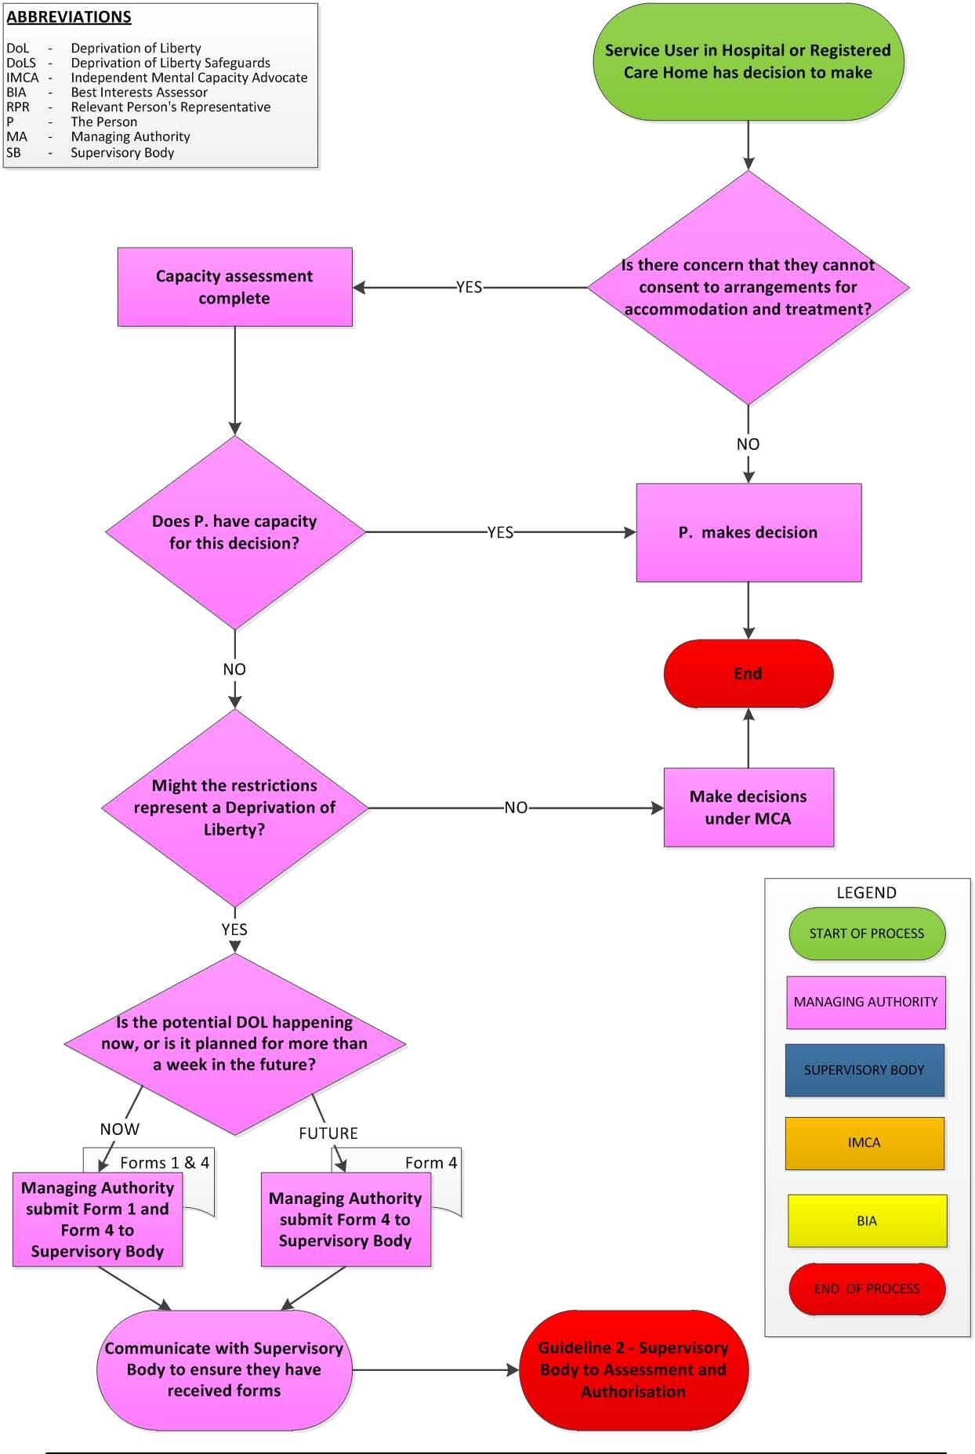

Guideline 2 - Supervisory Body to Assessment and Authorisation
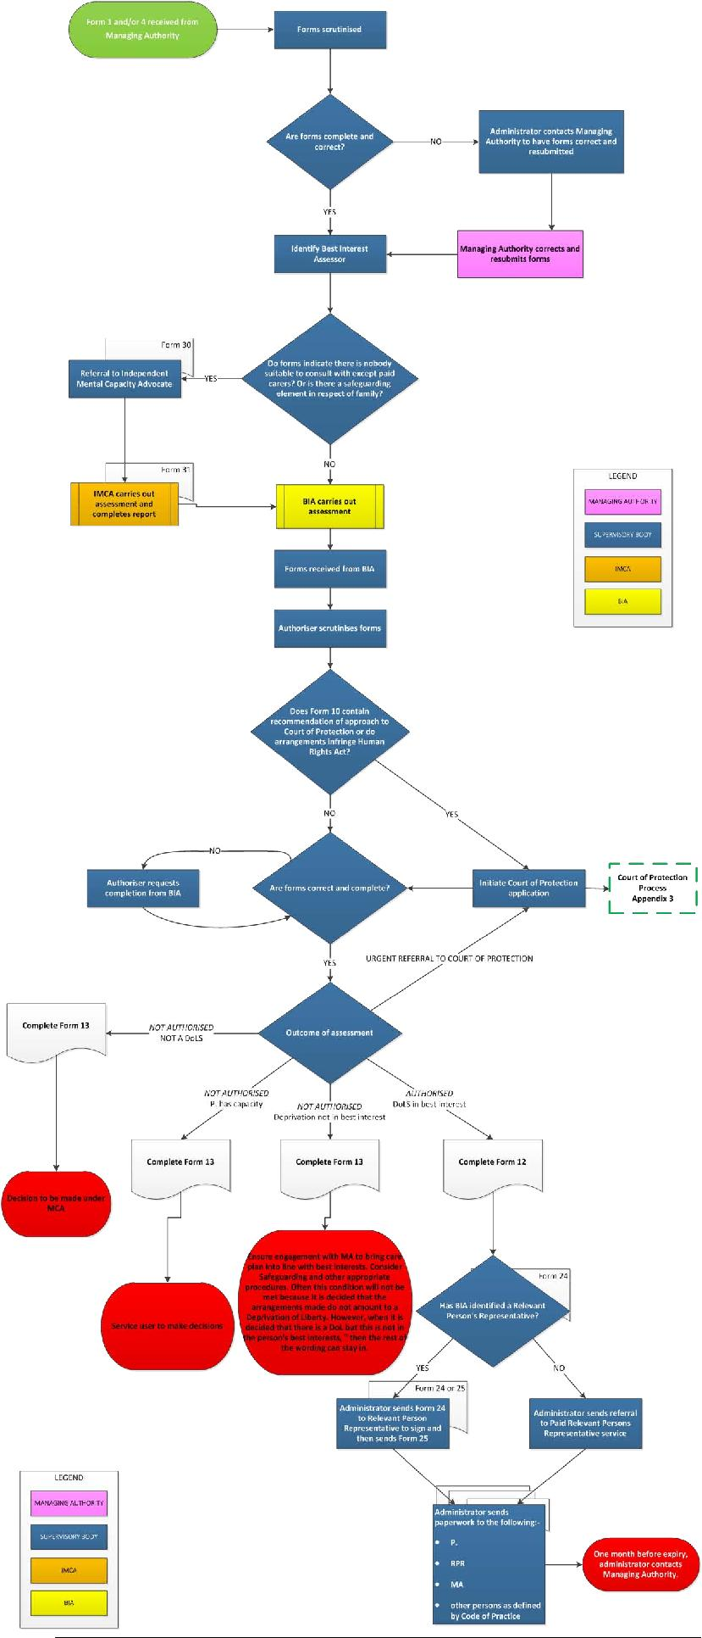

Guideline 3 – Court of Protection
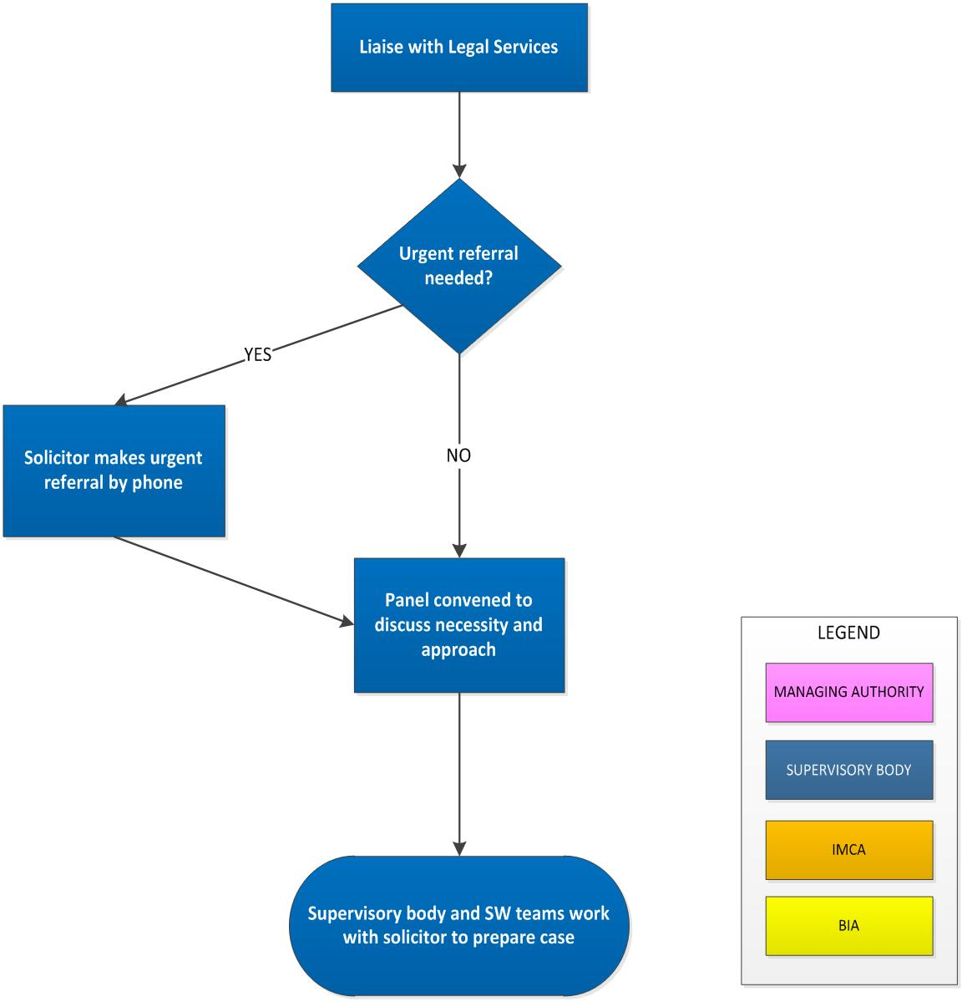

Date Issue: March 2014 | Responsibility for Review: Safeguarding Adults Manager
Ratified by: Safeguarding Adults Board | Review Date: April 2016

Solihull Local Practice Guidance - Page 5 of 5

