

Candidate Information


Gift of Friendship Administrator
Part-time
Fixed Term Contract ending July 2027
Closing Date: 8am on Thursday 26th March

Thank you for your interest in our vacancy for a Gift of Friendship Administrator. We’re so pleased that you’re considering working for Age UK South Gloucestershire.

In this Candidate Information Pack, you’ll find the following information:
• About us, our history and our links with Age UK
• The benefits of working at Age UK South Gloucestershire
• Job Description and Person Specification
• How to apply

If you have any questions about any aspect of the organisation or the role, please don’t hesitate to get in touch.

Age UK South Gloucestershire is an independent local charity with its own locally elected board of trustees and is part of the Age UK network. We've been working in the local community to help older people for 25 years. The charity makes a positive contribution to the lives of hundreds of older people in South Gloucestershire every week. Based from our main office in Thornbury High Street, Age UK South Gloucestershire actively designs services that meet the wants and needs of local older people and their families by:

• tackling loneliness and isolation
• promoting health, wellbeing and independence
• supporting families and carers
• helping people access services and financial benefit entitlements
• enabling people to get the most out of life

We respond to thousands of enquiries each year with our range of services, which include Activity Day Centres, Befriending, Digital Inclusion, Improving Homes and Wellbeing, Information & Advice provision, specialist Benefits Advice, Reconnect, Walking Groups and Volunteering opportunities.

About Age UK South Gloucestershire

Pack Overview
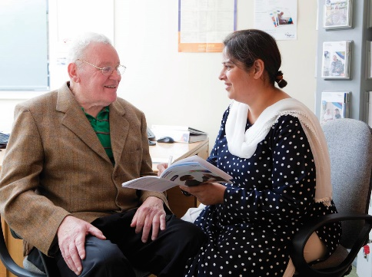

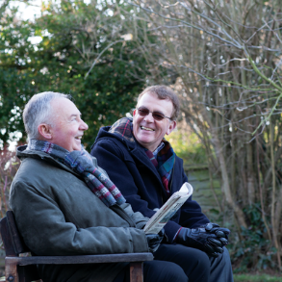

Our Partnership with Age UK
Age UK South Gloucestershire is an independent local charity, but we share a brand with Age UK. This trusted and well-known brand helps to open doors for us locally. Of course, we always have to deliver, but it helps to have the strength of the Age UK brand behind us.

Nationally, there are around 130 regional Age UKs, each with a defined geographical area and separate charity number.

We align ourselves with the work Age UK does nationally by supporting their campaigns, sharing reports and news stories, and using their research to underpin grant and tender applications.

Age UK also provides our local MPs with information about older people that can help drive forward local policies and influence at a national level.

Being an Age UK Brand Partner brings certain responsibilities – namely to deliver services to agreed quality standards and to subscribe to shared values of being:
• Caring
• Effective
• Enabling
• Influencing
• Innovative
• Inclusive

We are aligned with Age UK but we are still a local and independent charity. The services we deliver, the money we raise, the people we support are all in South Gloucestershire. Our Trustees are responsible for strategy, polices and legal compliance.

1997

Our history

Age Concern South Gloucestershire was formed.

…we become an Age UK Brand Partner and trade as ‘Age UK South Gloucestershire’.
Age Concern and Help the Aged merge to form the national charity, Age UK. Then in…
2010
2005
Age Concern South Gloucestershire changes its legal structure to become a charitable company.
2009

2022
Age UK South Gloucestershire celebrated our 25th Birthday.


We continue to look to the future!
2023
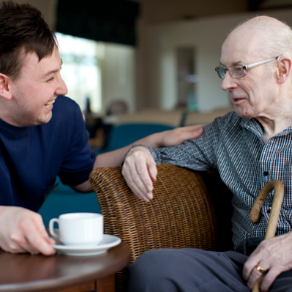
Working for Us

Age UK South Gloucestershire employs a team of over 30 paid staff, and over 160 wonderful volunteers support its work. The organisation's culture is one that puts people first, and the charity enjoys high staff morale. Age UK South Gloucestershire has an active board of trustees who, as well as providing good governance, work closely with the management team on matters of strategy and direction.

What we offer our staff:
- A living wage for employees across the organisation.
- A commitment to a work life balance, with flexible & hybrid working in many roles.
- A healthcare cash back plan allows employees to claim money back towards a variety of health, dental and optical treatments.
- An employee wellbeing scheme, providing free, confidential support, counselling, CBT, financial and legal information or support from a nurse or GP, 24 hours a day, 365 days a year.
- Generous life assurance up to 3 times your annual salary.
- Great discounts and rewards (perfect for pay day!).
- A great working atmosphere.
- 25 days holiday per year, rising to 28 days after 3 years' service, plus bank holidays.
- Regular learning and development opportunities with funding contributions toward career developing qualifications.
- Pension scheme enrolment.

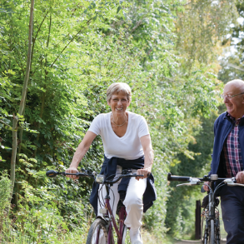



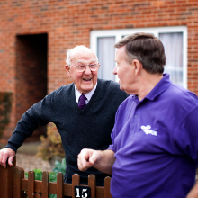

Gift of Friendship Administrator
Salary - £26.227.50, (£10,491.00 actual).
Part-time 15 hours per week
Fixed Term Contract – ending July 2027

We are looking to appoint an enthusiastic, positive and flexible Gift of Friendship Administrator to work across South Gloucestershire.

This role will undertake a range of administration duties supporting the organisation's Gift of Friendship programme aiming to reduce loneliness and isolation in older people.

It is essential that you have excellent verbal and written communication skills, along with a high level of organisation, and a passion for working positively with older people. If you are committed to improving the lives of older people, we would like to hear from you.

Age UK South Gloucestershire is committed to equalities, diversity and inclusion, and encourages applications from all sectors of the community.

If this role sounds perfect for you, download an application pack from our website. https://www.ageuk.org.uk/southgloucestershire/get-involved/work-for-us/.

Please return completed application forms to hr@ageuksouthglos.org.uk
Vacancy Details


Closing date:
8 am, on Thursday 26th March 2026

Interviews:
Within 2 weeks



Job Description

Job Title | Gift of Friendship Administrator
Salary | Scale Point 2. £26.227.50, (£10,491.00 actual)
Hours of work | Part-time, 15 hours per week
Working pattern | Hours to be agreed across 2-3 days
Place of work | Based at the Main Office, 67 High Street, Thornbury, BS35 2AW, with travel across South Gloucestershire to client's homes and to run meetings and training sessions.
Annual leave | 25 days annual leave (increasing to 28 after 3 years' service), plus public holidays, all pro rata
Status | Fixed Term Contract – ending July 2027
Job Purpose
This role will undertake a range of administration duties supporting the organisation's Gift of Friendship programme aiming to reduce loneliness and isolation in older people.
Responsible to
Volunteering Manager
Contacts
The post holder will need to build positive relationships and work closely with key staff and the wider staff team, volunteers, clients and partner organisations.

Key Responsibilities
- Act as the main point of contact for day-to-day operational enquiries
regarding volunteering, resolving day-to-day operational issues as they
arise, and escalating issues within the team when needed.
- Monitor the department email inbox and phone line, processing
incoming service enquiries, signposting internally and externally as
necessary.
- Process client referrals to the Befriending services and
maintain the waiting lists and relevant databases.
- Administration of Befriending volunteer activity logs.
- Administer and collate client surveys.
- Take and distribute notes at team meetings.
- General office duties including data entry, word-processing,
photocopying, scanning, filing and mailing.
- To support the organisation with volunteering and public events.
Key Responsibilities cont.
Support the work of the wider Befriending Services team by:
- Ensuring that all administration protocols and procedures are efficiently undertaken.
- Attending supervision sessions & other meetings as required by the CEO.
- Maintain a commitment to professional development through a combination of both formal and informal methods, including attendance at mandatory training and meetings as directed.
- Uphold the highest standards of personal conduct in all matters relating to the role, working within all policies and procedures of AUKSG
General Responsibilities of all staff members
- To ensure that all administration protocols and procedures are efficiently undertaken.
- To attend supervision sessions & other meetings as required by the CEO.
- Maintain a commitment to professional development through a combination of both formal and informal methods, including attendance at mandatory training and meetings as directed.
- Uphold the highest standards of personal conduct in all matters relating to the role, working within all policies and procedures of AUKSG.

Other Duties
This job description is intended as a guide to the general duties required of the post. The post holder may be required to undertake training and perform duties other than those given in the job description. The duties and responsibilities attached to posts may vary from time to time. Such variations are a common occurrence and would not justify the re-evaluation of a post. Where a permanent and substantial change in the duties and responsibilities occurs, then the post would be eligible for re-evaluation.
Requirements of the Post
The nature of this post will require:
- Regular travel; therefore, a requirement will be access to and the use of a reliable vehicle with Business Insurance. Car mileage will be paid at the prevailing HMRC-approved rate (currently 45p per mile.)
- Lone working; therefore, the advice and guidance of Age UK South Gloucestershire must be followed.
- An ability to physically access individuals' homes in a variety of locations and conditions.
- The flexibility for attendance at occasional meetings and events outside of any agreed working pattern, including evenings and weekends for which time off in lieu will be given. All evening or weekend work will usually be agreed upon with plenty of prior notice.
Disclosure and Barring Service (DBS)
This post is subject to a satisfactory Enhanced Disclosure and Barring Service check, which will disclose all relevant cautions, reprimands and warnings as well as convictions. In addition to completing this application form, you are required to provide us with details of all spent and unspent convictions. Please send this information to us under separate, confidential cover to the Chief Executive Officer. Remember to include your name, address and the position for which you are applying. We guarantee that the information you provide will be used fairly and will only be seen by those who need to see it as part of the recruitment process.

A criminal record will not necessarily bar you from the advertised position. This will depend on the nature of the position and the circumstances and background of your offences. However, failure to reveal this information could lead to the withdrawal of an offer of employment or disciplinary action.

Equal Opportunities
All employees have a responsibility to understand and abide by the obligations laid down in the organisation's equal opportunities policies.
Health and Safety
All employees have responsibility for their own health and safety and for that of others who may be affected by their acts or omissions. Staff members are required to adhere to all health and safety regulations, guidance and procedures at all times.
Confidentiality
All employees are expected to respect confidentiality in relation to Age UK South Gloucestershire business, client and service user data.


Person Specification
Essential Criteria
- Experience of working with volunteers.
- An understanding of the role of volunteering and the issues and opportunities it can bring.
- An understanding of the issues faced by older people; resilience to the nature of these issues, and a commitment to the aims and objectives of AUKSG.
- Excellent administrative and personal organisational skills.
- Excellent inter-personal communication skills and a range of written communication skills for a variety of audiences and purposes.
- Good presentation skills.
- An excellent level of IT skills, including using Microsoft Office packages such as Word, Excel, PowerPoint and Outlook.
- Good numeric skills.
- Ability to use initiative and work independently, but also to work cooperatively as part of a team when necessary.
- A positive and constructive approach to problem solving.
- Ability to establish and maintain effective working relationships with with a wide range of people and other agencies.
- Commitment to promoting and supporting equal opportunities & diversity.
- Commitment to data protection and confidentiality.
- Willingness to work occasional evenings and weekends (for which time off in lieu will be available).
- Willingness and ability to travel as required (The nature of this post will require regular travel throughout South Gloucestershire and occasionally further afield therefore access to and the use of a reliable car is essential).
Desirable Criteria
- Experience of working with older people.
- Experience of working with a Befriending service.
- A recognised training qualification.
- Experience in carrying out risk assessments.
How to Apply

If you are interested in becoming our new Gift of Friendship Administrator, please download an application form from our website: www.ageuksouthglos.org.uk

Completed application forms should be submitted via email or post FAO Tracy Marshall, Office Supervisor

hr@ageuksouthglos.org.uk
or
Age UK South Gloucestershire,
67 High Street, Thornbury, Bristol, BS35 2AW

Please ensure you have also completed the Equality and Diversity Monitoring section of the application form. The information on the form will be treated as confidential, and used for reporting purposes only. The form will be kept separate and will not form part of the application process.

Closing date:
8 am on Thursday 26th March 2026

Interviews:
Within 2 weeks

For general information on Age UK South Gloucestershire or if you have specific questions about the role, please contact Tracy Marshall, Office Supervisor and she will be happy to arrange for an informal discussion with the appropriate member of staff.


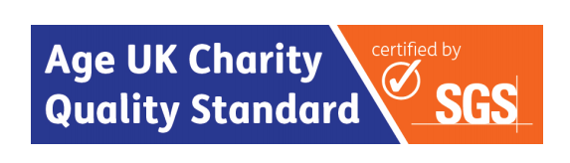


Age UK South Gloucestershire is a registered charity (1109999) and company limited by guarantee. Registered in England and Wales number 5464737. Registered office 67 High Street, Thornbury, Bristol, BS35 2AW.

