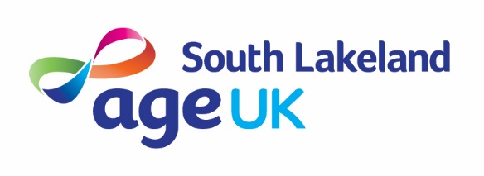

Equality & Diversity Policy Statement

By understanding and respecting people’s different needs and aspirations, we can stay in touch with the changing society in which we work, and address inequalities to ensure that everyone has the same access to the services and opportunities they need.

Staff and volunteers need to recognise and fulfil their personal role in making Age UK South Lakeland a genuinely inviting and inclusive organization.

Age UK South Lakeland has a commitment to diversity and equality, which is about:

- Recognising and valuing difference
- Recognising and seeking to redress inequality and disadvantage
- Treating everyone in a fair, open and honest manner
- Recognising the right of volunteers, employees and service users to be treated with dignity and respect
- Providing equality of opportunity and access to services
- Tackling discrimination and disadvantage
- Tackling harassment and intimidation

Age UK south Lakeland will not tolerate less favourable treatment on the grounds of gender, race, colour, nationality, ethnic origin, disability, sexual orientation, marital status, part-time status, age, religion or belief. Age UK South Lakeland believes that discrimination is wrong and should be actively opposed.

Discrimination denies human dignity, a freedom for people to be themselves and to have place in a free society. We will ensure that all people; Trustees, volunteers, employees and members of the public are treated fairly and consistently without discrimination.

The organization will therefore:

- Demonstrate its commitment to these statements by adopting a policy of Equality & Diversity, which will be reviewed annually and, when necessary, updated.
- Seek to remove bias from existing policies, procedures and practices, and taking steps to ensure equal access to employment, volunteering and services.
- Age UK South Lakeland believes that by drawing on and valuing diversity, the organization will be enriched, and its ability to provide services to older people in our community will be strengthened.

