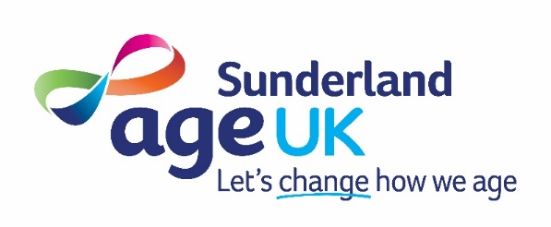

Trustee

(
Treasurer
)

Organisation:
Age UK Sunderland.
Age UK Sunderland is an independent local charity working with communities within the City of Sunderland for over 70 years supporting older people (aged 50 and over).
Dedicated teams of staff and volunteers help us to deliver our wide range of services and activities.
Volunteers play an important and integral role within our organisation and we are looking to recruit new volunteers to join our Charity’s Board of Trustees.
The treasurer is a trustee with a specific role on the board.
Generally, the treasurer role within Age UK Sunderland helps trustees carry out their financial responsibilities. They might do this by:

- presenting financial reports to the board in a format that helps the board understand the charity’s financial position
- advising the board on how to carry out its financial responsibilities
- liaising with professional advisors (e.g. auditors)
- overseeing the preparation and scrutiny of annual accounts
Age UK Sunderland Board members are responsible for ensuring the organisation is governed correctly and that we remain compliant with Charity Law and other internal/external guidance whilst ensuring we maintain our mission to “promote the well-being of all older people throughout the City of Sunderland, improve their quality of life and help them maintain independence”
The applicant must be able to demonstrate care and understanding of the needs of older people living in Sunderland and have financial experience at a managerial level, if you feel that you have the skills and experience that would bring a benefit to the role; we would like to hear from you.
The post of trustee is an unpaid volunteering role and you must be able to:
- Attend a minimum of six board meetings and six subcommittee meetings per annum
- Offer additional time and support as and when required
- Keep yourself briefed on issues relevant to the organisation and think strategically
- Ensure confidentiality and loyalty to Age UK Sunderland

Expressions of interest to be sent to Age UK Sunderland Chief Executive Officer, Tracy Collins by email at tracycollins@ageuksunderland.org.uk. This is an open recruitment at present with a provisional deadline for completed applications to received by end of May 2026.
Registered charity No 1086995

