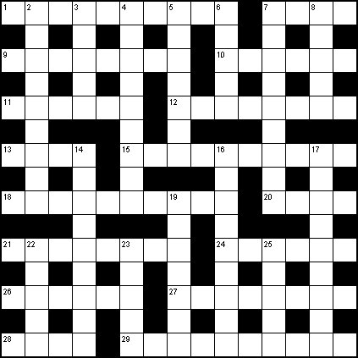

ACROSS
1 Rush around in old car, to find escaped criminal in Oz (10)
7 A disease singular to sponge (4)
9 English is almost never spoken poetically in Telford, for example (8)
10 Rotter is in modern art emporium (6)
11 Copper into Turner gets depression (6)
12 I am unpretentious? No (8)
13 Clothe with part of a corset (4)
15 Get mean about bird call (10)
18 Monster horribly present on the waves (3,7)
20 Who should really have written Diary of a Nobody? (4)
21 See 4
24 Enjoy the flavour (6)
26 Composer of Semiramide and La Mer? No (6)
27 As were the leftovers a man ate, being overdrawn? (8)
28 Scolded infant without a trace of leniency (4)
29 4,21's Mount is irregular cube next to a generation symbol (missing centrepiece) (10)
DOWN
2 Auntie hit boiling asphalt (9)
3 Told of journey to university to find poem (5)
4,21 The king of 7, this general axed threat strategically (9,3,5)
5 Not,we hear, a problem for 4,21 (7)
6 Province is to take up weapons again, changing sides (5)
7 4,21's country; a wine capital erected around the last stages of 300 (as it's written) (9)
8 Aeolian and Doric, say, in 12 (5)
14 Quarrelled in Hell over a sin (9)
16 Outside port finally, make fast a vessel – one that's engine driven (5,4)
17 Some garment to stitch, it's said – or more than one (9)
19 One goes into troubled centre, having some guts (7)
22 Man 'as old Erica (5)
23 Residential area in upwardly mobile part of Bruxelles (5)
25 Student priest in Guanaco (5)

