Isolation tips top 10

- Limit your news exposure

The news is great, in small doses. Listening to bad news constantly can affect your wellbeing by creating a bigger sense of worry and panic. Limit your viewing to the 6pm news or midday news every other day.

- Try keeping to a routine

With everything so uncertain currently, try and keep a bit of order in your life with a routine. Getting up, lunch, dinner, and bedtimes around the same time each day.

- Eat healthily

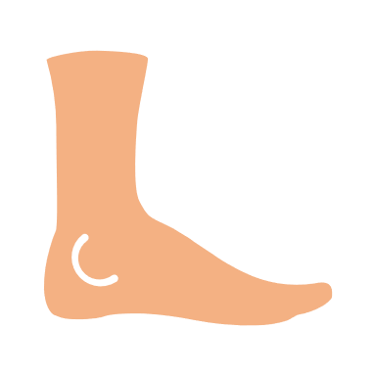
Try and have 1 cooked meal per day. Fruit and Veg. limit your snacks, drink plenty of fluids

- Move if you are able

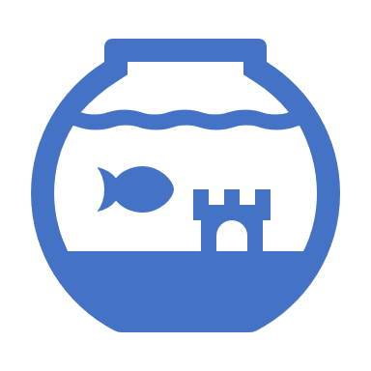
Chair based exercise, gardening, moving more to keep active if possible.

- Take time out

Take time for yourself, relax, breathe for at least 30 minutes a day.

- Do something you enjoy

Watch your favourite film, do your hobby, sing, play an instrument
- Learn a new skill

Learn a new language, play an instrument, or knit/crochet. Start a jigsaw or try your hand at drawing/doodling or write poetry.
Keeping your brain ticking over and active helps relieve stress and anxiety.

- Get the niggly jobs around the home done

If you’re able to, if you’ve been putting off doing those jobs around the house that you don’t really want to do. Tackle them one by one per day.

- Talk to someone

Write letters to pen pals, call someone on the phone, WhatsApp, Text messages, Facetime, Social media, Phone services (see useful contacts).

10. Ask for help

It’s ok to ask for help. See the list of useful numbers.

