Emergency contact numbers for utilities
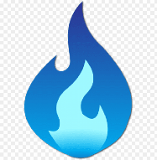
Gas: National Gas Helpline on 0800 111 999 (24 hours, 7 days a week)

Electric: If you have or suspect an electrical power cut, call the National Power Cut Helpline on 105 (24 hours, 7 days a week).
Electricity North West: 0800 195 4141
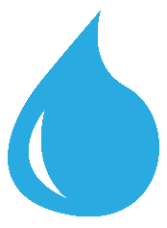
Water: United Utilities 0345 672 3723 (24-hours-a-day)
