
Menu
1ST DECEMBER 2025 – 4TH JANUARY 2025
*Please make your choice and return your order form to the driver
*If you prefer you can call 01843 223881
*Please select meal A or *B (*Vegetarian)
*Please choose a pudding if you would like to receive one.

*Meals are £10 including a pudding.
PLEASE NOTE
*Our delivery period is between 11.30am – 2.30pm, unfortunately we are unable to guarantee a time slot
*Meals must be delivered; we are unable to leave outside.
*PLEASE RETURN OUT CONTAINERS

*Our food is prepared where nuts, gluten and other allergies could be present.
*Our menu descriptions cannot always include all ingredients.
*We use fresh, locally sourced, seasonable vegetables
*We cannot commit to exact types

If you have a food allergy, please let us know before ordering.
Full allergen information is available
Meal B is suitable for vegetarians (V). Dishes with fish and chicken may contain bones.

Name: ………………………………………………………………………………………………………………….……

Address: ……………………………………………………………………………………………………………………….

……………………………………………………………………………………………………….………………

Tel. No: ……………………………………………………………………………………………………………………………….…
Any food Allergies: Y/N if Yes please specify ……………………………………………….

SALAD BOXES £6

We offer a choice of HAM, CHEESE, salads with
- A roll and butter
- Coleslaw and Potato Salad
- Variety of salad including:

Lettuce, tomato, cucumber, peppers, onions, carrot and maybe even radishes, beetroot, and cress.

Salads can now be considered as a meal alternative
if you do not fancy a hot meal pick me!

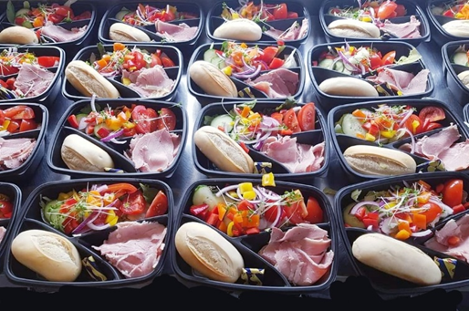

MONDAY 1st DECEMBER |  | A | B | Salad | Pud | Eve
MEAL A – MINCE AND ONION PIE WITH SEASONAL VEG
MEAL B – VEGGIE VERSION OF ABOVE
PUDDING
TUESDAY 2nd |  | A | B | Salad | Pud | Eve
MEAL A – CORNISH PASTIE WITH SAUTE POTATOES AND BEANS
MEAL B – VEGGIE VERSION OF ABOVE
PUDDING
WEDNESDAY 3rd |  | A | B | Salad | Pud | Eve
MEAL A – SAUSAGE, MASH AND ONION GRAVY WITH SEASONAL VEG
MEAL B – VEGGIE VERSION OF ABOVE
PUDDING
THURSDAY 4th |  | A | B | Salad | Pud | Eve
MEAL A – ROAST DINNER WITH ALL THE TRIMMINGS
MEAL B –VEGGIE VERSION OF ABOVE
PUDDDING
FRIDAY 5th |  | A | B | Salad | Pud | Eve
MEAL A – FISH PIE AND SEASONAL VEG
MEAL B – VEGGIE VERSION OF ABOVE
PUDDING
SATURDAY 6th – ONLY PACK UP MEALS DELIVERED ON FRIDAY |  | A | B | Salad | Pud | Eve
MEAL A – SANDWICH AND PACK UP
MEAL B – VEGGIE SANDWICH AND PACK UP
SUNDAY 7th – ONLY PACK UP MEALS DELIVERED ON FRIDAY | A |  | B | Salad | Pud | Eve
MEAL A –SANDWICH AND PACK UP
MEAL B – VEGGIE SANDWICH AND PACK UP
MONDAY 8th DECEMBER | A |  | B | Salad | Pud | Eve
MEAL A – LASAGNE WITH GARLIC BREAD AND SEASONAL VEG
MEAL B- VEGGIE OPTION OF ABOVE
PUDDING-
 | A |  | B | SALAD | Pud | Eve
TUESDAY 9th
MEAL A- CHICKEN CURRY WITH RICE AND NAAN BREAD
MEAL B- VEGGIE OPTION OF ABOVE
PUDDING
WEDNESDAY 10th | A |  | B | Salad | Pud | Eve
MEAL A- SAUSAGE, MASH AND BEANS
MEAL B- VEGGIE OPTION OF ABOVE
PUDDING
THURSDAY 11th | A |  | B | Salad | Pud | Eve
MEAL A- ROAST DINNER WITH ALL THE TRIMMINGS
MEAL B – VEGGIE VERSION OF ABOVE
PUDDDNG
FRIDAY 12th | A |  | B | Salad | Pud | Eve
MEAL A – FISH IN PARSLEY SAUCE WITH MASH AND SEASONAL VEG
MEAL B – VEGGIE OPTION OF ABOVE
PUDDING
SATURDAY 13th – PACK UP ONLY ( DELIVERED ON FRIDAY) | A |  | B | Salad | Pud | Eve
MEAL A- SANDWICH AND PACK UP
MEAL B – VEGGIE SANDWICH AND PACK UP
SUNDAY 14th PACK UP ONLY ( DELIVERED ON FRIDAY) | A |  | B | Salad | Pud | Eve
MEAL A- SANDWICH AND PACK UP
MEAL B- VEGGIE SANDWICH AND PACK UP
MONDAY 15th DECEMBER | A |  | B | Salad | Pud | Eve
MEAL A- SWEET AND SOUR PORK WITH RICE WITH SEASONAL VEG
MEAL B- VEGGIE OPTION OF ABOVE
PUDDING
TUESDAY 16th | A |  | B | Salad | Pud | Eve
MEAL A- CHICKEN, TURKEY AND HAM PIE WITH TWO SEASONAL VEG
MEAL B – VEGGIE VERSION OF ABOVE
PUDDING
WEDNESDAY 17th | A |  | B | Salad | Pud | Eve
MEAL A- SPAGHETTI BOLGNAISE WITH GARLIC BREAD
MEAL B – VEGGIE OPTION OF ABOVE
PUDDING
THURSDAY 18th | A |  | B | Salad | Pud | Eve
MEAL A- ROAST DINNER WITH ALL THE TRIMMINGS
MEAL B- VEGGIE OPTION OF ABOVE
PUDDING
FRIDAY 19th | A |  | B | Salad | Pud | Eve
MEAL A- CHICKEN STEW WITH MASH AND SEASONAL VEG
MEAL B- VEGGIE OPTION OF ABOVE
PUDDING
SATURDAY 20th PACK UP ONLY ( DELIVERED ON FRIDAY) | A |  | B | Salad | Pud | Eve
MEAL A- SANDWICH AND PACK UP
MEAL B- VEGGIE SANDWICH AND PACK UP
SUNDAY 21st PACK UP ONLY ( DELIVERED ON FRIDAY) | A |  | B | Salad | Pud | Eve
MEAL A- SANDWICH AND PACK UP
MEAL B- VEGGIE SANDWICH AND PACK UP

MONDAY 22nd DECEMBER | A | B | Salad | Pud | Eve
MEAL A- SAUSAGE, MASH AND BEANS
MEAL B- VEGGIE OPTION OF ABOVE
PUDDING
TUESDAY 23rd | A | B | Salad | Pud | Eve
MEAL A- QUICHE WITH SAUTE POTATOES AND SEASONAL VEG
MEAL B – VEGGIE VERSION OF ABOVE
PUDDING
WEDNESDAY 24th | A | B | Salad | Pud | Eve
MEAL A- MINCE AND RICE WITH CARROTS
MEAL B – VEGGIE OPTION OF ABOVE
PUDDING
THURSDAY 25th | A | B | Salad | Pud | Eve
MEAL A- CHRISTMAS DINNER WITH ALL THE TRIMMINGS
MEAL B- VEGGIE OPTION OF ABOVE
PUDDING
FRIDAY 26th | A | B | Salad | Pud | Eve
MEAL A- COLD CUTS WITH JACKET POTATOES, PICKLES AND COLESWLAW
MEAL B- VEGGIE OPTION OF ABOVE
PUDDING
SATURDAY 27th PACK UP ONLY ( DELIVERED ON FRIDAY) | A | B | Salad | Pud | Eve
MEAL A- SANDWICH AND PACK UP
MEAL B- VEGGIE SANDWICH AND PACK UP
SUNDAY 28th PACK UP ONLY ( DELIVERED ON FRIDAY) | A | B | Salad | Pud | Eve
MEAL A- SANDWICH AND PACK UP
MEAL B- VEGGIE SANDWICH AND PACK UP
MONDAY 29th DECEMBER | A | B | Salad | Pud | Eve
MEAL A- LASAGNE AND GARLIC BREAD WITH SEASONAL VEG
MEAL B- VEGGIE OPTION OF ABOVE
PUDDING
TUESDAY 30th | A | B | Salad | Pud | Eve
MEAL A- SAUSAGE ROLL WITH SAUTE POTATOES AND BEANS
MEAL B – VEGGIE VERSION OF ABOVE
PUDDING
WEDNESDAY 31st | A | B | Salad | Pud | Eve
MEAL A- CHICKEN STROGANOFF WITH MASH AND SEASONAL VEG
MEAL B – VEGGIE OPTION OF ABOVE
PUDDING
THURSDAY 1st JANUARY | A | B | Salad | Pud | Eve
MEAL A- ROAST DINNER WITH ALL THE TRIMMINGS
MEAL B- VEGGIE OPTION OF ABOVE
PUDDING
FRIDAY 2nd | A | B | Salad | Pud | Eve
MEAL A- FISH PIE WITH TWO SEASONAL VEG
MEAL B- VEGGIE OPTION OF ABOVE
PUDDING
SATURDAY 3rd PACK UP ONLY ( DELIVERED ON FRIDAY) | A | B | Salad | Pud | Eve
MEAL A- SANDWICH AND PACK UP
MEAL B- VEGGIE SANDWICH AND PACK UP
SUNDAY 4th PACK UP ONLY ( DELIVERED ON FRIDAY) | A | B | Salad | Pud | Eve
MEAL A- SANDWICH AND PACK UP
MEAL B- VEGGIE SANDWICH AND PACK UP

AFTERNOON TEA

Fridge ready!

We deliver at the same time as your hot meal delivery,
Sandwiches, fresh fruit and cake/biscuits

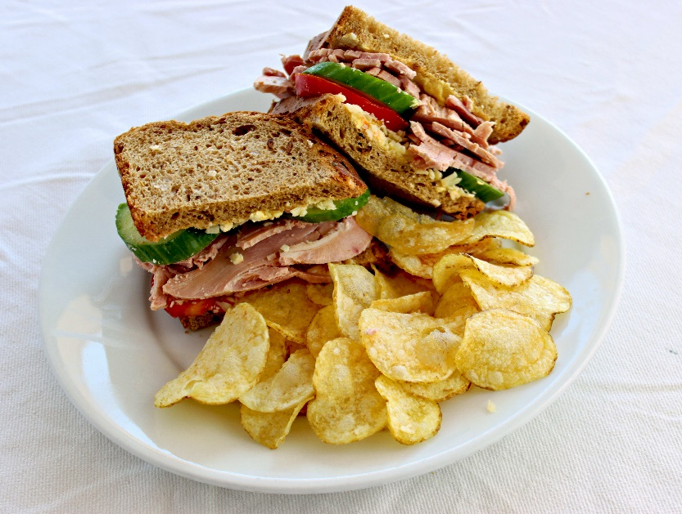
HAM OR CHEESE SANDWICHES

Containers
- Our containers ARE now microwavable, including the small black dessert ones.
- The containers CAN NOT go into the oven they will melt and are a fire and safety hazard.
- The containers are reusable.
- Please return rinsed containers to the driver, we sterilise and reuse them to help the environment
- NOT SUITABLE FOR THE OVEN

Not ready to eat at the time of delivery? Please put your food containers in the fridge and then reheat to 75-degree temperature in the microwave later.
Once menus have been returned amendments cannot be made.
Please only reheat this once to avoid any food poisoning.
We would like to thank you for your on-going support.
Any further queries or questions we are happy to help.
Thank you.

Age UK Thanet

