
Menu
2nd FEBRUARY 2026 – 2nd MARCH 2026
*Please make your choice and return your order form to the driver
*If you prefer you can call direct to the Kitchen on 01843 282910 (new number)
*Please select meal A or *B (*Vegetarian)
*Please choose a pudding if you would like to receive one.

*Meals are £10 including a pudding.
PLEASE NOTE
*Our delivery period is between 11.30am – 2.30pm, unfortunately we are unable to guarantee a time slot
*Meals must be delivered; we are unable to leave outside.
*PLEASE RETURN OUT CONTAINERS

*Our food is prepared where nuts, gluten and other allergies could be present.
*Our menu descriptions cannot always include all ingredients.
*We use fresh, locally sourced, seasonable vegetables
*We cannot commit to exact types

If you have a food allergy, please let us know before ordering.
Full allergen information is available
Meal B is suitable for vegetarians (V). Dishes with fish and chicken may contain bones.

Name: ………………………………………………………………………………………………………………….……

Address: ……………………………………………………………………………………………………………………….

……………………………………………………………………………………………………….………………

Tel. No: ……………………………………………………………………………………………………………………………….…
Any food Allergies: Y/N if Yes please specify ……………………………………………….

SALAD BOXES £6

We offer a choice of HAM, CHEESE, salads with
- A roll and butter
- Coleslaw and Potato Salad
- Variety of salad including:

Lettuce, tomato, cucumber, peppers, onions, carrot and maybe even radishes, beetroot, and cress.

Salads can now be considered as a meal alternative
if you do not fancy a hot meal pick me!

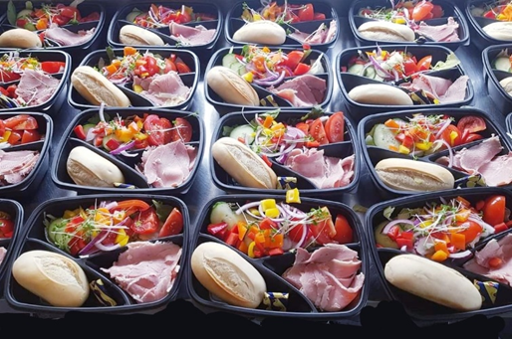

MONDAY 2nd FEBRUARY |  | A | B | Salad | Pud | Eve
MEAL A –SWEET AND SOUR PORK WITH RICE AND VEG
MEAL B – VEGGIE VERSION OF ABOVE
PUDDING
TUESDAY 3rd |  | A | B | Salad | Pud | Eve
MEAL A – SAUSAGE, MASH AND ONION GRAVY WITH ONE VEG
MEAL B – VEGGIE VERSION OF ABOVE
PUDDING
WEDNESDAY 4th |  | A | B | Salad | Pud | Eve
MEAL A – SHEPHRDS PIE WITH 2 VEG
MEAL B – VEGGIE VERSION OF ABOVE
PUDDING
THURSDAY 5th |  | A | B | Salad | Pud | Eve
MEAL A – ROAST TURKY WITH ALL THE TRIMMINGS
MEAL B –VEGGIE VERSION OF ABOVE
PUDDDING
FRIDAY 6th |  | A | B | Salad | Pud | Eve
MEAL A – FISH IN PARSLESY SAUTE POTATES AND VEG
MEAL B – VEGGIE VERSION OF ABOVE
PUDDING
SATURDAY 7th – ONLY PACK UP MEALS DELIVERED ON FRIDAY |  | A | B | Salad | Pud | Eve
MEAL A – SANDWICH AND PACK UP
MEAL B – VEGGIE SANDWICH AND PACK UP
SUNDAY 8th – ONLY PACK UP MEALS DELIVERED ON FRIDAY | A |  | B | Salad | Pud | Eve
MEAL A –SANDWICH AND PACK UP
MEAL B – VEGGIE SANDWICH AND PACK UP
MONDAY 9th FEBRUARY | A |  | B | Salad | Pud | Eve
MEAL A – CHICKEN STROGANOFF WITH MASH AND 1 VEG
MEAL B- VEGGIE OPTION OF ABOVE
PUDDING-
 | A |  | B | SALAD | Pud | Eve
TUESDAY 10th
MEAL A- QUICHE -BACON+EGG WITH SAUTE POTATOES AND VEG
MEAL B- VEGGIE OPTION OF ABOVE
PUDDING
WEDNESDAY 11th | A |  | B | Salad | Pud | Eve
MEAL A- SPAGhETTI BOLOGNESE WITH GARLIC BREAD
MEAL B- VEGGIE OPTION OF ABOVE
PUDDING
THURSDAY 12th | A |  | B | Salad | Pud | Eve
MEAL A- ROAST DINNER WITH ALL THE TRIMMINGS
MEAL B – VEGGIE VERSION OF ABOVE
PUDDDNG
FRIDAY 13th | A |  | B | Salad | Pud | Eve
MEAL A – FISH PIE WITH 2 VEG
MEAL B – VEGGIE OPTION OF ABOVE
PUDDING
SATURDAY 14th – PACK UP ONLY ( DELIVERED ON FRIDAY) | A |  | B | Salad | Pud | Eve
MEAL A- SANDWICH AND PACK UP
MEAL B – VEGGIE SANDWICH AND PACK UP
SUNDAY 15th PACK UP ONLY ( DELIVERED ON FRIDAY) | A |  | B | Salad | Pud | Eve
MEAL A- SANDWICH AND PACK UP
MEAL B- VEGGIE SANDWICH AND PACK UP
MONDAY 16th FEDEUARY | A |  | B | Salad | Pud | Eve
MEAL A- CHICKEN CURRY WITH NAAN BREAD AND RICE
MEAL B- VEGGIE OPTION OF ABOVE
PUDDING
TUESDAY 17st | A |  | B | Salad | Pud | Eve
MEAL A- LASAGNA WITH 2 VEG
MEAL B – VEGGIE VERSION OF ABOVE
PUDDING
WEDNESDAY 18nd | A |  | B | Salad | Pud | Eve
MEAL A- SAUSAGE MASH AND BEANS
MEAL B – VEGGIE OPTION OF ABOVE
PUDDING
THURSDAY 19rd | A |  | B | Salad | Pud | Eve
MEAL A- ROAST CHICKEN WITH ALL THE TRIMMINGS
MEAL B- VEGGIE OPTION OF ABOVE
PUDDING
FRIDAY 20th | A |  | B | Salad | Pud | Eve
MEAL A- CHICKEN STEW WITH SAUTE POTATO AND VEG
MEAL B- VEGGIE OPTION OF ABOVE
PUDDING
SATURDAY 21th PACK UP ONLY (DELIVERED ON FRIDAY) | A |  | B | Salad | Pud | Eve
MEAL A- SANDWICH AND PACK UP
MEAL B- VEGGIE SANDWICH AND PACK UP
SUNDAY 22th PACK UP ONLY (DELIVERED ON FRIDAY) | A |  | B | Salad | Pud | Eve
MEAL A- SANDWICH AND PACK UP
MEAL B- VEGGIE SANDWICH AND PACK UP

MONDAY 23th FEBRUARY | A | B | Salad | Pud | Eve
MEAL A- MINCE AND ONION PIE WITH 2 SEASONAL VEG
MEAL B- VEGGIE OPTION OF ABOVE
PUDDING
TUESDAY 24th | A | B | Salad | Pud | Eve
MEAL A- CORNISH PASTIES BEANS SAUTE POTATO
MEAL B – VEGGIE VERSION OF ABOVE
PUDDING
WEDNESDAY 25th | A | B | Salad | Pud | Eve
MEAL A- CHICKEN STEW WITH MASH AND 1 VEG
MEAL B – VEGGIE OPTION OF ABOVE
PUDDING
THURSDAY 26th | A | B | Salad | Pud | Eve
MEAL A- ROAST DINNER WITH ALL THE TRIMMINGS
MEAL B- VEGGIE OPTION OF ABOVE
PUDDING
FRIDAY 27th | A | B | Salad | Pud | Eve
MEAL A- FISH IN CHEESE SAUCE MASH AND 1 VEG
MEAL B- VEGGIE OPTION OF ABOVE
PUDDING
SATURDAY 28TH FEDRUARY PACK UP ONLY (DELIVERED ON FRIDAY) | A | B | Salad | Pud | Eve
MEAL A- SANDWICH AND PACK UP
MEAL B- VEGGIE SANDWICH AND PACK UP
SUNDAY 1st MARCH PACK UP ONLY (DELIVERED ON FRIDAY) | A | B | Salad | Pud | Eve
MEAL A- SANDWICH AND PACK UP
MEAL B- VEGGIE SANDWICH AND PACK UP

AFTERNOON TEA

Fridge ready!

We deliver at the same time as your hot meal delivery,
Sandwiches, fresh fruit and cake/biscuits

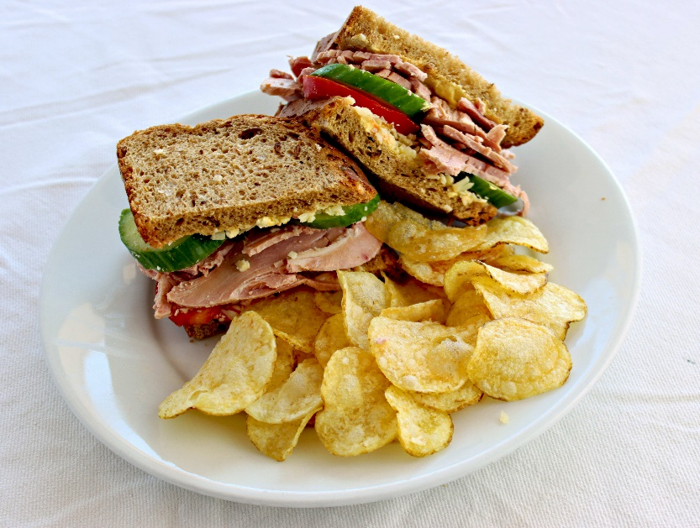
HAM OR CHEESE SANDWICHES

Containers
- Our containers ARE now microwavable, including the small black dessert ones.
- The containers CAN NOT go into the oven they will melt and are a fire and safety hazard.
- The containers are reusable.
- Please return rinsed containers to the driver, we sterilise and reuse them to help the environment
- NOT SUITABLE FOR THE OVEN

Not ready to eat at the time of delivery, please put your food containers in the fridge and then reheat to 75-degree temperature in the microwave later.
Once menus have been retuned amendments cannot be made.
Please only reheat this once to avoid any food poisoning.
We would like to thank you for your on-going support.
Any further queries or questions we are happy to help.
Thank you.

Age UK Thanet

