
Menu
2nd MARCH 2026 – 5th APRIL 2026
*Please make your choice and return your order form to the driver
*If you prefer you can call direct to the Kitchen on 01843 282910 (new number)
*Please select meal A or *B (*Vegetarian)
*Please choose a pudding if you would like to receive one.

*Meals are £10 including a pudding.
PLEASE NOTE
*Our delivery period is between 11.30am – 2.30pm, unfortunately we are unable to guarantee a time slot
*Meals must be delivered; we are unable to leave outside.
*PLEASE RETURN OUT CONTAINERS

*Our food is prepared where nuts, gluten and other allergies could be present.
*Our menu descriptions cannot always include all ingredients.
*We use fresh, locally sourced, seasonable vegetables
*We cannot commit to exact types

If you have a food allergy, please let us know before ordering.
Full allergen information is available
Meal B is suitable for vegetarians (V). Dishes with fish and chicken may contain bones.

Name: ………………………………………………………………………………………………………………….……

Address: ……………………………………………………………………………………………………………………….

……………………………………………………………………………………………………….………………

Tel. No: ……………………………………………………………………………………………………………………………….…
Any food Allergies: Y/N if Yes please specify ……………………………………………….

SALAD BOXES £6

We offer a choice of HAM, CHEESE, salads with
- A roll and butter
- Coleslaw and Potato Salad
- Variety of salad including:

Lettuce, tomato, cucumber, peppers, onions, carrot and maybe even radishes, beetroot, and cress.

Salads can now be considered as a meal alternative
if you do not fancy a hot meal pick me!

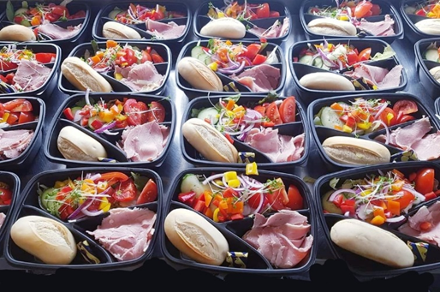

MONDAY 2nd MARCH |  | A | B | Salad | Pud | Eve
MEAL A –SHEPERDS PIE WITH TWO SEASONAL VEG
MEAL B – VEGGIE VERSION OF ABOVE
PUDDING
TUESDAY 3rd |  | A | B | Salad | Pud | Eve
MEAL A – CHICKEN KIEV WITH SAUTE POTATOES AND SEASONAL VEG
MEAL B – VEGGIE VERSION OF ABOVE
PUDDING
WEDNESDAY 4th |  | A | B | Salad | Pud | Eve
MEAL A – CHICKEN AND BACON PASTA
MEAL B – VEGGIE VERSION OF ABOVE
PUDDING
THURSDAY 5th |  | A | B | Salad | Pud | Eve
MEAL A – ROAST DINNER WITH ALL THE TRIMMINGS
MEAL B –VEGGIE VERSION OF ABOVE
PUDDDING
FRIDAY 6th |  | A | B | Salad | Pud | Eve
MEAL A – FISH IN PARSLESY SAUCE WITH MASH AND VEG
MEAL B – VEGGIE VERSION OF ABOVE
PUDDING
SATURDAY 7th – ONLY PACK UP MEALS DELIVERED ON FRIDAY |  | A | B | Salad | Pud | Eve
MEAL A – SANDWICH AND PACK UP
MEAL B – VEGGIE SANDWICH AND PACK UP
SUNDAY 8th – ONLY PACK UP MEALS DELIVERED ON FRIDAY | A |  | B | Salad | Pud | Eve
MEAL A –SANDWICH AND PACK UP
MEAL B – VEGGIE SANDWICH AND PACK UP
MONDAY 9th MARCH | A |  | B | Salad | Pud | Eve
MEAL A – MINCE AND ONION PIE WITH MASH AND SEASONAL VEG
MEAL B- VEGGIE OPTION OF ABOVE
PUDDING-
 | A |  | B | SALAD | Pud | Eve
TUESDAY 10th
MEAL A- SAUSAGE WITH SAUTE POTATOES AND BEANS
MEAL B- VEGGIE OPTION OF ABOVE
PUDDING
WEDNESDAY 11th | A |  | B | Salad | Pud | Eve
MEAL A- PORK STROGANOFF WITH MASH AND SEASONAL VEG
MEAL B- VEGGIE OPTION OF ABOVE
PUDDING
THURSDAY 12th | A |  | B | Salad | Pud | Eve
MEAL A- ROAST DINNER WITH ALL THE TRIMMINGS
MEAL B – VEGGIE VERSION OF ABOVE
PUDDDNG
FRIDAY 13th | A |  | B | Salad | Pud | Eve
MEAL A – CHICKEN CASSEROLE WITH TWO SEASONAL VEG
MEAL B – VEGGIE OPTION OF ABOVE
PUDDING
SATURDAY 14th – PACK UP ONLY ( DELIVERED ON FRIDAY) | A |  | B | Salad | Pud | Eve
MEAL A- SANDWICH AND PACK UP
MEAL B – VEGGIE SANDWICH AND PACK UP
SUNDAY 15th PACK UP ONLY ( DELIVERED ON FRIDAY) | A |  | B | Salad | Pud | Eve
MEAL A- SANDWICH AND PACK UP
MEAL B- VEGGIE SANDWICH AND PACK UP
MONDAY 16th MARCH | A |  | B | Salad | Pud | Eve
MEAL A- CHICKEN AND MUSHROOM PIE AND VEG
MEAL B- VEGGIE OPTION OF ABOVE
PUDDING
TUESDAY 17st | A |  | B | Salad | Pud | Eve
MEAL A- SPAGHETTI BOLOGNESE WITH GARLIC BREAD
MEAL B – VEGGIE VERSION OF ABOVE
PUDDING
WEDNESDAY 18nd | A |  | B | Salad | Pud | Eve
MEAL A- CORNISH PASTY WITH SAUTE POTATOES AND BEANS
MEAL B – VEGGIE OPTION OF ABOVE
PUDDING
THURSDAY 19rd | A |  | B | Salad | Pud | Eve
MEAL A- ROAST TURKEY WITH ALL THE TRIMMINGS
MEAL B- VEGGIE OPTION OF ABOVE
PUDDING
FRIDAY 20th | A |  | B | Salad | Pud | Eve
MEAL A- FISH PIE WITH TWO SEASONAL VEG
MEAL B- VEGGIE OPTION OF ABOVE
PUDDING
SATURDAY 21th PACK UP ONLY (DELIVERED ON FRIDAY) | A |  | B | Salad | Pud | Eve
MEAL A- SANDWICH AND PACK UP
MEAL B- VEGGIE SANDWICH AND PACK UP
SUNDAY 22th PACK UP ONLY (DELIVERED ON FRIDAY) | A |  | B | Salad | Pud | Eve
MEAL A- SANDWICH AND PACK UP
MEAL B- VEGGIE SANDWICH AND PACK UP

MONDAY 23th MARCH | A | B | Salad | Pud | Eve
MEAL A- CHILLI CON CARNE JACKET POTATO WITH SEASONAL VEG
MEAL B- VEGGIE OPTION OF ABOVE
PUDDING
TUESDAY 24th | A | B | Salad | Pud | Eve
MEAL A- SAUSAGE AND MASH IN ONION GRAVY AND SEASONAL VEG
MEAL B – VEGGIE VERSION OF ABOVE
PUDDING
WEDNESDAY 25th | A | B | Salad | Pud | Eve
MEAL A- BACON AND EGG QUICHE WITH SAUTE POTATOES AND VEG
MEAL B – VEGGIE OPTION OF ABOVE
PUDDING
THURSDAY 26th | A | B | Salad | Pud | Eve
MEAL A- ROAST DINNER WITH ALL THE TRIMMINGS
MEAL B- VEGGIE OPTION OF ABOVE
PUDDING
FRIDAY 27th | A | B | Salad | Pud | Eve
MEAL A- SMOKED HADDOCK WITH MASH AND PEAS
MEAL B- VEGGIE OPTION OF ABOVE
PUDDING
SATURDAY 28TH PACK UP ONLY (DELIVERED ON FRIDAY) | A | B | Salad | Pud | Eve
MEAL A- SANDWICH AND PACK UP
MEAL B- VEGGIE SANDWICH AND PACK UP
SUNDAY 29th PACK UP ONLY (DELIVERED ON FRIDAY) | A | B | Salad | Pud | Eve
MEAL A- SANDWICH AND PACK UP
MEAL B- VEGGIE SANDWICH AND PACK UP
MONDAY 30th MARCH | A | B | Salad | Pud | Eve
MEAL A- LASAGNE WITH GARLIC BREAD AND SEASONAL VEG
MEAL B- VEGGIE OPTION OF ABOVE
PUDDING
TUESDAY 31st | A | B | Salad | Pud | Eve
MEAL A- CHICKEN AND BACON PIE WITH TWO SEASONAL VEG
MEAL B – VEGGIE VERSION OF ABOVE
PUDDING
WEDNESDAY 1st APRIL | A | B | Salad | Pud | Eve
MEAL A- TUNA PASTA WITH VEG
MEAL B – VEGGIE OPTION OF ABOVE
PUDDING
THURSDAY 2nd | A | B | Salad | Pud | Eve
MEAL A- ROAST DINNER WITH ALL THE TRIMMINGS
MEAL B- VEGGIE OPTION OF ABOVE
PUDDING
FRIDAY 3rd | A | B | Salad | Pud | Eve
MEAL A- FISH IN CHEESE SAUCE MASH AND 1 VEG
MEAL B- VEGGIE OPTION OF ABOVE
PUDDING
SATURDAY 4th PACK UP ONLY (DELIVERED ON FRIDAY) | A | B | Salad | Pud | Eve
MEAL A- SANDWICH AND PACK UP
MEAL B- VEGGIE SANDWICH AND PACK UP
SUNDAY 5th PACK UP ONLY (DELIVERED ON FRIDAY) | A | B | Salad | Pud | Eve
MEAL A- SANDWICH AND PACK UP
MEAL B- VEGGIE SANDWICH AND PACK UP

AFTERNOON TEA

Fridge ready!

We deliver at the same time as your hot meal delivery,
Sandwiches, fresh fruit and cake/biscuits

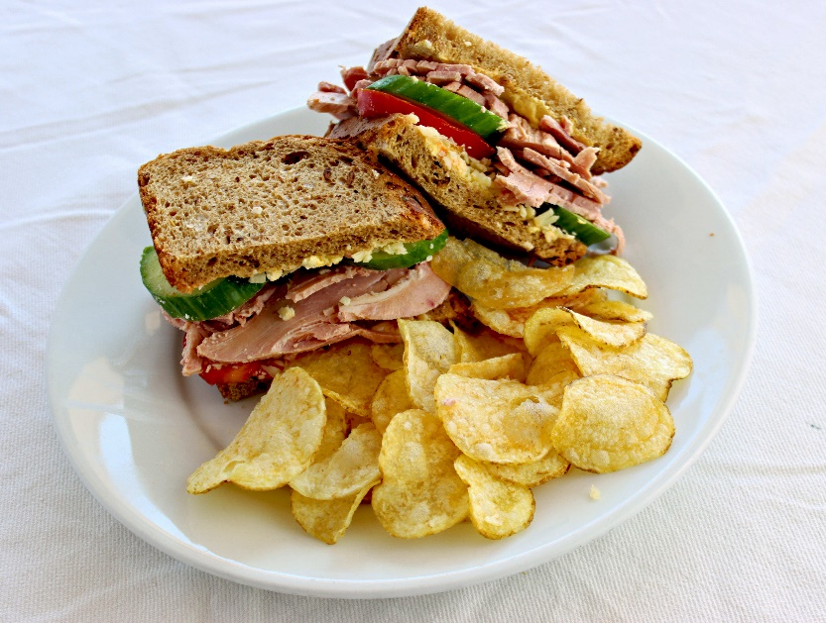
HAM OR CHEESE SANDWICHES

Containers
- Our containers ARE now microwavable, including the small black dessert ones.
- The containers CAN NOT go into the oven they will melt and are a fire and safety hazard.
- The containers are reusable.
- Please return rinsed containers to the driver, we sterilise and reuse them to help the environment
- NOT SUITABLE FOR THE OVEN

Not ready to eat at the time of delivery, please put your food containers in the fridge and then reheat to 75-degree temperature in the microwave later.
Once menus have been retuned amendments cannot be made.
Please only reheat this once to avoid any food poisoning.
We would like to thank you for your on-going support.
Any further queries or questions we are happy to help.
Thank you.

Age UK Thanet

