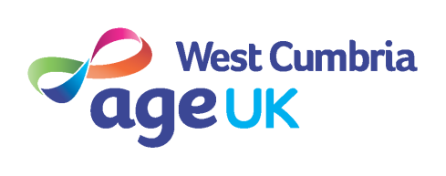

‘OUR COMMITMENT TO EQUALITY’

Age UK West Cumbria recognises that, in society, certain groups and individuals suffer discrimination. It is, therefore, the policy of the organisation to do all that is reasonably possible to promote Equal Opportunities in all areas of our work.

The organisation will make every endeavour to ensure that no individual receives less favourable consideration or treatment on any grounds eg:

Mental/Physical disability Personal Relationships Gender
Religious Beliefs Political Associations Health
Race/Ethnic Origin Social Class Age
Sexual Orientation Physical Appearance
Education Place of Birth (non local)

This policy will be implemented through training. It will be monitored, reviewed and updated as appropriate.

Age UK West Cumbria recognises that there may be situations where it proves difficult to treat people on an equal basis. Such situations will be dealt with on an individual basis with full consultation with those involved.

Where people feel they have been treated unfairly, they will be encouraged to take forward a complaint in accordance with our ‘Comments and Complaints’ procedure.

Age UK West Cumbria demonstrates its commitment to this policy by adopting a code of practice and a programme of action. The code gives guidance on employment practices, service provision and the general work of the organisation in our community. It will be reviewed, and when necessary, revised.

