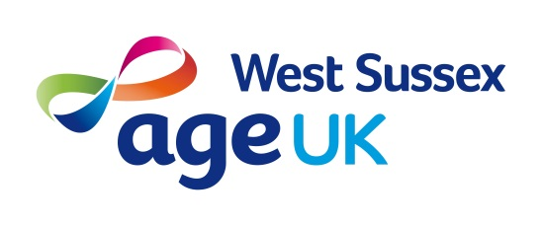Volunteering Role Profile
Outcomes Collector
Introduction
Age UK West Sussex Information and Advice (I&A) service provides information and advice to older people on matters such as welfare benefits, health and social care, housing and local services. The team is based in Littlehampton and made up of an I&A manager, 7 x advisers and
2 x I&A volunteers. The service is delivered from the office in Littlehampton between 10.00am – 2.00pm, and appointments in clients’ homes where necessary.
Helping older people to complete welfare benefit applications and other documentation is an important function of an Age UK I&A service. Finding out the results of this work is important because it can help the client attract further support and assistance; help us demonstrate our work and show funders the value we provide to local older people; and help the organisation plan further services and support to older people.
In this volunteering role, you will be helping the I&A service to establish the results of the work and outcomes of the service. It will involve making contact with older people. [This may be done by letter, online or using a telephone survey.]

Responsible to: Fiona May
Based at: Age UK West Sussex main office
Time involved: This volunteering role can be done flexibly or on an ad-hoc basis

Key responsibilities
- Making contact with recent Age UK West Sussex clients, who have been in receipt of an I&A service (by phone, letter or email)
- Assisting them to complete an outcomes questionnaire
- Collating the results and producing reports.

Previous experience and role requirements
No specific previous experience or qualifications are required as training and on-going support will be provided, but this role may suit someone who has previously worked in a customer-facing role and enjoys talking to older people. You will need to be able to demonstrate:
- excellent communication skills
- literacy, numeracy and IT skills
- a methodical and orderly approach
- an open-minded approach to individuals.

