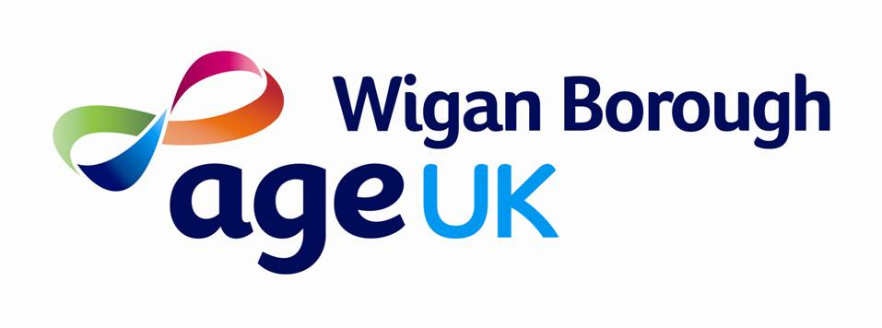

Age UK Wigan Borough Values Statement

We lead the way with PRIDE.

We are:
Person Centred
Respectful
Innovative
Dynamic
Empowering

Person Centred
The needs of older people are at the forefront of what we do. We recognise that everyone is individual and aim to ensure that the services we provide fit their individual needs. We work together with older people to enable them to get the support that they need to maximise their independence.

Respectful
We treat older people with the respect that they are due and recognise the contribution they have made to society. We respect the differences between older people. We also treat colleagues internally and people we work with externally with respect, recognising we are all part of a network of support for older people.

Innovative
If we are faced with a difficult problem, we won’t give up. We will seek alternative solutions to get the best for our organisation and the older people we work with.

Dynamic
Our organisation is constantly changing and we are quick to adapt to external pressures. We are energetic in our approach and we make large and small changes in the work we do to ensure our services are always improving.

Empowering
We aim to support older people to become stronger, more confident and in control of their lives. We aim for people within our organisation to grow in their work, develop new skills and be confident about what they do.

