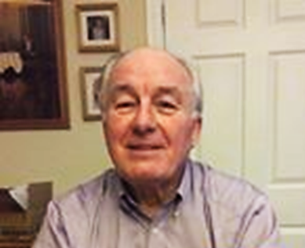

Terry is a #lockdownstar. He has been running a daily quiz for groups in his local area. Most are general knowledge quizzes but some are themed, such one he did for VE Day. The quiz is published on Facebook at about 11am and the answers can be checked at 3pm.

Terry initially did the quiz for the Good Deeds Trust Guardian Angels Group, which is based in Atherton. However, this has now been extended to other groups and you can check it out at https://www.facebook.com/terry.daly.5682

