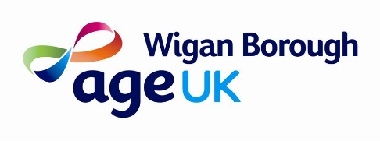

Trustee Recruitment Pack

Message from our Chair
Dear Candidate

Thank you for your interest in becoming a Trustee at Age UK Wigan Borough. We hope that when you have read through the information pack you will feel inspired to make an application.

It has been a challenging two years for Age UK Wigan Borough. The Covid-19 pandemic has meant that we have been unable to deliver some of our face-to-face services and difficult decisions have had to be made about how we provide services. We have developed Covid-19 safe working practices to enable our services to run in the most appropriate way.

As part of the brief for incoming Trustees we are looking for people with the skills and experience to support our future ambitions, so the charity has the maximum impact on improving the lives of local older people.

The priority of the Trustees and new Chief Executive Officer is to determine our future strategy as we emerge from the Covid-19 pandemic. The role will be challenging and exciting as we adapt to a changing world whilst remaining an integral part of the community.

One of the main tasks of the Chief Executive Officer, along with the management team, is to seek funding for current and future services. With the continuing decrease in Government grants for Local Authorities, who in the past have funded many of our services, it is necessary to secure financial sustainability by obtaining funding from a more diverse range of sources.

We remain optimistic about the future and are committed to continuing to support older people in Wigan Borough in every way we can.

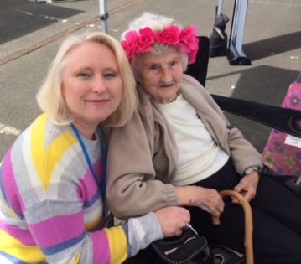
As a local Age UK we want to:

- Be the first point of contact for older people

- Deliver services that both meet the needs of older people and are person centred

- Tackle loneliness and isolation

If you’d like to help us on our journey, please read on and we look forward to receiving your application.

Thank you

Bryan Shepherd
Chair of Age UK Wigan Borough

Contents:
Page

- Trustee commitment: our ask of you 2

- About Age UK Wigan Borough 2

- Our Strategic Objectives 3

- Our range of services 4

- How we are funded 5

- Our partnership with Age UK 5

- Community Links 6

- Governance structure 6

- Role overview and Job Description (appendix 1) 7

- How to apply 7

- Trustee Commitment:
Six Board meetings a year, our AGM (usually on same day as a Board meeting), annual away day and some commitment in-between meetings to provide ad-hoc support that will work around your own commitments.
Act as ambassador for Age UK Wigan Borough and meet with key stakeholders/influencers from time to time to raise the profile of our work.
These are some of the skills we particularly are looking for:
- helping guide us in challenging funding environment – experience/skills in legacy/social enterprise/general fundraising
- Local business experience and knowledge, this could be in the private, social or statutory sectors
- HR or IT knowledge to support us identify our current and future needs
- Experience in change management and the development of building sustainable and resilient strategies
- About Age UK Wigan Borough
Age Concern Wigan Borough / Age UK Wigan Borough 1995 – 2022
Age Concern Wigan Borough was established as a charity in 1995, with an HQ office and shop on Market Street in the middle of Wigan town centre.
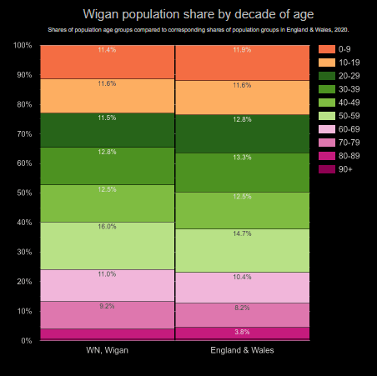
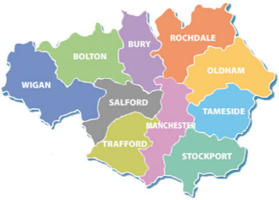
The charity’s area of benefit is the borough of Wigan, with twenty-five local government wards and seventy-five councillors; the population is close to a third of a million people. In geographical size it is the largest of the ten boroughs of Greater Manchester. The local government reorganisation of 1974 brought together one county borough, Wigan, one borough, Leigh, eleven urban district councils and one rural district council. Although almost fifty years have passed since that reorganisation, the locals’ sense of a particular identification with the place whose name is now descriptive rather than administrative is still very strong.
The age profile of Wigan is skewed towards the older cohorts, mortality rates across the borough vary by as much as eleven years between the poorest and richest parts. The legacy of Wigan’s industrial past is still evident in the high rates of heart and lung disease, with the incidence of COPD still significant. As the charity grew, it endeavoured to provide services and support that answered the needs of an older population.
One measure of the charity’s success is that its core service of information and advice has helped older people across the borough to access at least £1,800,000 of benefits each year over the past three years; benefits to which they were entitled but might not, without the charity’s help, have received.
In 2004, Age Concern Wigan Borough became an incorporated charity, following a recommendation by The Charity Commission. One consequence of the new status was that any chair of the trustee board could serve, as a maximum, two consecutive three year terms as chair.
In 2010/2011, the two major charities for older people in the UK, Age Concern and Help the Aged, merged and became Age UK. As a consequence, our charity took on a new working name – Age UK Wigan Borough, although our legal name remains Age Concern Wigan Borough.
From around 2010, the imposition of a national strategy of austerity by central government meant a profound change for all voluntary organisations. The charity’s growth slowed and then stopped. Nevertheless, despite the challenges of the last decade, where there have been opportunities for development they have been taken. For example, our paid-for Support at Home services have flourished, but it remains the case that services commissioned by other bodies or supported by time-limited grants always see themselves as having a threat hanging over them – the threat of cancellation of commissioning or the ending of the grant.
Perhaps the most significant challenge for our charity in the future - in a world where funding is increasingly limited - is to continue to serve the needs of local older people, but in a more entrepreneurial and financially sustaining way. The balance sheets of Age UK Wigan Borough over the past few years do not make for easy reading, although we are fortunate in that our level of reserves are still healthy due to good fiscal management during the years of growth.
The past months, since March 2020, have been particularly challenging, but it is a measure of the determination, resilience and the leadership of the charity that Age UK Wigan Borough has not only come through but in a quite remarkable way has demonstrated how essential its work is to the wellbeing of the whole fabric of the borough’s life. During the lockdown periods, when some of our services had to be temporarily suspended, we ensured essential help and support was provided to local older people. This included shopping and prescription collections for older people who were shielding or unable to go shopping during this difficult period; the regular distribution of free food parcels and hampers; and ‘check and chat’ phone calls which were very popular.
The services and support offered by Age UK Wigan Borough wouldn’t be possible without the dedication, commitment and passion of our staff and volunteers, along with support from partners and stakeholders. At the moment we currently employ 48 members of staff (8 full-time; 10 part-time; 30 on zero hour contracts). Up until the pandemic struck, we had around 50 volunteers, mostly older people, but many have not yet felt able to return.
- Our Strategic Objectives
As a charity, we regularly review our aims and objectives and consult with local older people, both those who use or have used our services, and others, to ensure our aims and objectives are in line with their needs and wishes.
Our Mission Statement is to provide high quality services designed to offer support to older people across the Borough. In doing this we will help older people live their lives as they would choose.
Our Strategic Aims underpin the work of our organisation and will be reviewing these as part of our new 3-year strategic plan. Our current strategic aims are:
- To market ourselves so that older people know about us and can get in touch easily;
- To work with others to increase the opportunities available to older people;
- To provide quality services which older people would choose and value;
- To encourage and support older people to make their views known in the planning, design, delivery and evaluation of services;
- To develop our internal systems and processes to support more effective service delivery.
These aims are reflected in our key priorities which are incorporated in our annual Business Plan which is used to help guide all our activities and provides strategic focus.
- Our range of services
The services currently offered by Age UK Wigan Borough include:
Information and advice:
Our information and advice service is free and assists all people aged 50 and over as well as their relatives, friends and carers who are resident within the Borough of Wigan. We offer information, advice and practical assistance such as completion of a benefit claim or other application forms, general telephone advice is available including signposting to other services.
Support at Home:
Handyperson assistance we provide includes:
- Working with health and the local authority to support hospital discharge and older residents to remain at home
- Home security and safety including levelling flags and pathways and installing key safes
- Hand rails and Grab rails
- Putting up shelves, pictures and curtain rails
- Changing light bulbs
Our excellent team of Home Helpers are able to tailor to individual needs and provide a range of services, including:
- Vacuuming & dusting
- Changing Bedding
- Cleaning the inside of windows
- Ironing & laundry
- Cleaning out cupboards
- Small, local shopping
Bright Days:
- We work in partnership with other services and organisations to provide a range of activities to suit everyone, located at various venues within Wigan Borough. Our activities include Walking Football, Silver Choir, Ukulele Club, Craft Club, Jamming Sessions, Classic Cinema Club and Soup and Sandwich.
For further information about each of these services and our work please visit our website: https://www.ageuk.org.uk/wiganborough/
- How we are funded
In 2020/21, our total incoming resources were £749,155 and total expenditure £748,996.
Over many years of successful operation, the charity has built up cash reserves of just over £1 million which have allowed trustees to take a long term view of the organisation’s future, despite the challenges of the changing funding environment and, more recently, the pandemic.
In accordance with the view of the Board of Trustees and charity legislation, income is derived from a variety of sources:
- Grants from the local authority and National Lottery for specified services such as Information and Advice and our Bright Days project which offers many opportunities for older people to meet up and enjoy a programme of activities on-line or in person to support tackling isolation and in-activity.
- Our Support at Home service provides a range of paid-for services including:
  - Income from our Local Authority – supporting the Handyperson Service
  - The Home Help initiative provides a range of paid for services under specific support packages to an increasing number of borough residents.
- Donations and occasional legacies have supported the operating costs of the charity and helped to fund specific projects in line with donors’ wishes.
Finances are managed under the control of the Chief Executive Officer assisted by a full-time Finance Manager who is part of the senior management team. This is supported by external providers who assist with budget monitoring and preparing the records for our annual audit.
As local authority and traditional grant funding becomes more scarce, our organisation is embarking on identifying more diverse sources of finance for projects that meet our mission to improve the lives of older people in the Borough. Our resources mean that the challenges can be addressed in a measured way with a view to the long-term sustainability of the charity.
- Our partnership with Age UK
Age UK Wigan Borough is an independent local charity, but we share a Brand Partnership with Age UK. This trusted and well-known brand helps to open doors for us locally. Of course, we always have to deliver, but it helps to have the strength of the Age UK brand with us.
Nationally, there are around 130 Age UKs, each with a defined geographical area and separate charity number. Our charity number is 1103022 and we are a company limited by guarantee – our company number is 5004789.
We align ourselves with the work Age UK does nationally by supporting their campaigns, sharing reports and news stories, and using their research to underpin grant and tender applications. Age UK also provides our local MPs with information about older people that can help drive forward local policies and influence at a national level.
Being an Age UK Brand Partner brings certain responsibilities to deliver services to agreed quality standards and to subscribe to shared values of being:
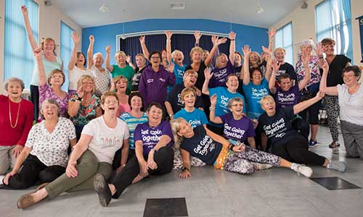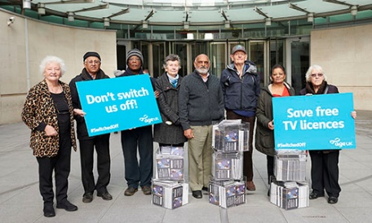
We are Focussed We act together We are bold
While we are aligned with Age UK, we are still a local and independent charity. The services we deliver, the money we raise, the people we support are all in Wigan Borough and our Trustees are responsible for our strategy, polices and legal compliance.
- Community Links
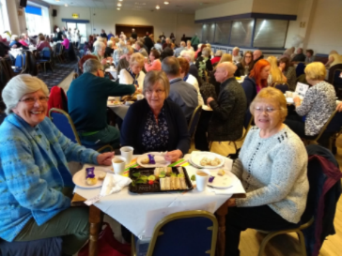
We believe in working with others to make Wigan Borough a better place to grow older and have a range of networks and partnerships to ensure we can:
• Raise awareness of the support and services we offer
• Stay up to date with local developments
• Represent the voices of older people
• Influence local services.
These community links can also generate income, contracts and services. Examples of organisations we currently or have worked with include:
Age UK, Wigan Council, GM Ageing Hub, Be Well, Wrightington, Wigan and Leigh NHS, Soil Association, Citizens’ Advice Wigan Borough, Wigan AFC and many local community groups.
- Governance structure
Age UK Wigan Borough has one subsidiary company Age UK Wigan Borough Enterprises Ltd.
As a not-for-profit organisation, all income generated through paid for services helps to support our work with older people in local communities.
Board & committee
Age UK Wigan Borough has a Board of Trustees with between 3 and 8 Trustees at any time. Our Trustees ensure we have a clear strategy and that our work and goals are in line with our vision. The Trustees have independent control over, and legal responsibility for, the charity’s management and administration. They are also responsible for the corporate governance of the organisation and report annually to the Charity Commission and Companies House.
We have Board meetings six times a year and an annual away day. The Finance, Audit & Risk sub-committee also meets six times a year. We have no other subcommittees at this time. There may be other ad hoc groups or task groups formed from time to time as required.
- Role overview
Our trustees are essential to our success as a charity. The role is essentially strategic, with Trustees focussing on the overall direction of the organisation and monitoring performance of the organisation and senior management.
As a trustee, you will set our direction and hold staff to account, making sure we are always doing the best we possibly can for older people across Wigan Borough. Trustees focus on the overall direction of the organisation, whilst monitoring performance of the organisation and the leadership team.
The Board of Trustees are responsible for the corporate governance of the organisation and reports the actual achievements on an annual basis to Charity Commission and Companies House.
The Board accepts a range of skills and experience given the range, variety and diversity of the organisation. These include financial management, governance and legal matters, health and social care issues, fundraising, HR, public relations, marketing, information technology, mental health and wellbeing, education and learning.
New trustees are given an induction to the Charity and an opportunity to spend some time with the Senior Leadership Team and other key members of staff. There will be opportunities for specific training for the Board as a group and individual trustees as identified. Trustees serve a three-year term of office and can be re-elected to serve additional three-year terms.
Trusteeship can be rewarding for many reasons, from a sense of making a difference, to gaining new skills and experiences and new understanding, and although it is an honorary position, trustees will be reimbursed for out of pocket expenses.
Job Description
Please see appendix 1.
- How to apply
If you would like an informal discussion about any aspect of becoming a Trustee for Age UK Wigan Borough then please contact Bryonie Shaw, CEO by calling 01942 615892.
Closing date for applications is 25th February 2022, 5pm

Appendix 1: Role description for Board members
Who are the charity’s trustees/directors?
The Charities Act 1993 defines charity trustees as those responsible under the charity’s governing document (the Articles of Association) for controlling the administration and management of the charity. This is the case regardless of the terminology used; in Age UK Wigan Borough (AUKWB), the charity trustees are the board of directors and comprise the Chair and up to eight elected members.
The role of the Board
The Board maintains a strategic overview of the charity and are responsible for key decisions such as setting an annual budget, agreeing a business plan, undertaking a risk assessment and ensuring the charity meets its key legal obligations.
The Board must always act in the best interests of AUKWB, board members must strive to maintain the good reputation of the organisation and be effective ambassadors for its work.
The directors must act as a group and not as individuals.
Duties of a Board member
Ensure AUKWB is carrying out its purposes for the public benefit
You and your co-trustees must make sure that the charity is carrying out the purposes for which it is set up, and no other purpose. This means you should:
- understand AUKWB’s purposes as set out in its governing document
- plan what AUKWB will do, and what you want it to achieve
- understand how all of AUKWB activities are intended to further or support its purposes
- understand how AUKWB benefits the public by carrying out its purposes
Comply with your AUKWB governing document and the law
You and your co-trustees must:
- make sure that AUKWB complies with its governing document
- comply with charity law requirements and other laws that apply to AUKWB
- take reasonable steps to find out about legal requirements, for example by reading relevant guidance or taking appropriate advice when you need to.
Registered charities must keep their details on the register up to date and ensure they send the right financial and other information to the Charity Commission and Companies House in their annual return or annual update.
Act in AUKWB’s best interests
You must:
- enable AUKWB to carry out its purposes
- with your co-trustees, make balanced and adequately informed decisions, thinking about the long term as well as the short term
- avoid putting yourself in a position where your duty to AUKWB conflicts with your personal interests or loyalty to any other person or body
- not receive any benefit from AUKWB unless it’s properly authorised and is clearly in the charity’s interests
Manage AUKWB’s resources responsibly
You must act responsibly, reasonably and honestly. You and your co-trustees must:
- make sure AUKWB’s assets are only used to support or carry out its purposes
- not take inappropriate risks with AUKWB assets or reputation
- not over-commit AUKWB
- take special care when investing or borrowing
- comply with any restrictions on spending funds
You and your co-trustees should put appropriate procedures and safeguards in place and take reasonable steps to ensure that these are followed.
Act with reasonable care and skill
As someone responsible for governing a charity, you:
- must use reasonable care and skill, making use of your skills and experience and taking appropriate advice when necessary
- should give enough time, thought and energy to your role, for example by preparing for, attending and actively participating in all trustees’ meetings
Ensure your charity is accountable
You and your co-trustees must comply with statutory accounting and reporting requirements. You should also:
- be able to demonstrate that AUKWB is complying with the law, well run and effective
- ensure appropriate accountability to members, if AUKWB has a membership separate from the trustees
- ensure accountability within AUKWB, particularly where you delegate responsibility for particular tasks or decisions to staff or volunteers
When you and your co-trustees make decisions about AUKWB, you must:
  - act within your powers
  - act in good faith, and only in the interests of your charity
  - make sure you are sufficiently informed, taking any advice you need
  - take account of all relevant factors you are aware of
  - ignore any irrelevant factors
  - deal with conflicts of interest and loyalty
  - make decisions that are within the range of decisions that a reasonable trustee body could make in the circumstances
You should record how you made more significant decisions in case you need to review or explain them in the future.

