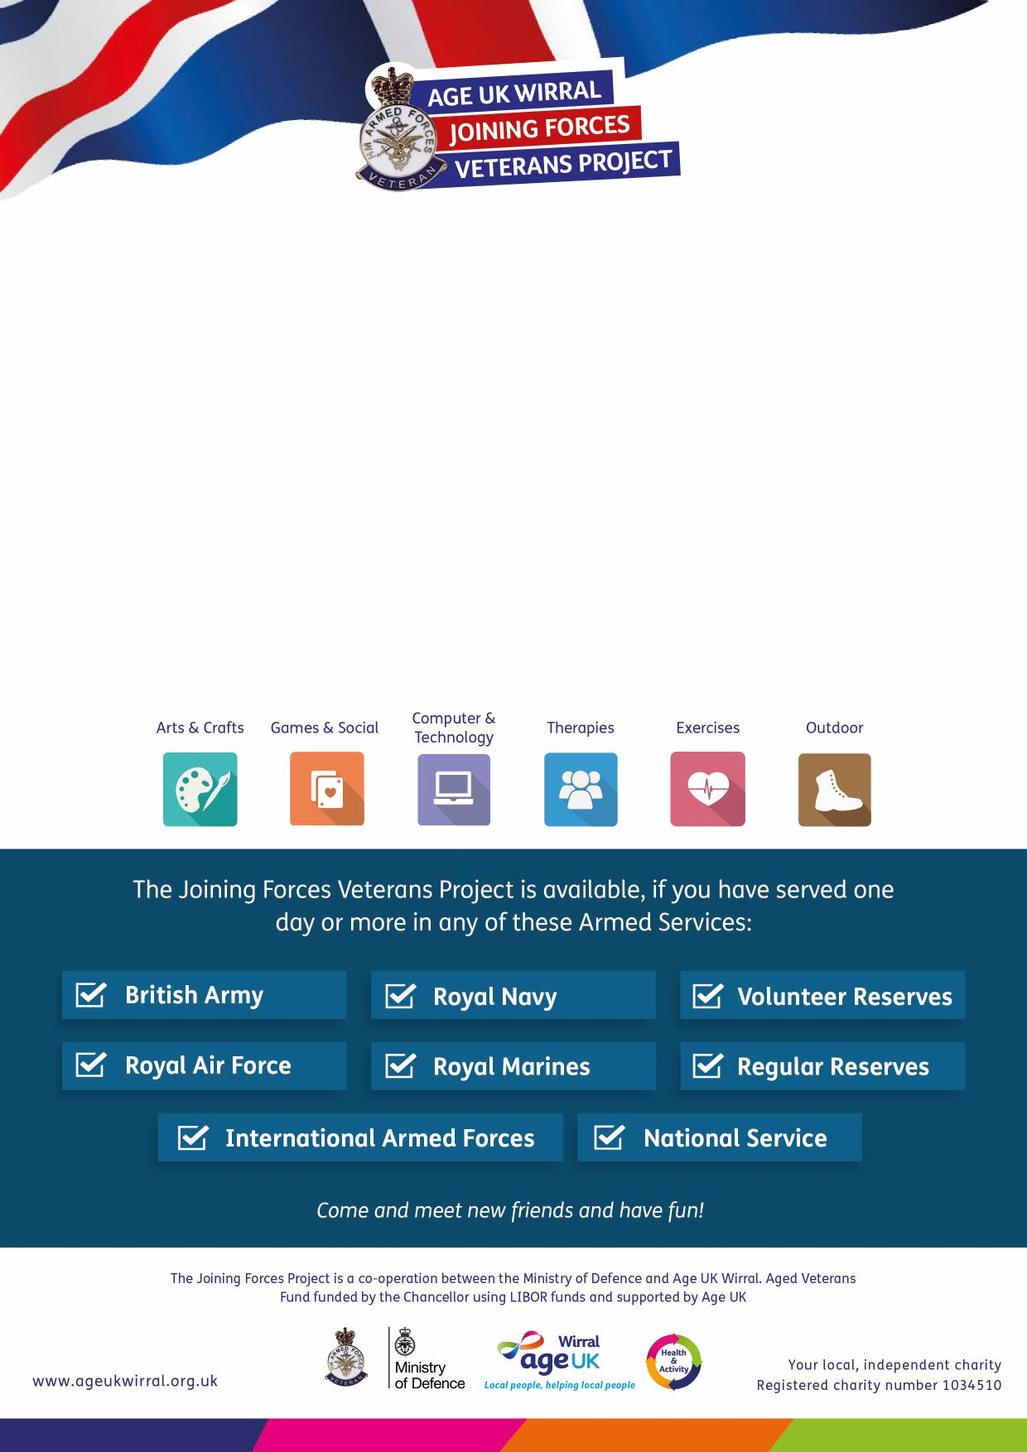

Research, Explore and Discover your...
FAMILY HISTORY
Meadowcroft Activity Hub
304 Spital Road, Bromborough CH62 2DE

on the first and third Friday of each month
10am – 12pm
(Starting 17th November 2017)

Join our beginners Family History Club. Learn tips and hints on how to
research and build your family tree in a relaxed and friendly environment.

For more information please call:
0151 482 3456

The Joining Forces Veterans Project provides you with a range of activities and
services designed to meet your needs, right here in Wirral.

For more information please call:
0151 482 3456
The Joining Forces Veterans Project provides you with a range of activities and
services designed to meet your needs, right here in Wirral.

