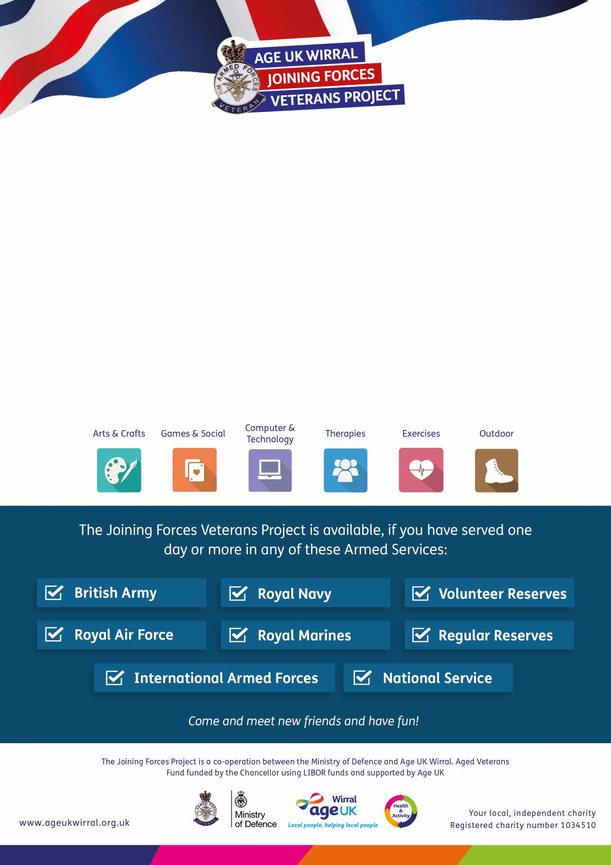

For more information please call:
0151 482 3456

Veteran’s Reminiscence Group
Wirral Military Community Services
Unit 7, Brandon Street, Birkenhead, CH41 5HN

On the first Wednesday of each month
2pm – 4pm
Re-call, re-live and re-experience your service in our reminiscence group.
Share your stories of life in and out of the Forces with your peers in a
comfortable, relaxed, friendly environment.

The Joining Forces Veterans Project provides you with a range of activities and
services designed to meet your needs, right here in Wirral.

For more information please call:
0151 482 3456
The Joining Forces Veterans Project provides you with a range of activities and
services designed to meet your needs, right here in Wirral.

