**Candidate Information Pack:**

**Café Assistant**

**Registered Charity No. 1034510**

**CONTENTS**

**Section 1 – Introduction from Jamie Anderson, Chief Executive 3**

**Section 2 - About Age UK Wirral 4**

**Section 3 - Job Description & Person Specification 8**

**Section 4 - How to apply 12**

**Section 5 - Top Tips for your application and interview 13**

**Section 6 - Key Contact Details 15**

**Section 1 - Introduction from Jamie Anderson, Chief Executive**

I would like to thank you for showing an interest in working for Age UK Wirral. We are a local, independent and innovative Wirral-based organisation, offering a large range of services and activities which support and engage with over 30,000 local people each year.

We are extremely proud of the work that we do, and we seek to be a diverse organization representative of the communities we serve. We want to make Wirral a great place to grow older, and hope that you do too. Our team of staff and volunteers are incredibly important to us, as demonstrated by us being awarded Investors in People Platinum Status.

Staff and volunteers joining the organization need to embody the values that underpin our culture, and this Candidate Application Pack has been produced to provide you with information about what working for us really means before you submit your application.

The role of Café Assistant is to provide assistance in our new Cafés in West Kirby and Tranmere. Taking responsibility for preparing light lunches, snacks and refreshments to our customers, you will create a warm and welcoming environment where people feel safe, supported and included whilst receiving the best customer service possible.

I hope that you feel that this is the right place for you to work, and we look forward to your application.



**Jamie Anderson**

**Chief Executive & Nominated Individual**

**Section 2 - About Age UK Wirral**

**History of Age UK Wirral**

The roots of Age UK Wirral go back to 1948 when, in a small office in Hamilton Square, an Old People's Welfare Committee was formed, specifically devoted to the welfare of elderly people in the Birkenhead area. Back in those early days one volunteer provided an advice and information service for local elderly people, and during the early 70's a special house contents insurance service for elderly people - which had been developed by Age Concern England - was promoted locally by two volunteers. It was then that the organisation took the new name of **Age Concern Birkenhead** which it kept until 1988 when it was reconstituted as **Age Concern Wirral**, taking on responsibility for the whole of the Metropolitan Borough of Wirral.

A further name change came in May 2011 when we became an Age UK Brand Partner and, whilst retaining the legal constitutional name of Age Concern Wirral, we adopted the working title of **Age UK Wirral**.

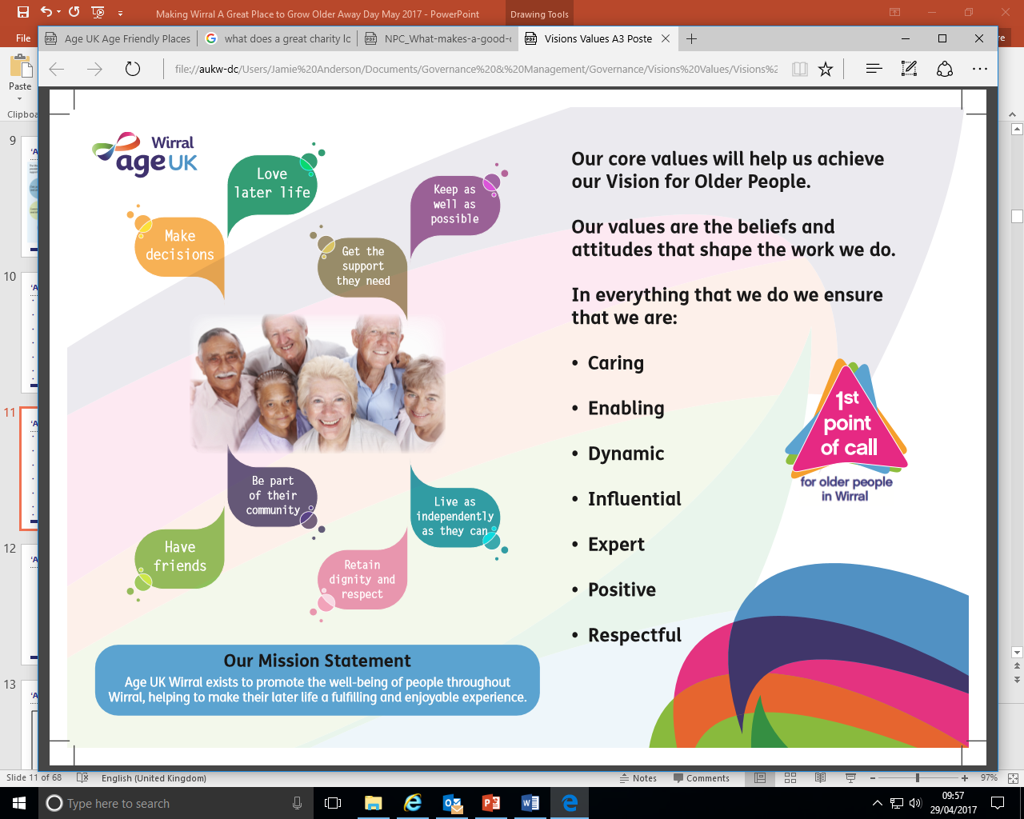

**The Age UK Network**

Age UK is Network of local, autonomous registered charities (‘Brand Partners’), collectively forming the largest organisation working with and for older people in the UK, alongside national partners – Age England, Age Cymru, Age Scotland and Age Northern Ireland.

Brand Partners are completely independent organisations, responsible for establishing their own policies, determining their own activities and raising their own funds. United through use of a household name and branding, Brand Partners adhere to the Age UK Organisational Quality Standards (OQS), to ensure the quality of governance and operations across over 200 independent organisations.

**Age UK Wirral - Today**

Whilst the name of the organisation, its size and range of services have changed considerably over the years, our *raison d'être* has remained the same - to support and care for people in Wirral. Today, the organisation employs approximately 150 paid staff, works with over 350 volunteers and has a turnover of around £3 million per annum.

As one of the largest charities in Wirral, we deliver a wide portfolio of services and activities. Our charitable work fall under 7 key thematic areas:

* Dementia & carers
* Digital inclusion
* Information and advice
* Out of hospital services
* Practical support
* Wellbeing

Please see our website [www.ageukwirral.org.uk](http://www.ageukwirral.org.uk) for up-to-date information about our current work. We deliver charitable services funded through our self-generated income, services under contract to the local statutory sector and have a number of projects funded through charitable grants. Our unrestricted income comes through fundraising, the profit from our network of charity shops in Wirral and donations and legacies from members of the public.

**Our Vision & Values**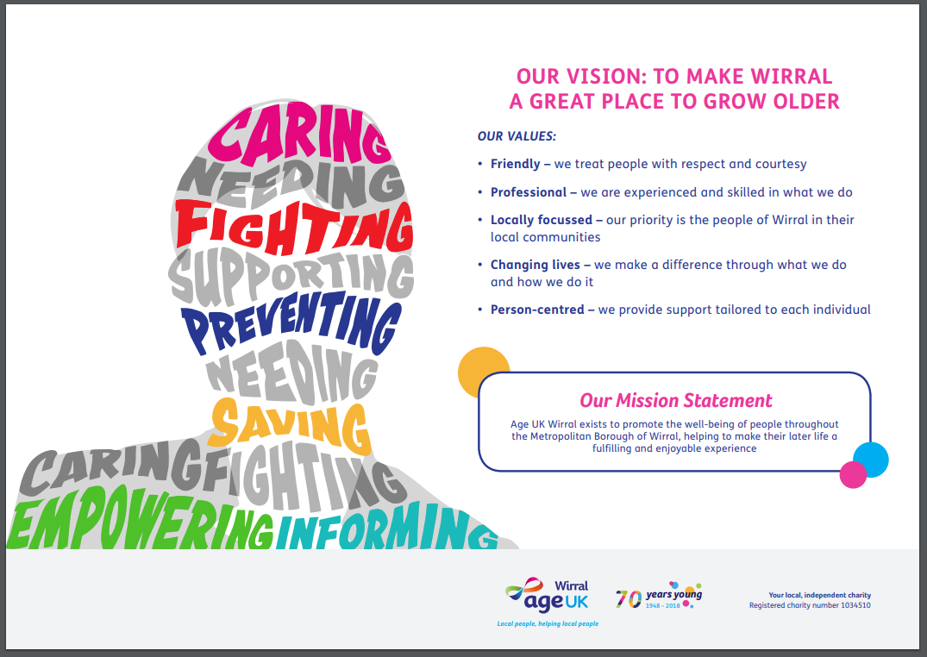

Our Vision for Age UK Wirral is that it will:

• Be a high profile organisation, visibly active in the community, and the first point of contact for older people in the Borough wanting information or support.

• Deliver a range of high quality services and activities that respond to the needs, expectations and aspirations of people in the local community, making a difference to their later life and adding social value.

• Have a focus on early intervention and prevention of deterioration in peoples’ health and well-being, in order to maintain their independence and quality of life for as long as possible.

• Have clearly defined charitable services as well as those delivered under contract.

• Have a variety of secure funding streams, from both external sources and self-generated income, to establish a sound, firmly controlled financial basis for its continuing operation and development.

• Be working in partnership rather than competition if this achieves the best result for older people.

• Have a workforce we can be proud of, who feel valued, supported and respected.

**Working for Age UK Wirral**

People have many different reasons for coming to work with and for Age UK Wirral. Some people may say that they have a ‘belief in the cause’ and others may say that they wish to ‘help other people’. Prospective applicants need to recognize that working for a charity is not a case of ‘getting out of the rat race’ as working in charities is anything but a soft option: it is just as demanding as the world of business or public service, and often may be more regulated in terms of operating as a registered charity and in providing a range of registered care services.

Age UK Wirral takes pride in the way in which it operates the business of the organisation. The organisation holds a number of quality marks, including Investors in People at Platinum Award level, Age UK Organisational Quality Standards, the Advice Quality Standard and Mentoring & Befriending Accreditation.

Staff working for the organisation can expect to receive:

* Full induction into Age UK Wirral.
* Training and support relating to their job role.
* Regular supervision, support and appraisal.
* Ongoing personal and professional development.
* The opportunity to become involved in the planning processes of the organisation.

We thrive through staff who are achievers, who get things done, are willing to go ‘the extra mile’, who can influence and convince others, and who enjoy tackling problems which cannot be solved easily. The reward of this work is the satisfaction of doing something which is worthwhile – and doing it well.

The organization can only be as good as the people in it – we are looking for individuals who take pride in their work, who recognize what a privilege it is to share in local people’s lives with them and who want to take personal responsibility in maintaining and improving standards.

The main factor which differentiates the ‘voluntary’ sector from other areas of work is the fact that most charities rely largely and historically on unpaid volunteers – as trustees, helpers, collectors, campaigners and general supporters. Paid employees have to tread carefully in their relationships with volunteers. They must be sensitive to volunteers' views, for example, with regard to expenditure and overall policy. Volunteers cannot be ordered; they must be asked, inspired and directed without losing their goodwill.

Everyone likes to think they are ‘good with people’. Working in a charity - balancing the requirements of service users, clients, customers, trustees, volunteers and paid staff - puts this platitude to the test. What is needed is an ability to deal with people at all levels, not by talking down (or up) to them, but through a genuine understanding and respect for their situation.

We operate a ‘coats off’ culture and general versatility. The organisation is a place where purpose, motive and mission matter and where professionalism is the goal. We need and expect everyone working for the us to be willing and able to help with all sorts of tasks and to be flexible in their approach in helping to meet the needs of the business. Our staff very much have a ‘can do’ attitude. We aim to ensure that contact with Age UK Wirral through any one of our services or activities opens the door to the whole range of available support.

**What our staff need**

Our staff need to have all or most of the following skills and attitudes:

* Genuine respect for older people and desire to enhance their quality of life.
* Recognition that voluntary does not equate to amateur, and a commitment to maintaining professionalism and high standards in every aspect of what we do.
* Flexibility and a willingness to adapt to work with the wider team to accomplish our goals.
* Ability to remain cheerful under stress, and ever helpful to people (however awkward) who may be potential service users, donors or volunteer helpers.
* A creative and innovative approach to making the most of resources (people, money, equipment, buildings).
* Sense of humour, a positive ‘can do’ attitude and a zest for life!

We believe that Age UK Wirral provides quality services that are appreciated and valued and welcome new staff and volunteers who want to be part of that mission.

We aim to make time spent within the organization an enjoyable experience for staff and volunteers as well as for our clients, and believe that this will be achieved through the satisfaction of knowing we have made a real difference to the lives of older people.

**Section 3 - Role Description & Person Specification**

|  |  |  |  |
| --- | --- | --- | --- |
| **YOUR TIER** | Navigator | **PRIMARY FOCUS** | Café Assistant |
| **AREA OF WORK** | West Kirby and Tranmere | **YOUR LEADER** | Café Lead |
| **SALARY (PER HOUR)** | | £12.21 per hour | |
| **FUNDING AND LENGTH OF CONTRACT** | | Age UK Wirral | |
| **CONTRACTED HOURS PER WEEK** | | Average 21 Hours Per Week – Holiday  Working on a rota system over the year  Opening Times of Cafes  Marine Place – 9am-4.30pm  St Catherines Café – 7.30am-3.30pm | |
| **LOCATION**  *NB – You may be required to work from other locations as part of the service delivered for Age UK Wirral* | | Marine Lake Health Centre, West Kirby and St Catherines Hospital, Tranmere | |

|  |
| --- |
| **IMPACT OF YOUR ROLE ON LOCAL OLDER PEOPLE** |
| People visiting our cafes will feel safe, supported and welcomed whilst receiving the best customer service possible. |

|  |
| --- |
| **THE VALUES YOU WILL SHARE WITH ALL OF US** |
|  |



|  |
| --- |
| **WHAT YOU GET IN RETURN FOR WORKING FOR US** |
| * Great terms and conditions, including:   + Generous annual leave – plus bank holidays   + 3% pension contribution   + Company sick pay scheme   + Reimbursement of all travel expenses incurred in the course of work * A culture which helps you to grow and develop through:   + Supportive and inclusive work environment where everyone is listened to   + Regular supervision and appraisal   + Opportunity to truly make a difference in a person-centred organisation   + Full Corporate Induction and access to ongoing learning and development   + Being part of a quality organisation accredited Platinum by Investors in People |

|  |
| --- |
| **YOUR ROLE** |
| As the Café Assistant you will:   * Work with the lead and team and all other supporting volunteers to create a welcoming environment and a high level of service to customers is maintained at all times. * Assist in the preparation and cooking of the meals. * To serve meals in accordance with cafe protocols. * Operate the till to take payments from customers. * Ensure the required checks and inspections are undertaken in line with Food Safety. Regulations and Health and Safety requirements. * To clean the kitchen, cafe and associated areas to ensure the cleanliness of the facility is maintained to the highest standard. * To ensure all food served is at the correct temperature, has not been hot held longer than is recommended and is presented nicely and in portions size requested by the customer. * Ensure all tasks undertaken are performed to the required standard and HACCP guidelines and records are adhered followed. * Ensure the required checks and inspections are undertaken in line with Food Safety Regulations and Health and Safety requirements. * Observe for any areas of concern or safeguarding and report any concerns you have to your line manager straight away. * Record and report all incidents and accidents in accordance with Castell policies and procedures. * Listen and consult with customers enabling their participation in all matters which affect them and liaise with colleagues on all matters effecting the wellbeing of customers. |
| **BEING PART OF THE ORGANISATION** |
| **As colleagues, we all agree that we will work together by:**   * Living the values of the organisation at all times. * Recognising that change is essential to our growth and development. * Looking for solutions and having a ‘can do’ attitude. * Seeing ourselves as part of the bigger picture and playing our role in that wider team. * Making sure that everything we do enriches the lives of local people. * Looking after our own wellbeing and that of those around us. * Cascading the culture of the organisation constantly. * Always acting in the best interests of the organisation and local people. * Ensuring safeguarding is always at the forefront of our minds. * Being comfortable in raising issues and concerns and working together to find solutions. * Recognising, celebrating and support the contribution that our volunteers make. * Celebrating the strengths and assets that diversity brings to our organisation. * Understanding the strategic direction of the organisation and playing our full part in that journey. * Treating each other with respect. * Contributing to ongoing development of the organisation. * Always seeking to achieve the best impact through scarce resources. * Adhering to the policies and procedures of the organisation at all times. * Taking part in ongoing learning and development. * Recognising that fundraising is a collective responsibility. * Undertaking additional appropriate duties when requested and appropriate to grade and role. |

|  |
| --- |
| **OUR GOLDEN THREADS** |

|  |
| --- |
| **We are united through our Golden Threads which mean that we all:**   * Work together to make the best possible impact for local people. * Work in a person-centred way, focussed on maximising people’s strengths and assets. * Keep focussed on local people across Wirral. * Treat people as we would expect to be treated. * Have a ‘can do’ attitude with a genuine desire to change people’s lives for the better. * Embed quality conversations with people, identifying people’s goals and supporting them to achieve them, at the heart of what we do. * Have high levels of personal integrity – we are open, honest and transparent. * Embrace a learning culture where we improve from our mistakes. * Embrace team working. * Commit to working with people to empower them. * Have good ICT skills to enable us work at our best. |

|  |
| --- |
| **PERSON SPECIFICATION** |

|  |
| --- |
| **Essential Criteria against which shortlisting will take place are:**  ***You must demonstrate in your application form how you meet all of the Essential Criteria if you are to be considered for shortlisting.***   * Hold or be working towards Food Hygiene Level 2. * Experience of working in a busy café/catering environment |

**This job description is intended as a summary of the main elements of your job described and may be amended from time to time, in consultation with you.  It does not form part of your formal Terms and Conditions of Employment.**

|  |  |
| --- | --- |
| **Date last updated** | **February 2025** |

**Section 4 - How to apply**

Our application process is via our website using our [online application form (click here to complete)](https://forms.office.com/e/NDX23gxXzB) We strongly suggest that you ensure that you have read the whole of this application pack before commencing your application – particularly Section 5 which gives more information about what we are looking for in an application and, should you be invited for interview, top tips for interview.

It is important to remember the key dates for this recruitment process:

**Closing date for applications to be submitted online – TBC**

**Interview dates for successful applications – TBC**

**The Application Form**

We recommend you make sure that you have the following information available when you commence the application as there is no facility to save and return to and incomplete application.

|  |  |  |  |
| --- | --- | --- | --- |
| **Section 1 – Personal Details** | Name  Address  Telephone Number  Email Address | **Section 5 – Education & Qualification** | General Education – subjects, level, grade, year  Further Education – course, qualification, grade, class |
| **Section 2 – Current Employment** | Employer Name  Role  Description of role  Start date  Salary  Notice period | **Section 6 – Additional Details** | Volunteering or public service duties  Driving licence / transport  Relationship to anyone in Age UK Wirral  Details of current or previous disciplinary / criminal convictions |
| **Section 3 – Previous Employments** | Dates, Employer, Role, Description, Salary, Reason for leaving | **Section 7 – Age UK Wirral Values** | Evidence of how you embody our 5 values.  Evidence of how you embed equality, diversity and inclusion. |
| **Section 4 – Referees** | Names, addresses, email and telephone numbers for two referees | **Section 8 – Demonstrating Skills & Competencies** | Evidence of how you meet the Essential Criteria Evidence of how you are the best candidate for this role and Age UK Wirral. |
| **Section 8 -** | Anonymous EDI monitoring information | | |
| **Section 9 – Submission** | **Please note that when you submit your application you will be given the option to print and / or save a copy of your answers. We strongly recommend that you do this so that if you are called for interview you can reread your application in advance.** | | |

**Section 5 - Top Tips for your application and interview**

**Application form**

* Answer every question.
* Your application form will be our first impression of you – make it count! The effort you put into your application tells us a lot about the effort you would put into your work.
* Do not type in BLOCK CAPITALS – this makes it very difficult for the Interview Panel to read.
* Make sure you are answering what the question is actually asking – always read the question twice.
* Don’t assume that we know anything about you – we can only go off what you write in the form.
* When we shortlist, we will be assessing against all of the criteria in the Job Description – please make sure that you cover all evidence in your application form.
* Answer honestly.
* If you are asked to demonstrate skill, experience and competency please remember the following:
  + You can use experiences from employment, voluntary work or your personal life.
  + Lots of skills and experiences are transferable. For example, you may not have managed a budget in work but you might be responsible for managing your household budget.
  + Do not write something like ‘I have managed projects’. You need to be more precise and explain how you have actually managed a project.

**If you are called for interview**

* We know that interviews can be difficult, and we want to ensure you can showcase your best talents, skills and potential. We have designed interview questions that help us assess your skill level and fit with the job description, golden threads and values of our organisation.
* Make sure you reread your Application Form and the Candidate Application Pack before your interview – these are the documents we will be asking questions around.
* Remember we are not trying to catch you out – we can explain questions or repeat them if you would like us to. If our questions are long, we may also prompt you to help you to cover all components.
* We want to see your personality and get to know the whole of you! We employ people who we think will enjoy working for our organisation – don’t be afraid to bring in examples from your personal life as well as your professional life.
* Do your research - our website and social media pages will give you insight into our organisation and the way we work. Show us that you really want to work for our organisation.
* We will only score on the answers given at interview - tell us everything even if we have met before, or if you covered it in your CV/application.
* Virtual interviews can add in another element of stress – try to ensure you are near your WIFI connection and ensure that your camera and microphone are working prior to interview. We will have your mobile number with us if there are technical difficulties and will continue interviewing via phone if it cannot be solved.
* We use Microsoft Teams as a virtual platform, you should be able to easily join the calls through the link that will be sent to you. Have a practice run beforehand!
* If your interview involves a case scenario, be mindful of the time allocated.
* Feel free to have notes with you – your interview is not a test of your memory!
* We will be writing down everything that is said, so be prepared for some pauses in the conversation.
* We will ask you at the end of your interview if you have any questions for the Interview Panel. A candidate who has questions to ask shows that are genuinely engaged in the process.

Good luck!

**Section 6 - Key Contact Details**

If you have any questions or queries about the recruitment process, please contact:

**Sue Sanford**

**PA to the CEO**

**0151 482 3456**

[**suesanford@ageukwirral.org.uk**](mailto:suesanford@ageukwirral.org.uk)

If you want to find out more about the organisation, please visit our website:

[**www.ageukwirral.org.uk**](http://www.ageukwirral.org.uk)

Alternatively, why not follow us on social media?

**Twitter - @ageukwirral**

F*or information about the organisation’s services and activities*

**Twitter - @ageukwirralCEO**

*Our Chief Executive’s ‘blog’ about the organisation*



**Facebook - @AgeUKWirral**

*Constant news updates about what is going in the organisation*

**Age UK Wirral**

**Head Office**

**Devonshire Resource Centre**

**141 Park Road North**

**Birkenhead, Wirral**

**CH41 0DD**