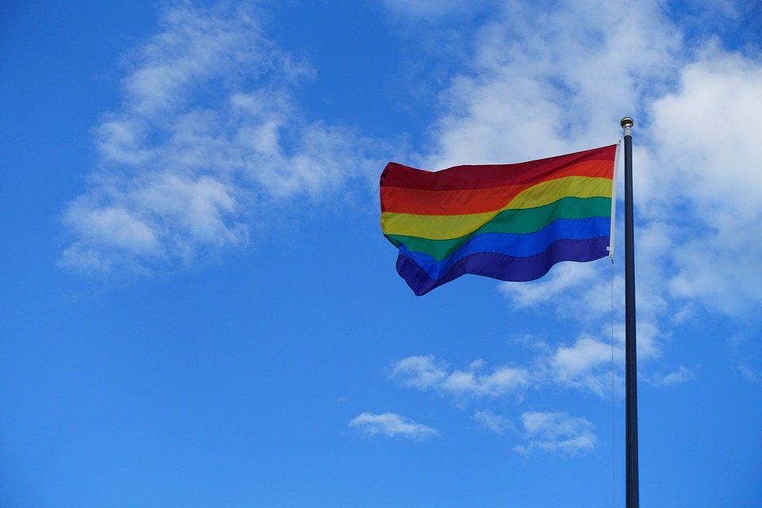

**Enjoy tea, coffee and cakes with other lesbians and bisexual women.**

**We meet in comfortable and pleasant surroundings on the 2nd Friday of the month 3pm - 5pm at:**

**Bradbury Wing  
141 Park Road North  
Birkenhead  
CH41 0DD**

**Free parking is available, we are close to bus routes and Birkenhead Park station.**

**For more information please contact  
Claire Thomson  
0151 488 7805**[**claire.thomson@ageukwirral.org.uk**](mailto:claire.thomson@ageukwirral.org.uk)

**Registered charity no 1035410**



**Athena Group**