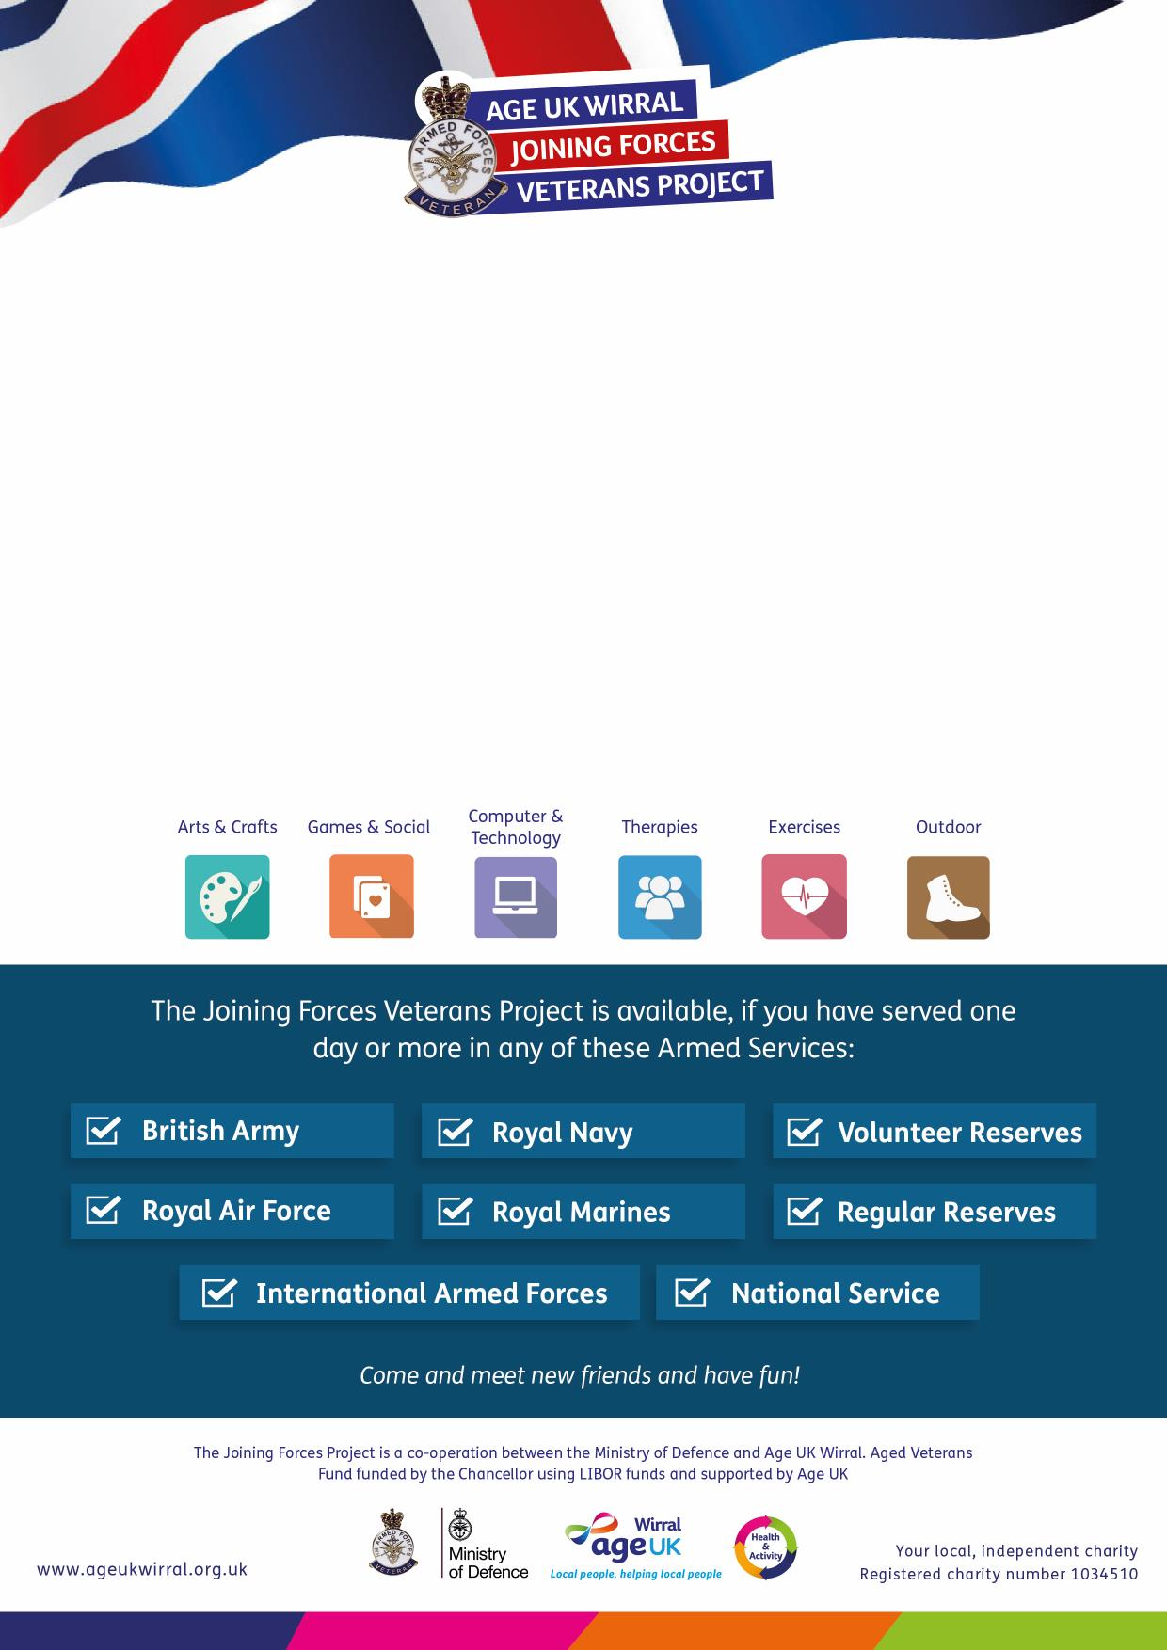

Information & Advice Clinic  
**Drop-in Clinic at Wirral Military Community Services**

**Unit 7, Brandon Street, Birkenhead CH41 5HN**

on the first **Monday** of each month

**9am – 1pm**

Our Information & Advice caseworker is on hand to support you with a

wide range of issues such as accommodation, health and wellbeing, pensions,

benefits, home improvement and more. If you aren’t able to visit the clinic,

you can be visited at home or at an Age UK Wirral centre.

**For more information please call:  
0151 482 3456**

The **Joining Forces Veterans Project** provides you with a range of activities and   
services designed to meet your needs, right here in Wirral.

***For more information please call:  
0151 482 3456***

The **Joining Forces Veterans Project** provides you with a range of activities and   
services designed to meet your needs, right here in Wirral.