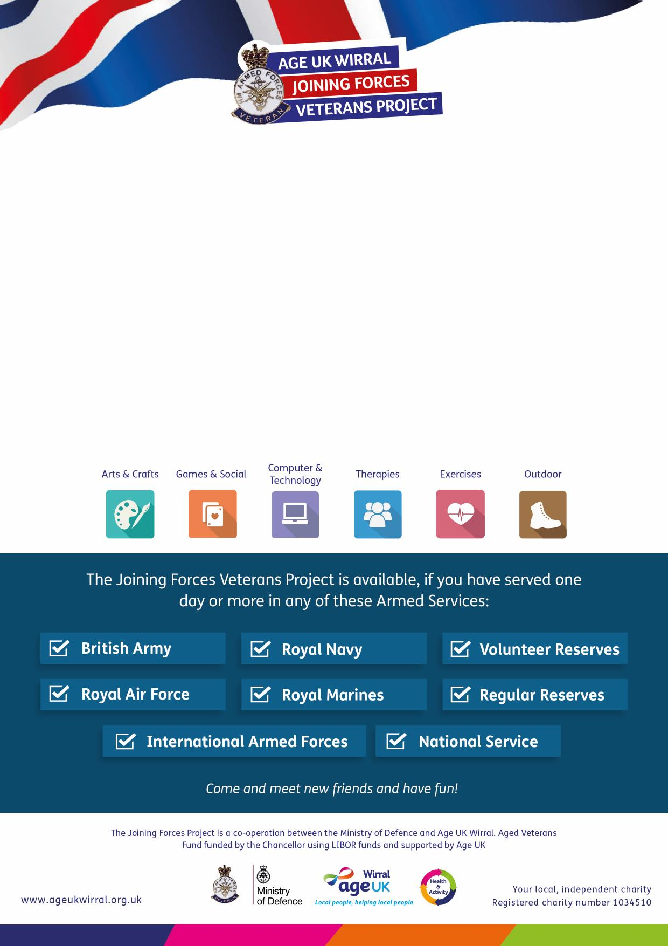

Research, Explore and Discover your...

**FAMILY HISTORY**

**Meadowcroft Activity Hub**

**304 Spital Road, Bromborough CH62 2DE**

on the first and third **Friday** of each month

**10am – 12pm**

**(Starting 17th November 2017)**

Join our beginners Family History Club. Learn tips and hints on how to

research and build your family tree in a relaxed and friendly environment.

**For more information please call:  
0151 482 3456**

The **Joining Forces Veterans Project** provides you with a range of activities and   
services designed to meet your needs, right here in Wirral.

***For more information please call:  
0151 482 3456***

The **Joining Forces Veterans Project** provides you with a range of activities and   
services designed to meet your needs, right here in Wirral.