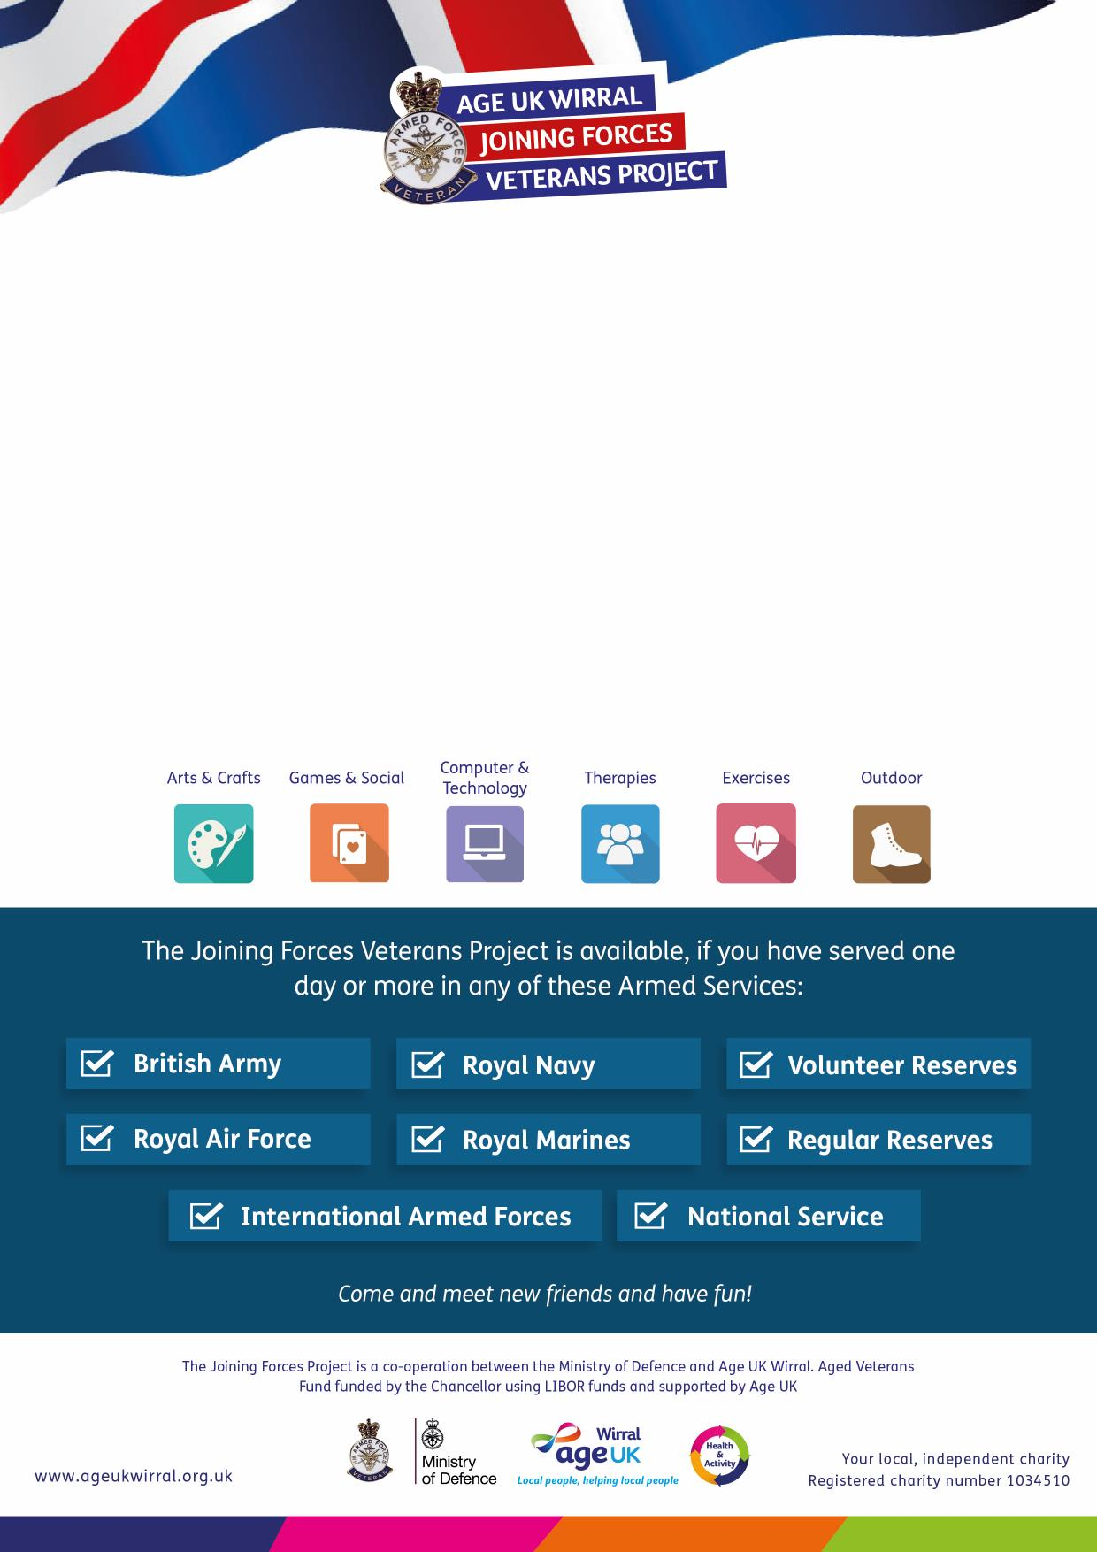

**For more information please call:  
0151 482 3456**

Veteran’s Reminiscence Group  
**Meadowcroft Activity Hub**

**304 Spital Road, Bromborough CH62 2DE**

on the first **Tuesday** of each month

**10am – 12pm**

Re-call, re-live and re-experience your service in our reminiscence group.

Share your stories of life in and out of the Forces with your peers in a

comfortable, relaxed, friendly environment.

The **Joining Forces Veterans Project** provides you with a range of activities and   
services designed to meet your needs, right here in Wirral.

***For more information please call:  
0151 482 3456***

The **Joining Forces Veterans Project** provides you with a range of activities and   
services designed to meet your needs, right here in Wirral.