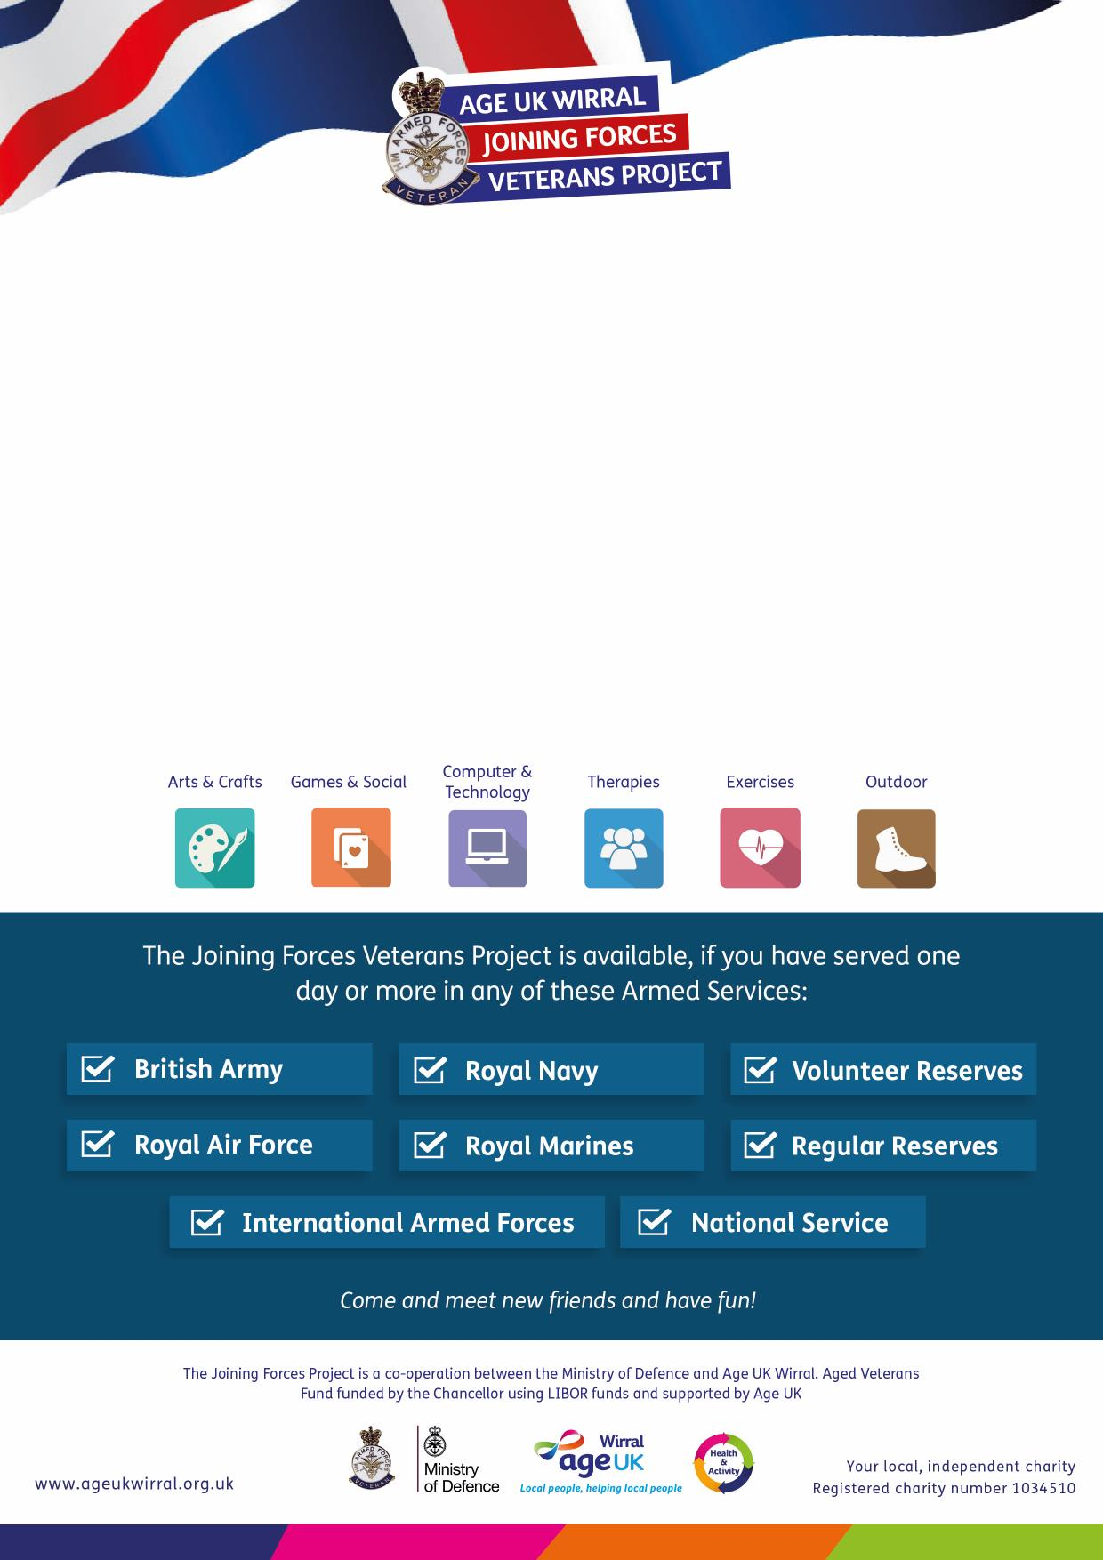

**For more information please call:  
0151 482 3456**

**Veteran’s Breakfast Club   
The Heart of Egremont, Old Egremont Mission,**

**Guildford Street, Egremont, Wallasey**

on the second **Thursday** of each month

**10am – 12pm**

Join fellow veterans for a cooked breakfast or bacon butty* at

The Heart of Egremont Café and find out about the services and activities

offered by the Joining Forces Veterans Project.

*Please note charges apply

The **Joining Forces Veterans Project** provides you with a range of activities and   
services designed to meet your needs, right here in Wirral.

***For more information please call:  
0151 482 3456***

The **Joining Forces Veterans Project** provides you with a range of activities and   
services designed to meet your needs, right here in Wirral.